# Weekly Completed Activity:

Update to 10AM EDT

Communications Activity:

1. Processed “Mail from website”
   1. One request for TCAS II CAS-67 processor forwarded to Dave
2. MailChimp
   1. Ready to launch press release for Hawker 4000 STC announcement
      1. Awaiting posting of PR to website once Forrest has internet
   2. Ready to launch Bombardier STC press release on Mailchimp
   3. Finalizing Airborne Image Recorder PR
3. Sent AEA ad to Rachel Hill at AEA
4. Website activity
   1. Continued tuning of Google Analytics account and streams analyzer.

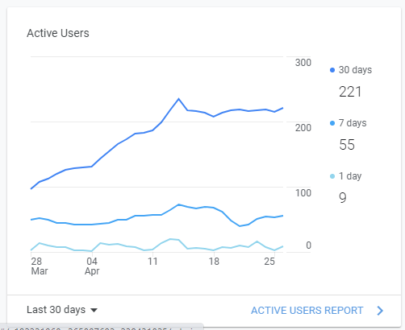

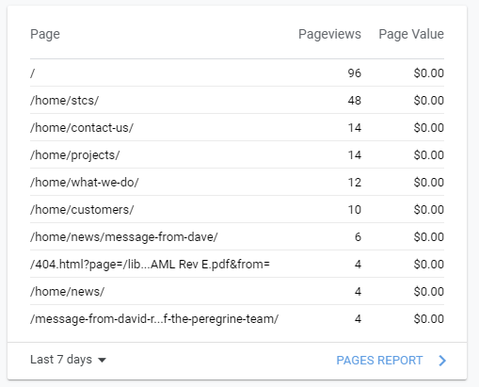STC detailed download report is attached as a PDF.

1. STC information:

|  |  |  |
| --- | --- | --- |
| **Need** | **STC** | **Subject** |
| STC Doc | SA09886AC | BendixKing CG100P Connected Gateway Installation Part 23 AML (King Air 200/B200) |
| STC Doc | SA01044DE | PC12 TB44 Battery |
| STC Doc | SA01053DE | PC-12 GoGo AVANCE L3 |
| STC Doc, STC # | Not yet available | Peregrine and Lee Aerospace announce Aviation Clean Air (ACA) system Supplemental Type Certificate (STCs) for the Citation 560XL |
| STC Doc, STC # | Not yet available | Peregrine, Lee Aerospace and ACA announce COVID-19 Aviation Clean Air System STC for Bombardier Challenger series Aircraft |
| STC Doc, STC # | Not yet available | Peregrine, Lee Aerospace and ACA announce COVID-19 Aviation Clean Air System STC for Gulfstream G-IV and G-IV SP series Aircraft |

# Next Activities

**Website activity:**

| **Prioritized Topic** | **Estimated Start** | **Estimated Completion** | **Comments** |
| --- | --- | --- | --- |
| Update Trig STC References | When Roper sends links | TBD | Awaiting link from Peregrine |
| Update STC data | Awaiting Data | TBD | Awaiting data from SharePoint |
| SEO/Analytics | Ongoing | Ongoing - SEO refinements and Google analytics recommendations | Next steps will be to address home page complexity and page loading issues, plus linkage of Google Search and MailChimp analytics to the basic reporting. |
| File manager installation | 26 April 2021 | 3 May 2021 |  |
| Manage Press Release and other Posting Announcements | Ongoing |  |  |
| Security & Maintenance | Ongoing |  |  |

**Communication Activity:**

1. Transmit Hawker 4000 press release, include Talon (Andy Hall)
2. Validate and send recorder PR

| **Prioritized Topic** | **Estimated Start** | **Estimated Completion** | **Comments** |
| --- | --- | --- | --- |
| Hawker 4000 |  | Coordinate with Andrew Hall 6 Apr 21 | Ready to go   * Awating PMA * Review by Talon |
| CW Cockpit Video | 6 Apr 2021 | 9 Apr 2021 |  |
| Bombardier Press Release | Awaiting WL |  | Kevin tasking |
| GAC G150 Heater PR | Awaiting GAC |  | Lumry tasking |

# Press Release Status:

|  |  |  |  |
| --- | --- | --- | --- |
| **Press Release** | **Audience** | **Status** | **Release Date** |
| ACA RTCA EUROCAE Participation | Press, 145 shops | mailchimp | 16-Feb-2021 |
| Bombardier CL Exclusive ACA | Press | awaiting - Wes |  |
| G150 Actuator Heater | Press | awaiting - GAC/Wes |  |
| 560XL ACA | Press | Released | 16-Dec-2020 |
| PC-12 Gogo AVANCE L3 | Press | Released | 15-Dec-2020 |
| CAS 67 Change 7.1 Owner Campaign | CAS 67 Aircraft non 7.1 | Released | 9-Sep-2020 |
| G700 TXi STC Expertise for Your Next Upgrade Project | Garmin Dealers | Released | 11-Aug-2020 |
| G700 TXi STC EMB-120 Press | Press | Released | 10-Aug-2020 |
| G700 TXi STC EMB-120 Operator | EMB-120 Operators | Released | 10-Aug-2020 |
| ACA CL-600 Series | Press | Released | 13-Jul-2020 |
| ACA G-IV | Press | Released | 8-Jul-2020 |
| May Covid-19 Update | 145 shops, press, prior contacts | Released | 5-May-2020 |
| Covid-19 Status | 145 shops, press, prior contacts | Released | 30-Mar-2020 |