Peregrine Web Site Activity

(Detailed PPT attached from Forrest C)

* Continued tuning of Google Analytics account and streams analyzer

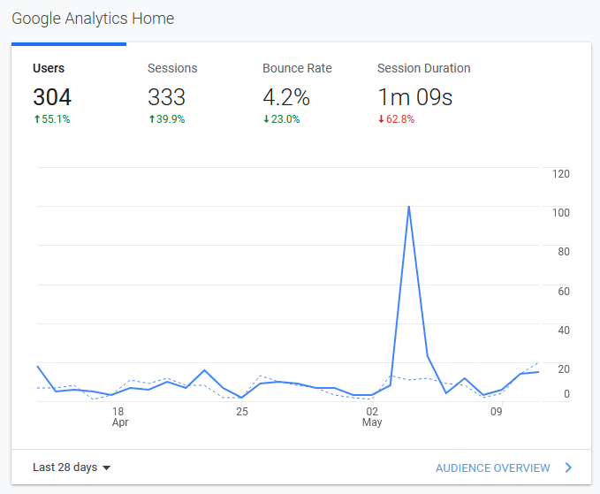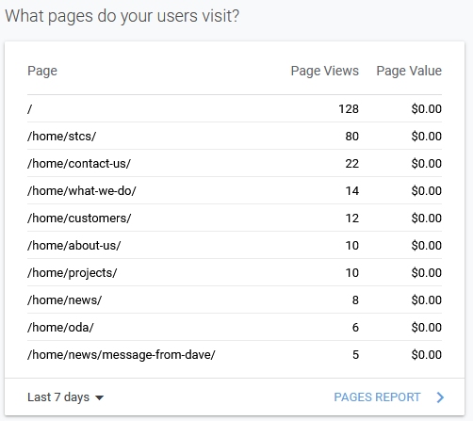

* **Updated Website with Press Release on Hawker Blower (Blog, Press Page, STCs)**
* **Forecast Website Activity (coming 30 days)**

| **Prioritized Topic** | **Estimated Start** | **Estimated Completion** | **Comments** |
| --- | --- | --- | --- |
| Update Trig STC References | When Roper sends links | TBD | Awaiting link from Peregrine |
| Update STC data | Awaiting Data | TBD | Awaiting data from SharePoint |
| SEO/Analytics | Ongoing | Ongoing - SEO refinements and Google analytics recommendations | Next steps will be to address home page complexity and page loading issues, as well as ongoing security alerts. |
| File manager installation | 24 May 2021 | 28 May 2021 |  |
| Manage Press Release and other Posting Announcements | Ongoing |  |  |
| Security & Maintenance | Ongoing |  |  |

Marketing Communications Activity

* **Processed “Mail from website”**
  + ED-800 with new CMA-6800 for S-76's forwarded to Brad Sutphin and acknowledged
  + KT74 inquiry forwarded to Marshall Mortley
* **MailChimp**
  + Send Hawker 4000 email
    - Two significant Responses to Peregrine directly
    - Picked up by “Business Air News” and featured on their website
      * <https://www.businessairnews.com/mag_story.html?ident=21156>
  + Ready to launch Bombardier STC press release on Mailchimp
  + Finalizing Airborne Image Recorder PR
* **Press Release Status**

|  |  |  |  |
| --- | --- | --- | --- |
| **Press Release** | **Audience** | **Status** | **Release Date** |
| Hawker 4000 Blower | 145 shops, press, prior contacts | Released | 3-May-2021 |
| ACA RTCA EUROCAE Participation | Press, 145 shops | Released | 16-Feb-2021 |
| Bombardier CL Exclusive ACA | Press | awaiting - Wes |  |
| G150 Actuator Heater | Press | awaiting - GAC/Wes |  |
| 560XL ACA | Press | Released | 16-Dec-2020 |
| PC-12 Gogo AVANCE L3 | Press | Released | 15-Dec-2020 |
| CAS 67 Change 7.1 Owner Campaign | CAS 67 Aircraft non 7.1 | Released | 9-Sep-2020 |
| G700 TXi STC Expertise for Your Next Upgrade Project | Garmin Dealers | Released | 11-Aug-2020 |
| G700 TXi STC EMB-120 Press | Press | Released | 10-Aug-2020 |
| G700 TXi STC EMB-120 Operator | EMB-120 Operators | Released | 10-Aug-2020 |
| ACA CL-600 Series | Press | Released | 13-Jul-2020 |
| ACA G-IV | Press | Released | 8-Jul-2020 |
| May Covid-19 Update | 145 shops, press, prior contacts | Released | 5-May-2020 |
| Covid-19 Status | 145 shops, press, prior contacts | Released | 30-Mar-2020 |

* **STC Information Status - Press Releases (STC detailed download report attached PDF)**

|  |  |  |
| --- | --- | --- |
| **Need** | **STC** | **Subject** |
| STC Doc | SA09886AC | BendixKing CG100P Connected Gateway Installation Part 23 AML (King Air 200/B200) |
| STC Doc | SA01044DE | PC12 TB44 Battery |
| STC Doc | SA01053DE | PC-12 GoGo AVANCE L3 |
| STC Doc, STC # | Not yet available | Peregrine and Lee Aerospace announce Aviation Clean Air (ACA) system Supplemental Type Certificate (STCs) for the Citation 560XL |
| STC Doc, STC # | Not yet available | Peregrine, Lee Aerospace and ACA announce COVID-19 Aviation Clean Air System STC for Bombardier Challenger series Acft |
| STC Doc, STC # | Not yet available | Peregrine, Lee Aerospace and ACA announce COVID-19 Aviation Clean Air System STC for Gulfstream G-IV and G-IV SP series Acft |

* **Next Communications Activities**
  + Transmit Hawker 4000 press release, include Talon (Andy Hall)
  + Validate and send recorder PR

| **Prioritized Topic** | **Estimated Start** | **Estimated Completion** | **Comments** |
| --- | --- | --- | --- |
| Hawker 4000 |  | Coordinate with Andrew Hall 6 Apr 21 | Ready to go   * Awaiting PMA * Review by Talon |
| CW Cockpit Video | 6 Apr 2021 | 9 Apr 2021 |  |
| Bombardier Press Release | Awaiting WL |  | Kevin tasking |
| GAC G150 Heater PR | Awaiting GAC |  | Lumry tasking |

* **Advertisement Placement - Wes suggested possible advert on Flt planning and/ WXR apps**
  + Ad submitted and finalized for AEA
  + Response WIP/ Lee
* **Industry Events Planning**
  + AEA – Dallas 22-25 June 2021
    - Created, coordinated review, and provided AEA ad to Rachel Hill at AEA
    - Requested that Lee C support Peregrine AEA activities on site during event
    - Interview with Jim Campbell/ ANN during show … ionization?, flight recorder, L3 AVANCE, GAC actuator heaters
    - Daily press release?
    - New product briefing re ACA ionization STCs? (Feature Lee Aerospace 560XL) EMB-120 flight deck? Others?
  + NBAA – Las Vegas 12-14 Oct 2021
    - Assuming ODA is main thrust, if not what is plan B? (See ODA item, follows)

Special Topics

* **ACA (Aviation Clean Air)**
  + ACA SAV Situation Update
  + Chase & Capture Status?
    - Piedmont, Horizon, Textron,
  + RTCA SC241/ EUROCAE WG-121 (DO-388) Rev A Update
    - ***Boeing released their study re ionization, 28APR2021***

<https://www.boeing.com/confident-travel/research/use-of-bipolar-ionization-for-disinfection-within-airplanes.html>

* + - Review in progress, as of 28APR2021 & will update when review complete
    - Consider what actions we, Peregrine, can take, if any, to counter any potential, perceived negativity as a result of the Boeing white paper
      * Go on the offensive (?) and issue PR, media blitz, touting the "layer defense against COVID-19 & other pathogens" to protect VVIPs in bizjets = smaller cabin size, length of exposure, ECS differences, etc.
      * Even though Boeing is an air transport OEM, they are an industry leader and will have impact in the bizjet segment
* **FATB Situation Discussion**
  + Not a Peregrine priority at this time
  + Assume there will be some FATB status questions from those entities with whom, at 2019 AirVenture, we discussed the concept
    - Dynon, Aspen, Hon Bendix King, Avidyne, Appareo, UND Aviation, Alpha Systems, Sandia Aero and maybe some others?
    - Create a consistent FAT-B message or presence, for use if or, as needed
    - If selling off the FAT-B IP is the plan, perhaps AEA is a good forum at which we can directly progress such a plan
      * Between now and AEA, undertake a low-profile effort to determine feasibility of go/ no go and action accordingly
      * Directly by pre-AEA event interfacing with target entities
      * Queue targets up for key discussions at AEA or eliminate targets from further actions?

Work In Progress

* **ODA - Status?**
  + DRAFT Publicity Plan the Plan – **1st Draft 01 July**
    - Target industry event - NBAA Annual – LAS 12-14 Oct 2021
      * For planning purposes ONLY, at this time, depends on FAA ODA approval
      * Encompass those different messages we want to get to specific audiences
      * Interviews, white paper, industry panels, working groups (RTCA, FAA, etc.)
        + "What great things are gained by working with ODA?"
      * Comprehensive approach and not rely only on mail chimp and www site
        + Lobby trade journals for feature article placement
        + Local & CO State government PR, CO Congressional?
        + Joint PR with some clients … Mtn Avia, Air Methods, ???
        + Less technical & more general marketing
        + Mail chimp is conduit for more focused technical approach
* **Wichita Peregrine/ GAC Engineering Services**
  + Status & planning?
  + How to leverage publicity given situation?