Marketing Communications Activity

* **Processed “Mail from website”**
  + One request for TCAS II CAS-67 processor forwarded to Dave
* **MailChimp**
  + Ready to launch press release for Hawker 4000 STC announcement
    - Awaiting posting of PR to website once Forrest has internet
  + Ready to launch Bombardier STC press release on Mailchimp
  + Finalizing Airborne Image Recorder PR
* **Wes/ Lee – Wes suggested possible advert on Flt planning and/ WXR apps – WIP/ Lee**
* **STC Information Status For Press Releases**

|  |  |  |
| --- | --- | --- |
| **Action Needed** | **STC Ref** | **Subject** |
| STC Doc | SA09886AC | BendixKing CG100P Connected Gateway Installation Part 23 AML (King Air 200/B200) |
| STC Doc | SA01044DE | PC12 TB44 Battery |
| STC Doc | SA01053DE | PC-12 GoGo AVANCE L3 |
| STC Doc, STC # | Not yet available | Peregrine and Lee Aerospace announce Aviation Clean Air (ACA) system Supplemental Type Certificate (STCs) for the Citation 560XL |
| STC Doc, STC # | Not yet available | Peregrine, Lee Aerospace and ACA announce COVID-19 Aviation Clean Air System STC for Bombardier Challenger series Aircraft |
| STC Doc, STC # | Not yet available | Peregrine, Lee Aerospace and ACA announce COVID-19 Aviation Clean Air System STC for Gulfstream G-IV and G-IV SP series Aircraft |

* **Industry Events Planning**
  + AEA – Dallas 22-25 June 2021
    - Created, coordinated review, and provided AEA ad to Rachel Hill at AEA
    - Requested that Lee C support Peregrine AEA activities on site during event
      * Lee to coordinate with Jennie A regarding logistics
    - Interview with Jim Campbell/ ANN during show … ionization?, flt recorder, AVANCE, GAC actuator heaters
    - Daily press release?
    - New product briefing re ACA ionization STCs? (Feature Lee Aerospace XL) EMB-120 flt deck? Others?
    - PLAN NOW
  + NBAA – Las Vegas 12-14 Oct 2021
    - Assuming ODA is main thrust, if not what is plan B? (See ODA item, follows)

Peregrine Web Site Activity

(Detailed download report attached)

* Continued tuning of Google Analytics account and streams analyzer

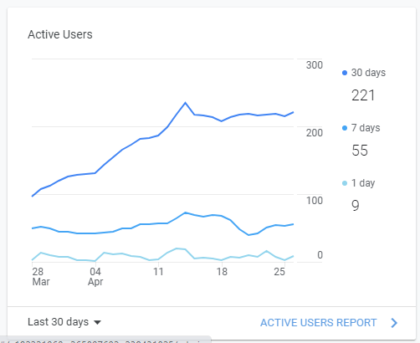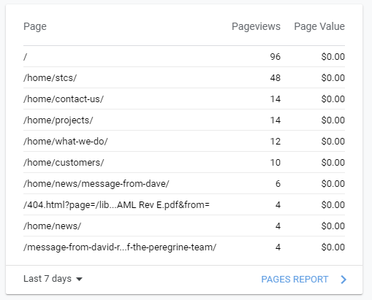

Special Topics

* **ACA (Aviation Clean Air)**
  + ACA SAV Situation Update
  + Chase & Capture Status?
    - Piedmont, Horizon, Textron,
  + RTCA SC241/ EUROCAE WG-121 (DO-388) Rev A Update
    - ***Boeing released their study re ionization, 28APR2021***

<https://www.boeing.com/confident-travel/research/use-of-bipolar-ionization-for-disinfection-within-airplanes.html>

* + - Review in progress, as of 28APR2021 & will update when review complete
    - Consider what actions we, Peregrine, can take, if any, to counter any potential, perceived negativity as a result of the Boeing white paper
      * Go on the offensive (?) and issue PR, media blitz, touting the "layer defense against COVID-19 & other pathogens" to protect VVIPs in bizjets = smaller cabin size, length of exposure, ECS differences, etc.
      * Even though Boeing is an air transport OEM, they are an industry leader and will have impact in the bizjet segment
* **FAT-B Situation Discussion**
  + Action Plan TBD?
  + Assume there will be some FAT-B status questions from those entities with whom, at 2019 AirVenture, we discussed the concept
    - Dynon, Aspen, Hon Benidx King, Avidyne, Appareo, UND Aviation, Alpha Systems, Sandia Aero and maybe some others?
    - Create a consistent FAT-B message or presence, for use if or, as needed
    - If selling off the FAT-B IP is the plan, perhaps AEA is a good forum at which we can directly progress such a plan
      * Between now and AEA, undertake a low-profile effort to determine feasibility of go/ no go and action accordingly
      * Directly by pre-AEA event interfacing with target entities
      * Queue targets up for key discussions at AEA or eliminate targets from further actions?

Work In Progress

* **ODA - Status?**
  + DRAFT Publicity Plan the Plan – **1st Draft 01 July**
    - Target industry event - NBAA Annual – LAS 12-14 Oct 2021
      * For planning purposes ONLY, at this time, depends on FAA ODA approval
      * Encompass those different messages we want to get to specific audiences
      * Interviews, white paper, industry panels, working groups (RTCA, FAA, etc.)
        + "What great things are gained by working with ODA?"
      * Comprehensive approach and not rely only on mail chimp and www site
        + Lobby trade journals for feature article placement
        + Local & CO State government PR, CO Congressional?
        + Joint PR with some clients … Mtn Avia, Air Methods, ???
        + Less technical & more general marketing
        + Mail chimp is conduit for more focused technical approach
* **Wichita Peregrine/ GAC Engineering Services**
  + Status & planning?
  + How to leverage publicity given situation?