# Summary

Peregrine has developed an approved solution to resolve issues with the G150 flap and slat actuation systems that may arise during approach and landing in certain situations. When a G150 has been exposed to precipitation or high humidity, followed by exposure to freezing temperature at altitude, the flap and slat actuation drives can freeze, preventing the high lift devices from deploying. A no-flap/no-slat landing configuration can lead to a steeper descent path and high-speed landings without flap or slat deployment; possibly requiring a diversion away from the destination airport. Operational impacts may include costly diversions to alternate destination with a runway of suitable length, passenger-experienced delays and increased direct and indirect operational costs.

# I. Introduction

Gulfstream G150 aircraft can experience freeze-up of the slat or flap actuation system that can prevent their deployment during approach and landing phases of flight. The Peregrine STC covers the installation of wrap-around, cuff-style heaters (Figure 3), controls, monitoring systems and cockpit indications.

The G150 flap and slat drive system is composed of a Power Drive Unit (PDU), flexible drive shafts, and twelve linear ball screw actuators (3 per wing, 2 systems) as shown in Figure 1. The STC does not modify the G150 Flap/Slat drive system including controls, indications, safety mechanisms or recommended lubrication maintenance procedures. The existing Flap/Slat actuators are modified by the installation of external supplemental heaters only.



Figure 1: G150 Equipment Installation Locations, Left Wing Shown. STC does not modify the G150 Flap/Slat drive system including controls, indications, safety mechanisms or recommended lubrication maintenance procedures

# II. System Description - Heater Cuff System

The Peregrine STC installation kit includes Peregrine-specific control and heater components. The Flap/Slat Actuator Heating System (FSAHS), when powered on by the cockpit ON/OFF switch, shown in Figure 2, is designed to automatically heat the actuator when temperatures are below 40° F. Thermistors installed on each heater are used to both activate the heaters at the proper temperature and ensure the actuator never reaches the upper operating temperature limit of 130° F.

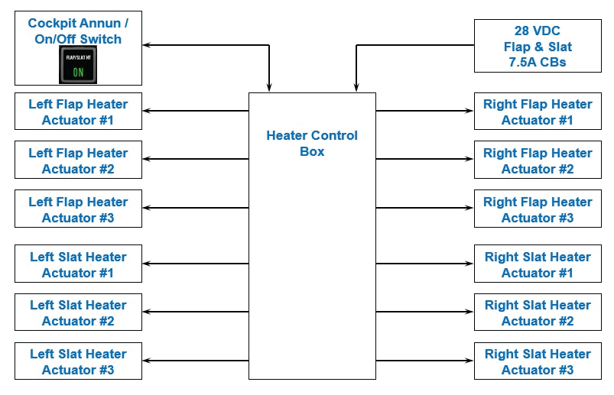

Figure 2: Heater Cuff System Overview

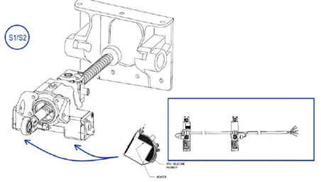

Figure : Wrap-around, cuff-style, design and are mounted on the exterior of the actuators

# III. System Control Logic

The Flap/Slat Actuator Heating Control Unit (FSHCU) has two separate sections (channels); one controls the six (6) flap actuator heater circuits while the other controls the six (6) slat actuator heater circuits. The controller will activate all of the heaters on a channel when any of the sensors on that channel read a temperature below 40° F. To prevent overheating actuators, if any of the channel temperature sensor readings exceed 130° F, the system will shut off the affected channel, even if another sensor is reading below 40° F. The system will remain shut off until a power cycle or self-test is initiated at the heater box.

Figure : Gulfstream FAST G150

Additionally, if the system detects a heater fault on either channel, the affected channel will be automatically and entirely shutoff until repairs are made.

# IV. Built in Test Function

No preflight check is required. However, system validation may be accomplished with the system’s Built‑In‑Test (BIT) function.

A Press-To-Test (PTT) switch initiates a Built-In-Test procedure that checks the integrity of the controller and the corresponding heaters when pressed and held for approximately 2 seconds. The controller also performs a Power-On BIT (PBIT) and a Continuous BIT (CBIT) to ensure system integrity.

The LED indicators on the face of the control box allow a test of the system by manually pressing the Press-To-Test Switch and visually verifying the indicators for each heater are illuminated. The system is powered by the main direct current (DC) Power when the engines are running. To test the system prior to flight, power is provided by an auxiliary power unit (APU) or external power by means of an additional circuit.

# V. STC Details

The Peregrine FAA STC, ST01075DE, certifies the fitting of heater components to each of the twelve (12) actuator devices, installation of a control module and cockpit switch/annunciator installation.

The installation process requires approximately three (3) weeks of downtime and a six (6) month lead time from order placement.

# VI. Solution Pedigree

Gulfstream operates several ‘Gulfstream Field and Airborne Support Teams (FAST)’ G150 aircraft, Figure 4, to provide factory service for customers.

The FAST G150 aircraft encountered this flap/slat actuation issue and worked with Peregrine and their selected authorized repair station to develop a retrofit solution.

Peregrine answered the challenge and developed a complete STC solution that has subsequently been installed on the FAST aircraft.

While not a Service Bulletin from Gulfstream, the STC has been recognized by Gulfstream FAST operation as solving the issue with high lift actuation system freeze-up.

# VII. For Further Information

Peregrine is ready to schedule your STC installation or delivery of the STC and installation package to your preferred repair station.

The STC and associated components are available directly from Peregrine.

Peregrine also offers a turnkey solution including labor, STC and project management for complete installation and return to service of your G150 at a Denver area FAA repair station familiar with this STC.

# VIII. Contact:

Peregrine

7385 S. Peoria Street Unit C4

Englewood, CO 80112

+1 (303) 325-3873

www.peregrine.aero