**AeroCheck**

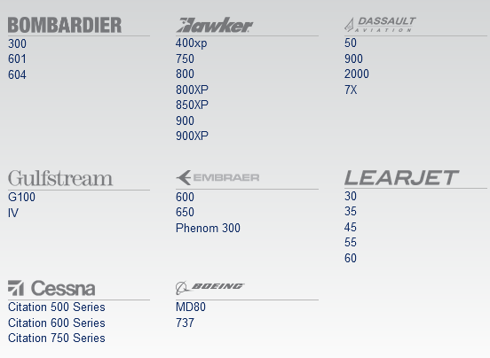**Phone**

(480) 991-0900

**Address**

AeroCheck MRO  
At Swift Aviation  
2710 E. Old Tower Road  
Phoenix, AZ 85034

https://www.aerocheckmro.com

**Airport**

Sky Harbor Airport – KPHX

----------------------------------------------------------------------------------------------------------------------------------------

**Broadie’s Aircraft** is located at Meacham International Airport in Fort Worth, Texas, the heart of the Dallas-Fort Worth metroplex. https://broadiesaircraft.com

4701 North Main Street  
Fort Worth, Texas 76106  
Phone: (817) 626-1532  
[After Hours & Emergency Support](https://broadiesaircraft.com/after-hours-service/): (682) 330-3694  
Fax: (817) 626-1537  
General E-Mail: [hello@broadiesaircraft.com](mailto:hello@broadiesaircraft.com)  
Parts Department: [parts@broadiesaircraft.com](mailto:parts@broadiesaircraft.com)  
Maintenance: [service@broadiesaircraft.com](mailto:service@broadiesaircraft.com)  
Employment: [careers@broadiesaircraft.com](mailto:careers@broadiesaircraft.com)

**Aircraft Phase Inspections:**

Event Inspections  
Annual Inspections  
Mobile and AOG Support  
Pre-purchase Inspections & Evaluations

We offer **Structure Repair** on all types of aircraft from piston to jet when the unexpected strikes:

Hangar Rash  
Bird Strikes  
Gear Up Damage  
Accidents  
Corrosion  
STC Modifications

Broadie’s Aircraft is an **Authorized Service Center** For:

Beechcraft  
Caravan  
Cessna  
FreeFlight  
Garmin  
Honeywell  
Innov8 Cabin Solutions  
Lycoming  
Pratt & Whitney  
Quest  
Raisbeck  
SMR Ice Shield de-ice Boots

Broadie’s Aircraft offers Maintenance on these Aircraft:

All Makes & Models of GA (General Aviation) Aircraft  
Beechjet  
Beechcraft Premier  
Cessna Citation  
Caravan  
Challenger  
Dassault Falcon  
Gulfstream  
Hawker  
King Air (King Air 90 and 100, Super King Air 200, 300, and 350)  
Learjet  
Piaggio  
Pilatus  
TBM

Broadie’s Aircraft is an **FAA 145 Repair Station**

Class 3 Airframe  
Class 1 Engine  
**Dozens of Limited Airframe, Engine & Accessory Ratings Including:**

**Beechcraft**  
Beechcraft 200  
Beechcraft 300  
Beechcraft 1900 Series

**Bombardier**  
Bombardier CL-601  
Bombardier CL-604

**Learjet**  
Lear 24  
Lear 25  
Lear 31  
Lear 31A  
Lear 35  
Lear 36A  
Lear 40  
Lear 45  
Lear 60

**Citation**  
Citation 500 Series  
Citation 550 Series  
Citation 560 Series  
Citation 650  
Citation 680  
Citation 750

**Dassault Falcon**  
Falcon 10  
Falcon 20  
Falcon 50  
Falcon 900  
Falcon 2000  
Falcon 2000EX Series

**Gulfstream**  
Gulfstream G150  
Gulfstream G200  
Gulfstream Galaxy  
Gulfstream GIV  
Gulfstream GV  
Gulfstream GIV-X (G450)  
Gulfstream GV-SP (G550)  
Gulfstream GVI

**Hawker**  
Hawker 125 Series  
BAE 125 Series  
Hawker 400  
Hawker 400A  
Hawker 700A  
Hawker 700B  
Hawker 750  
Hawker 800A  
Hawker 800B  
Hawker 850XP  
Hawker 900XP  
MU – 300-10

**Chicago Executive Service Center/ Chicago Executive Airport (PWK)**

**DBA NJet**

743 Sumac Rd.   
Hangar 15   
Wheeling, IL 60090

(DNB)

Address: 1109 S Wolf Rd Hngr 8-1B Wheeling, IL, 60090-6473 United States

Phone: (847) 537-1205

Website: www.n-jet.com

Employees (this site): 11

Modelled

NJet  
Employees (all sites): 11

Modelled

Revenue: $754,147

Modelled

Year Started: 2002   
[815-455-7707](tel:+8154557707) and [888-FLY-NJET (888-359-6538)](tel:+8883596538)

Howard Seedorf

President and CEO   
[howards@n-jet.com](mailto:howards@n-jet.com)   
[1-815-261-3301 (office)](tel:+18152613301)

Chad Seedorf

Chief Pilot   
[chads@n-jet.com](mailto:chads@n-jet.com)   
[1-815-261-3302 (office)](tel:+18152613302)

Lou-Anne Cronin

General Manager   
[louannec@n-jet.com](mailto:louannec@n-jet.com)   
[1-847-850-5739 (office)](tel:+18478505739)

Ronna Hyde

Accounting   
[ronnah@n-jet.com](mailto:ronnah@n-jet.com)   
[1-847-850-5730 (office)](tel:+18478505730)

Maintenance

Edward Leonard

Director of Maintenance   
[edwardl@ce-sc.com](mailto:edwardl@ce-sc.com)   
[847-850-5738 (office)](tel:+8478505738)

(HA Note: Web site show them with three Astra SP/SPX (G100) and no other GAC aircraft. No listing of aircraft repair capabilities so cannot determine if GAC MRO, but doubtful. All info is shown in NJets www and could not find any www site for Chicago Executive Svc Ctr.)

**Elliot Aviation of Atlanta/ Elliot Aviation**

“Atlanta, GA, Dec. 13, 2021 – Elliott Aviation Inc., a leader in a diverse set of business aviation services, is excited to announce the completion of its integration and full re-brand of its fourth facility in the US, Elliott Aviation of Atlanta!”

(HA Note: Has no GAC maintenance.)

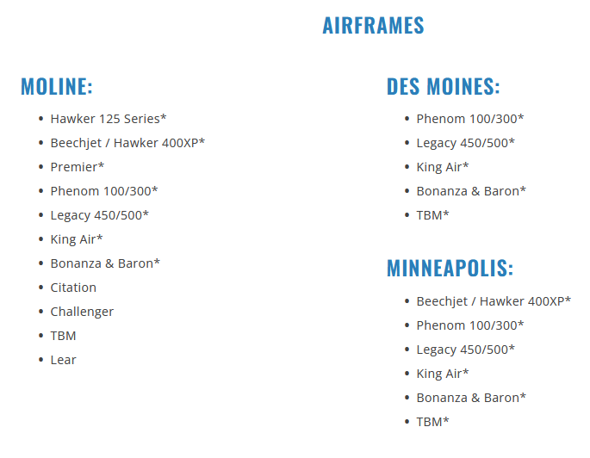

**Hawthorne Global Aviation Services**

**Headquarters, Charleston, SC**  
3955 Faber Place Drive, Ste. 202  
North Charleston, SC 29405  
Telephone: (843) 553-2203  
Email: [info@hawthorne.aero](mailto:info@hawthorne.aero)

Hawthorne Global Aviation Services is an FBO acquisition and operating company managed by Hawthorne Corporation with the financial backing of NexPhase Capital ("NPC"). Hawthorne and NPC believe that further consolidation in the fragmented FBO segment of the general aviation services industry creates a compelling value proposition for customers and airport sponsors and offers liquidity to FBO owners seeking an exit.

**Atlanta Cobb County International Airport**  
Post Office Box 339  
Kennesaw, GA 30156  
Telephone: (770) 422-4300  
Email: [kryy@hawthorne.aero](mailto:kryy@hawthorne.aero)

**Chicago Executive Airport**  
1120 South Milwaukee Avenue  
Wheeling, IL 60090  
Telephone: (847) 325-0566  
Email: [kpwk@hawthorne.aero](mailto:kpwk@hawthorne.aero)

**Chippewa Valley Regional Airport**  
3800 Starr Ave  
Eau Claire, WI 54703  
Telephone (715) 835-3181  
Email: [keau@hawthorne.aero](mailto:keau@hawthorne.aero)

**Long Island MacArthur Airport**  
2221 Smithtown Ave  
Ronkonkoma, NY 11779  
Telephone: (631) 913-7102  
Email: [kisp@hawthorne.aero](mailto:kisp@hawthorne.aero)

**Tuscaloosa Regional Airport**  
4800 Carter Drive  
Tuscaloosa, AL 35401  
Telephone: (205) 349-3991  
Email: [ktcl@hawthorne.aero](mailto:ktcl@hawthorne.aero)

**Sioux Gateway Airport**  
5815 Mitchell Street  
Sioux City, Iowa 51111  
Telephone: (712) 258-6563  
Email: [ksux@hawthorne.aero](mailto:ksux@hawthorne.aero)

**ExcelAire, Long Island, NY**  
2221 Smithtown Ave  
Ronkonkoma, NY 11779  
Telephone: (631) 737-0477

**Headquarters, Charleston, SC**  
3955 Faber Place Drive, Ste. 202  
North Charleston, SC 29405  
Telephone: (843) 553-2203  
Email: [info@hawthorne.aero](mailto:info@hawthorne.aero)

**Specializing in Heavy Maintenance of Gulfstream Aircraft**

* 12, 24, 36, 48, 96 and 72 month inspections
* 5000 landing structural inspection
* MSG-3 inspections
* CR dedicated structural capabilities
* Avionics service, navigation and communication system upgrades
* Custom interior refurbishment
* Technical evaluations for buyer/seller
* NDT capabilities including x-ray

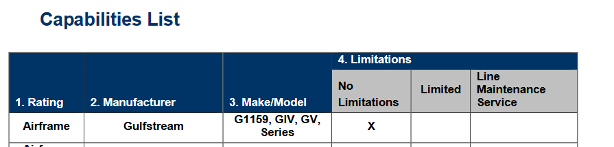



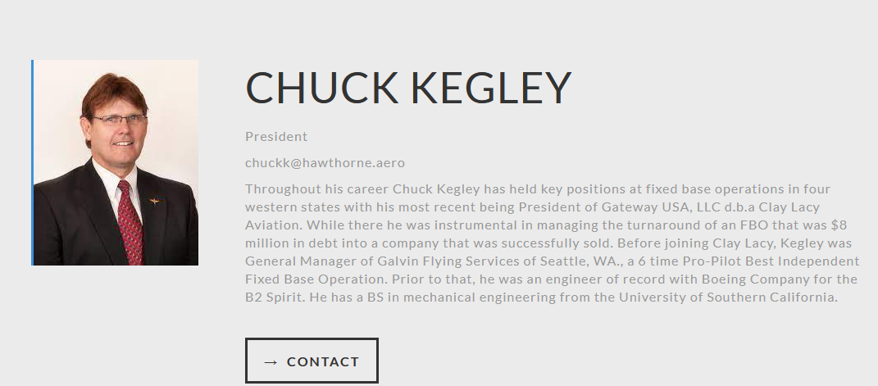

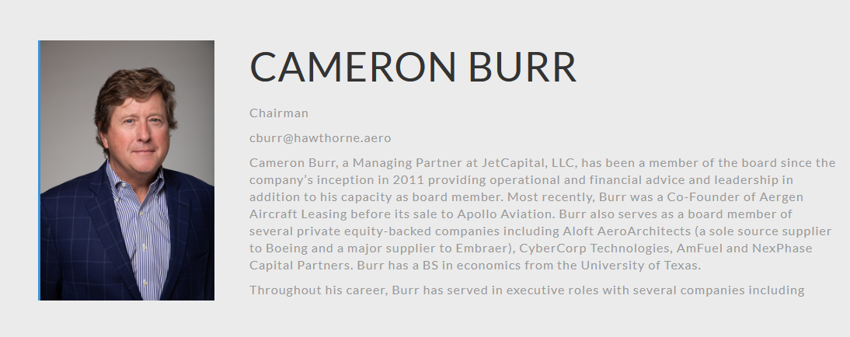

_____________________________________________________________________________________

**Meta Special Aerospace**

5600 Philip J. Rhoads Avenue  
Oklahoma City, OK 73008

phone: +1 (405) 694-4755  
fax: (405) 455-2354  
email: info@msa.meta.aero

Meta Special Aerospace’s team of experts have designed, rebuilt, improved, operated, and delivered high-reliability advanced multi-spectral airborne payloads and training to our tip of the spear forces consistently for over 30 years. Throughout our history, we have developed and built over 100 modified King Air and expanded this reach into custom enhancements for the entire King Air Family and other general and business aviation-class aircraft. In addition to modified aircraft, our experts have developed products for government and international security services, providing many modifications, ISR solutions, and Special Missions Operations.

(HA Note: Basically “special mission” aircraft. Very limited access, info from www but clearly do maint on “G series” aircraft; very well known as platforms for special missions.)

**Maintenance, Repair, and Overhaul (MRO)**

We offer a full spectrum of aviation services including complex special mission integration, aircraft modernization and upgrades, maintenance, and logistics support. We design, prototype, engineer, and field-test for commercial, military, and government special mission applications for our US government and international defense customers, OEM partners, and private aircraft owners.

• FAA Part 145 repair station specializing medium turboprop and jet aircraft – including Beechcraft King Air Series, B1900, Dash 8 Series, Gulfstream G Series, Cessna Citation, Learjet, and Dassault Falcon – services including inspection, scheduled maintenance and systems integration

• Provide custom-designed aircraft performance STC applications for fuel efficiency, gross weight increase, payload provisions*,* custom tire modifications, and light weight interior modifications

• Upgrade or replace existing avionics systems to include installation of laser wire harness identification

• Service and deliver aircraft internationally to include Australia, Canada, Central and South America, Mexico, and Western Europe

• AS9110C certification

• Depot-level and heavy repair MRO capabilities

• ISO 9001:2015 quality certification

• Full service FBO based at Wiley Post Airport (KPWA) in OKC

• Comprehensive parts chain for commercial and defense programs (DCMA certified)

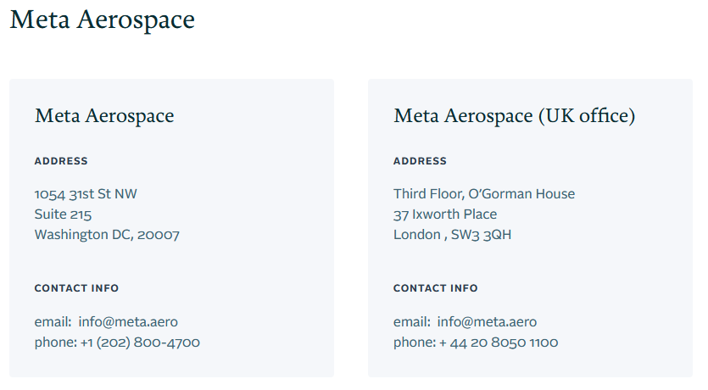

**Sunrise Jets** (formerly known as EastWay Aviation)

**Company Headquarters**

310 Sheldon Way  
Gabreski Airport  
Westhampton Beach,  
New York 11978

**Phone: 631-737-9911  
Fax: 631-737-4926**

**Private Jet Maintenance**

Phone: 800-927-0209  
maintenance@sunrisejets.com

Sunrise Jets offers state of the art jet maintenance services and is the only FAA Certified Repair Station (AOBR190C) on the East end of Long Island, NY. We have over 40 years of experience serving the New York Metropolitan aviation community, and boast a well-earned reputation for quality, service, and reliability.

**Gulfstream Private Jets - Maintenance Service**

+ Full Service Available (* Line Service Maintenance Only)

Gulfstream I*

Gulfstream G100*

Gulfstream G150*

Gulfstream II*

Gulfstream G200*

Gulfstream G280*

Gulfstream III*

Gulfstream G300*

Gulfstream G350*

Gulfstream G400*

Gulfstream G450*

Gulfstream V*

Gulfstream G500*

Gulfstream G550*

Gulfstream G650*

_____________________________________________________________________________________

**Thornton Aviation**

**Mailing Address**

7520 Hayvenhurst Avenue  
Van Nuys, CA 91406

**Phone** (818) 787-0205 (**Fax** (818) 787-9334)

**Van Nuys Airport (KVNY)**7520 Hayvenhurst Avenue  
Van Nuys, CA 91406

**Burbank Airport (KBUR)**

2930 N. Clybourn Avenue  
Hangar 89  
Burbank, CA 91505

**Directory**

Director of Maintenance:  
[Tim Johnston](mailto:tim@thorntonaviation.com) ([tim@thorntonaviation.com](mailto:tim@thorntonaviation.com))

Operations Specialist:  
[Gary Gilberts](mailto:gary@thorntonaviation.com)

Chief Inspector:  
[Paul Yamashita](mailto:paul@thorntonaviation.com)

Director of Restorations:  
[Rob McGregor](mailto:rob@thorntonaviation.com)

General Manager:  
[Steve Zimmerman](mailto:steve@thorntonaviation.com) ([steve@thorntonaviation.com](mailto:steve@thorntonaviation.com) )

Parts Manager:  
[Tina Martinez](mailto:parts@thorntonaviation.com)

Thornton Aviation specializes in delivering critical services at the Van Nuys Airport (KVNY) and Burbank Airport (KBUR), both near Los Angeles.

* Scheduled Inspections
* Calendar Inspections
* Hourly Inspections
* Unscheduled / [AOG](https://www.thorntonaviation.com/aog-services/) / Off-Site Support
* Maintenance Tracking Programs (CAMP, CMP, CESCOM, Flight Docs, V-LOG etc)
* Engineering Repairs
* Avionics Upgrades

**GULFSTREAM MAINTENANCE — FAA PART 145 CERTIFIED**

Inspection, Maintenance & Avionics Repair Services

___________________________________________________________________________________

**TRIMEC Aviation**

**TEXAS – DFW**

Full Service Facility: Maintenance, Repair, and Operations (MRO)

116 Texas Way  
Fort Worth, Texas 76106

(888) 303-1124  /  (817) 626-1376

(817) 626-1402

[sales@trimecaviation.com](mailto:sales@trimecaviation.com)

Trimec Aviation is a full service FAA certified MRO facility in Fort Worth, Texas providing aircraft services for schedule and unscheduled maintenance, avionics installations, engine removal and replacements, battery servicing, paint, and interior refurbishments. We offer comprehensive MRO service and part sales for multiple aircraft platforms: Astra/SPX/Gulfstream G100, G150, Galaxy/Gulfstream G200, Falcon 50, King Air 90/300, and Westwind 1124/1124A.

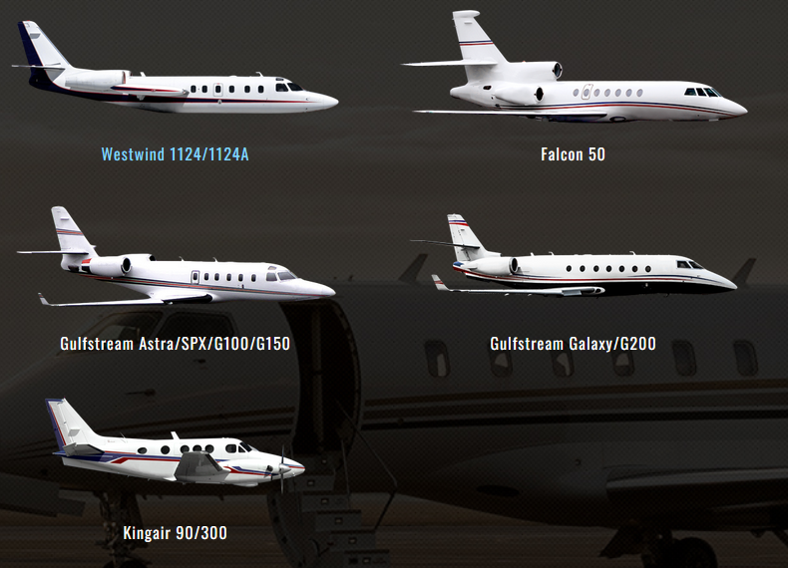

**FAST Air**

Telephone: [204.982.7240](tel:+1204.982.7240)

Toll-Free: [1.888.372.3780](tel:+11.888.372.3780)

Fax: [204.783.2483](tel:+1204.783.2483)

Email: [info@flyfastair.com](mailto:info@flyfastair.com)

80 Hangar Line Road  
Winnipeg, Manitoba Canada  
R3J 3Y7

**Fast Air Jet Centre (FBO)**

Toll-Free: [1.844.831.7714](tel:+18448317714)

Fax: [204.831.0878](tel:+12048310878)

Email: [service@flyfastair.com](mailto:service@flyfastair.com)

10 Hangar Line Road  
Winnipeg, Manitoba Canada  
R3J 3Y7

A Transport Canada certified AMO, authorized to Maintain Repair and Overhaul (MRO) Gulfstream; Hawker; Challenger; King Air; Westwind; Piper and Cessna aircraft, as well as Bell 206 series helicopters. Fast Air is certified to work on a variety of business jets including Gulfstream 150, Gulfstream 200, Beechcraft Hawker 800, Textron Cessna.

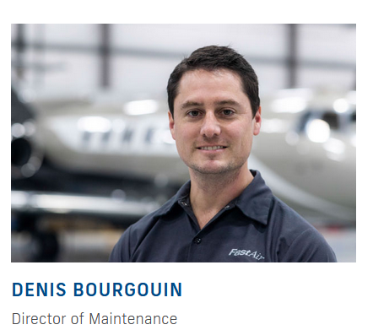

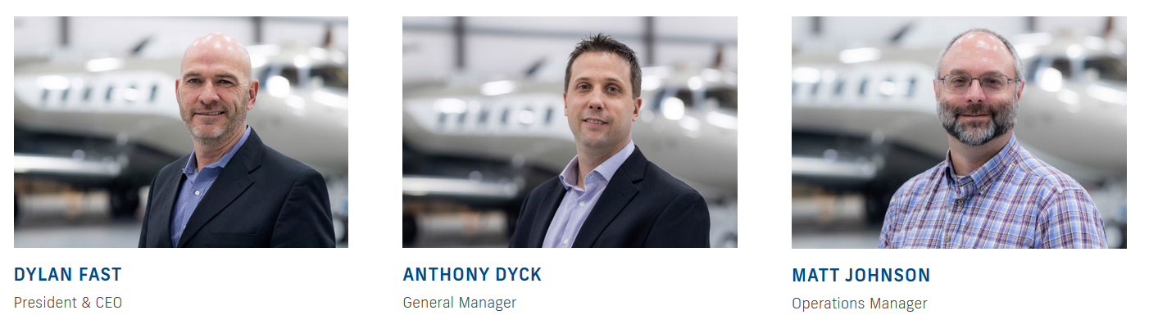

**JETPORT**

Hamilton International Airport  
520-9300 Airport Road  
Mount Hope, Ontario, Canada  
L0R 1W0

[](tel:+1%20888-887-7713) +1 888-887-7713 or +1 905-679-2400  +1 905-679-2810

**General/FBO:** [info@jetport.com](mailto:info@jetport.com)

**Maintenance:** [amo@jetport.com](mailto:amo@jetport.com)

**Charters:** [charters@jetport.com](mailto:charters@jetport.com)

**Aircraft Management:** [sales@jetport.com](mailto:sales@jetport.com)

**Line maintenance *capabilities*:**

Beech King Air series

Beech twin piston powered

Bombardier (Canadair) Challenger 600 series (600, 601, 604, 605)

Bombardier (Global Express) BD-700 series (GLEX, GL XRS, 5000, 6000, 6500)

Cessna Citation 500 series

Cessna single turbo/propeller

De Haviland DHC-8 series (100, 200, 300, Q400)

Gates Learjet series

Gulfstream G100 series

IAI Astra series

Pilatus series

Piper turbo-propeller

Piper twin piston powered

Single piston powered

**Maintenance services:**

Minor & major inspections

Line maintenance

Engine changes (piston & turbine)

Troubleshooting & snag rectification

Maintenance management

Pre-purchase inspections

Importation of aircraft

Ministers Delegate Import/Export (MD-M) service

Records management

Weighing of aircraft

Video boroscopes

Pitot/static checks

ELT Recertification

CVR FDR ULB Re-Certification

Parts sourcing

Uncompromising safety standards

Competitive pricing

Wholly owned hangar facility & FBO

AOG mobile services

**Transport Canada AMO certificate**



“We offer our own MD-M (Ministers Delegate) services to expedite paperwork on behalf of Transport Canada.”



**Sunwest Aviation Ltd.**

217 Aero Court NE  
Calgary Alberta T2E 7C6

Telephone: +1 (403) 275-8121  
Toll Free: 1-888-291-4566  
Facsimile: +1 (403) 275-5900

**Aircraft Maintenance**

Sunwest operates a wide range of aircraft from King Air turboprops to long range jets such as the Gulfstream G650ER. This ensures that we have specialized maintenance professionals for several aircraft:

* Gulfstream G150, G550, G650
* Challenger 300, 350, 604
* Cessna Citation Sovereign
* Learjet 35, 45, 55
* Dash 8 Q200/300
* King Air and Beechcraft

We are approved by Transport Canada to perform maintenance on Canadian registered aircraft.

Our Maintenance Implementation Procedures (MIP) have also been approved by Transport Canada, certifying us to perform maintenance on US registered aircraft as well.

Sunwest has G150 in fleet.

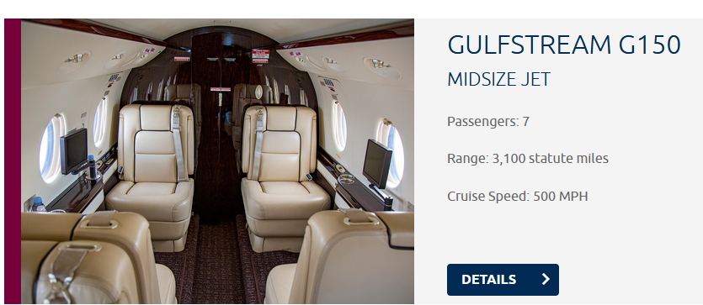



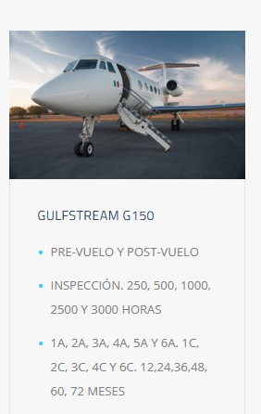• Carretera Federal 30 Km. 7 - Frontera, Coahuila - México

• Conmutador: +52 (866) 634.2034

• [antair@gan.com.mx](mailto:antair@gan.com.mx)

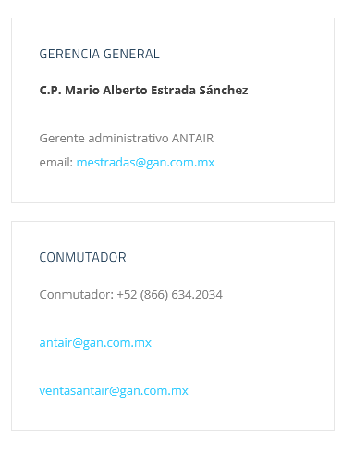

**Soporte Técnico**

**Ing. Eduardo A. Salgado Cruz**  
Gerente de mantenimiento  
email:[esalgado@gan.com.mx](mailto:esalgado@gan.com.mx)

**T.A. Zenon Guadalupe Sanchez Zamudio**  
Jefe de mantenimiento ala rotativa  
email: [zsanchezz@gan.com.mx](mailto:zsanchezz@gan.com.mx)

**T.A. Luis Humberto Leyva Juárez**  
Jefe de mantenimiento de aeronaves externas  
email: [lhleyvaj@gan.com.mx](mailto:lhleyvaj@gan.com.mx)

**T.A. Aaron Alonso Díaz**  
Jefe de Avionica  
email:[aalonsod@gan.com.mx](mailto:aalonsod@gan.com.mx)



(HA Note: Appears that Signature TechnicAir ***does not*** service Gulfstream aircraft?)

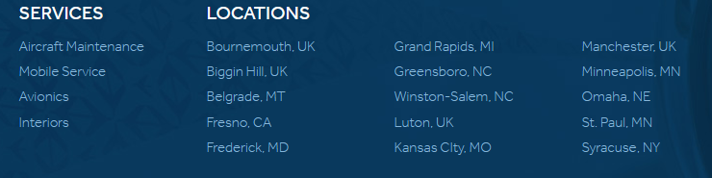

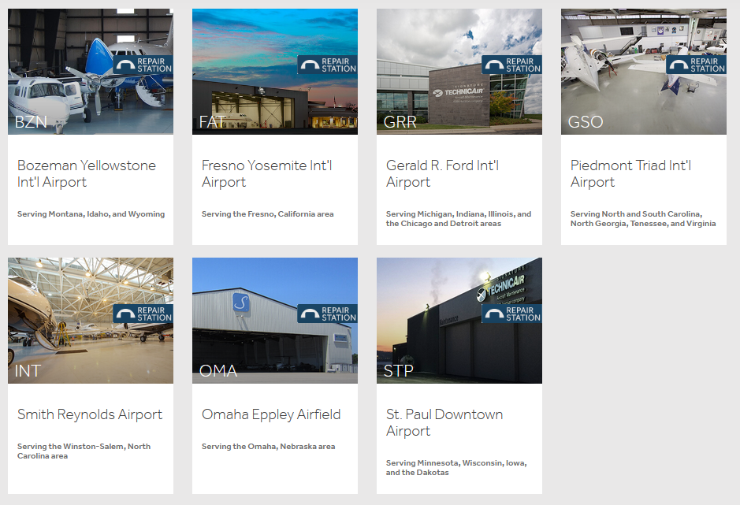



**West Star Aviation (Hqtrs)**2 Airline Court  
East Alton, IL 62024

800.922.2421

**West Star Aviation**7761 S. Peoria St.  
Englewood, CO 80112

• 970.261.789

(HA Note: I assume Peregrine is familiar with the West Star APA operation. >> ***02 March 2022*** - ” ***West Star Aviation has been acquired*** (from Norwest Equity Partners***) by The Sterling Group, an operationally-focused middle market private equity firm***.”, Jim Rankin CEO West Star)

**Locations**

[East Alton](https://www.weststaraviation.com/locations/east-alton/)

[Grand Junction](https://www.weststaraviation.com/locations/grand-junction/)

[Chattanooga](https://www.weststaraviation.com/locations/chattanooga/)

[Perryville](https://www.weststaraviation.com/locations/perryville/)

[Aspen](https://www.weststaraviation.com/locations/aspen/)

[Chicago](https://www.weststaraviation.com/locations/chicago/)

[Denver](https://www.weststaraviation.com/locations/denver/)

[Houston](https://www.weststaraviation.com/locations/houston/)

[Minneapolis](https://www.weststaraviation.com/locations/minneapolis/)

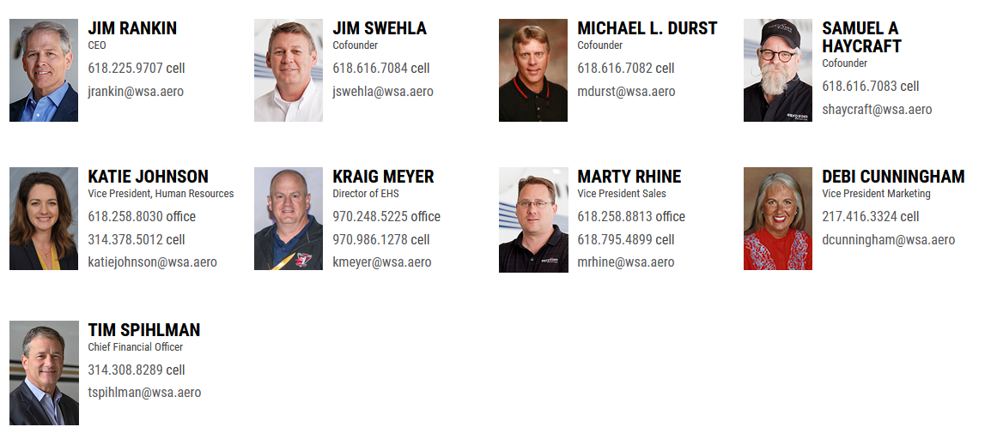



**Michael Zeris** Technical Sales Manager, Gulfstream

* ALN
* [314.440.9731](tel:3144409731)cell [mzeris@wsa.aero](mailto:mzeris@wsa.aero)



**ERIC VALDES** Program Director, Gulfstream and Accessories

* ALN
* [618.709.6248](tel:6187096248)cell [evaldes@wsa.aero](mailto:evaldes@wsa.aero)



**Chris Landry** Project Manager

* CHA
* [clandry@wsa.aero](mailto:clandry@wsa.aero)



**Michael Ditmeyer** Program Manager, Gulfstream

* CHA
* [423.304.8537](tel:4233048537)cell [mditmeyer@wsa.aero](mailto:mditmeyer@wsa.aero)



**LARRY MARLER** Technical Sales Manager, Avionics

* CHA
* [423.598.1578](tel:4235981578)cell [lmarler@wsa.aero](mailto:lmarler@wsa.aero)

**Dumont Aviation Group/ Dumont Aviation MRO**​  
2000 Brett Road  
​New Castle, DE 19720  
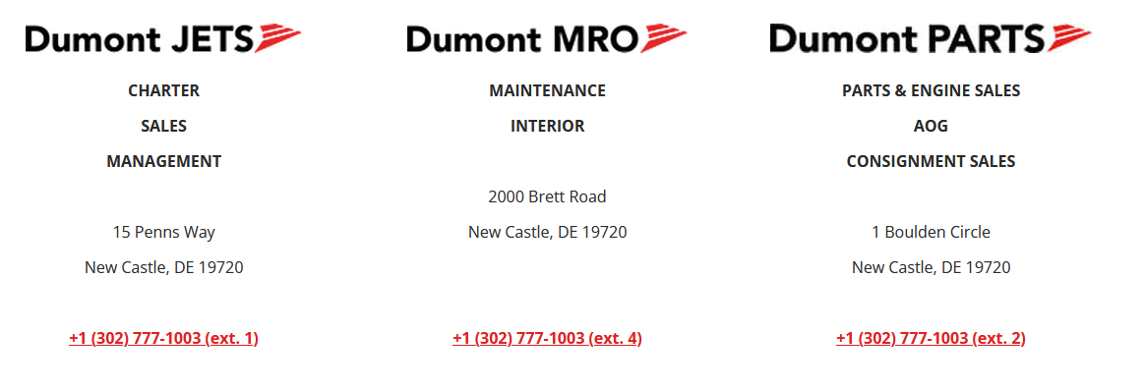  
​  
[**+1 (302) 777-1003 (ext. 4)**](tel:3027771003)

Dumont MRO is a FAA Part 145 Repair Station with locations nationwide offering fast maintenance, high quality workmanship, and unparalleled customer service.​

**AIRCRAFT MAINTAINED**

|  |  |
| --- | --- |
| Bombardier Cessna Challenger Dassault Falcon Dornier | ​Embraer Gulfstream Hawker/Beechcraft Learjet *​and more!* |

