# Summary

Peregrine has developed an approved solution to resolve issues with the G150 flap and slat actuation systems that may arise during approach and landing in certain situations. When a G150 has been exposed to precipitation or high humidity, followed by exposure to freezing temperature at altitude, the flap and slat actuation drives can freeze, preventing the high lift devices from deploying.

# How do I equip my G150 with this STC?

Peregrine can provide a complete STC and installation package to your preferred repair station. The STC and associated components are available directly from Peregrine.

Peregrine also offers a turnkey solution including labor, STC and project management for complete installation and return to service of your G150 at our selected Denver area FAA authorized repair station that is familiar with this STC.

# Why did Peregrine develop this STC?

Gulfstream operates several ‘Gulfstream Field and Airborne Support Teams (FAST)’ G150 aircraft to provide factory service for customers.

The FAST G150 aircraft encountered this flap/slat actuation issue and worked with Peregrine and their selected authorized repair facility to develop a retrofit solution.

Peregrine answered the challenge and developed a complete STC solution that has subsequently been installed on the FAST aircraft.

# What is added to my aircraft?

The G150 flap and slat drive system is composed of a Power Drive Unit (PDU), flexible drive shafts and twelve linear ball screw actuators (3 per wing, 2 systems).

The STC adds heater components to each of the twelve (12) actuator devices, a control module located in the fuselage, a cockpit switch/annunciator and associated bracketry and wiring. Figure 1 shows an overview.

The installed system weight totals less than 22 lbs. See Table 2.

# How does this affect operation and maintenance of the aircraft and the flap/slat systems?

The STC does not modify the G150 Flap/Slat drive system including controls, indications, safety mechanisms or recommended lubrication maintenance procedures.

External supplemental heaters are added to existing components.



Figure 1: G150 Equipment Installation Locations, Left Wing Shown. STC does not modify the G150 Flap/Slat drive system including controls, indications, safety mechanisms or recommended lubrication maintenance procedures

# Does the system provide freeze-up protection automatically?

The system will automatically heat the actuators when temperatures are below 40° F. Thermistors installed on each heater are used to both activate the heaters at the proper temperature and ensure the actuators never reach the upper operating temperature limit of 130° F.

# What does the STC Cost?

Call or email Peregrine today for a price and schedule quotation to meet your aircraft or fleet requirements.

# Can the STC be purchased from Peregrine and parts sourced by my installer?

The heaters and control system components are available exclusively through Peregrine as part of the STC.

# Is there a Gulfstream Service Bulletin?

While not a Service Bulletin from Gulfstream, the STC has been recognized by Gulfstream FAST operation as solving the issue with high lift actuation system freeze-up.

# Will my Gulfstream Service Center install this for me?

Yes, inquire with your Service Center for pricing and scheduling.

# What is involved in the installation of the system?

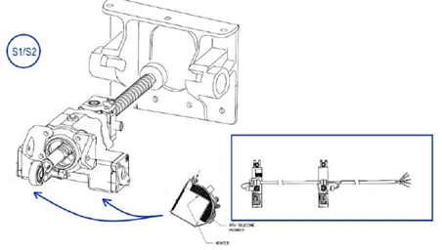The flaps and slats are removed to access the drive system. Once the heaters (Figure 2), control modules and wiring (Figure 3) are installed, the flaps and slats are replaced and, if necessary, rigged in accordance with Gulfstream service procedures detailed in G150 ATA 100 documentation. (ATA 27‑82‑01, 27‑80‑00‑AT, 27‑51‑05‑RI, 27‑50‑00‑AT).

Figure 2: Wrap-around, cuff-style, design and are mounted on the exterior of the actuators

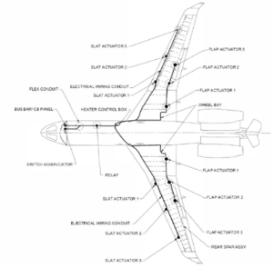

Figure : Wiring and component installation locations are described fully in the STC

# Who can do this work?

The STC and associated components are available directly from Peregrine.

* Peregrine can deliver of the STC and installation package to your preferred repair station.
* Peregrine is ready to schedule the installation as a turnkey solution including labor, STC, project management and return to service of your G150 at our Denver area FAA repair station familiar with this STC.

# When can I schedule my aircraft?

There is a nominal lead time for STC components.

The installation requires approximately three (3) weeks for installation at the Peregrine affiliated FAA Repair station.

Your repair station can provide their estimated completion time.

# What are the power and weight considerations?

Table 1 shows electrical loads and Table 2 provides weight and balance information.

Table : In‑Flight Electrical Bus Load changes due to Installed Equipment

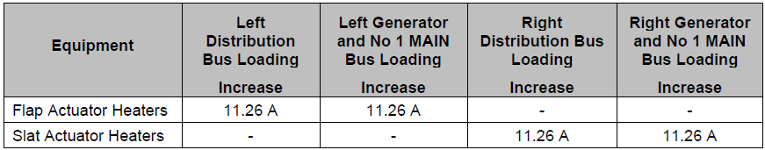

Table : G150 Weight and Balance Data

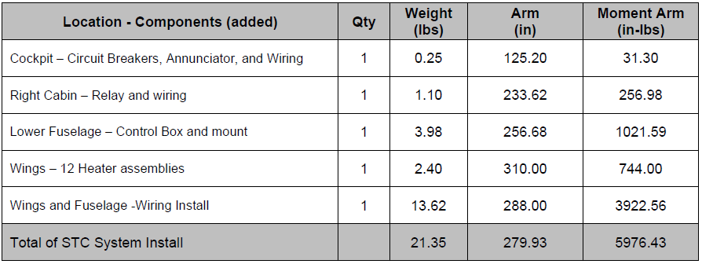

# For further information:

Peregrine

7385 S. Peoria Street Unit C4

Englewood, CO 80112

+1 (303) 325-3873

www.peregrine.aero