Gulfstream Aerospace
Permission to Use ST01075DE Data
November 13, 2020
STC-ST01075DE-1002

This letter provides the aircraft owner the permission to use data for STC # ST01075DE to support an alteration on _G150___________ serial number _215__. This letter is provided for and is limited to the assigned aircraft.

STC: ST01075DE
Make: Gulfstream
Model: G150
Description: Installation of Supplemental Flap/Slat Actuator Heater System in accordance with Document No. E-GS-20-0002, Master Drawing List, Flap/Slat Actuator Supplemental Heaters Gulfstream 150, Revision C dated 10/9/2020, FAA approved 11/2/2020 or later FAA approved revision. Instructions for Continued Airworthiness (ICA), Document No. E-GS-20-0008, Revision IR dated 10/9/2020 FAA Accepted 11/2/2020, or later FAA accepted revision are required to be made available at installation. FAA Approved Airplane Flight Manual Supplement, Document No. E-GS-20-0009, Revision IR dated 10/12/2020, FAA Approved 11/2/2020 or later FAA approved revision is required for this modification.

This STC is managed and exclusively distributed by Peregrine LLC, Englewood, CO. Any further usage of this STC on aircraft not specifically identified herein requires an additional authorization.

Sincerely,

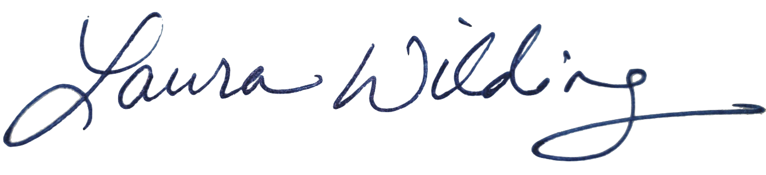
Laura Wilding
Certification Engineer, Peregrine

