**Aviation Clean Air Touts Air Purification System**

[September 15, 2020](https://www.avm-mag.com/aviation-clean-air-touts-air-purification-system/) AVM Article

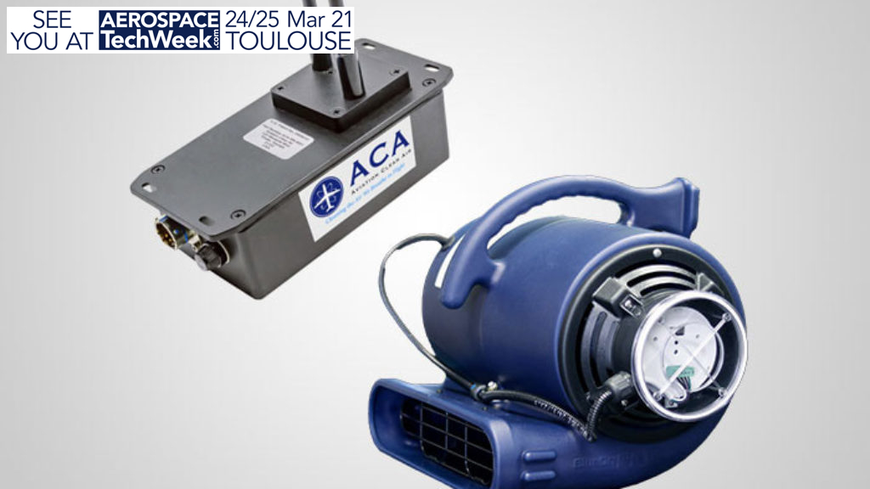

Aviation Clean Air, a system that is designed to immediately improve interior air quality and neutralize pathogens, has undergone a second phase of testing. The company says their NeedlePoint Bi-Polar Ionization (NPBI) technology that powers its airborne and ground-use purification systems “has shown a 99.99% neutralization via ionization of the COVID-19 virus after just 30 minutes.” The ACA airborne system is a patented Ionization Purification System certified by the Federal Aviation Administration (FAA) on numerous aircraft with STC. NPBI is ozone-free and is the only one in its category to pass the RCTA DO-160 standard for aircraft, the company says.

The laboratory tests were conducted by Innovative Bioanalysis, a CAP, CLIA, AABB Certified Safety Reference Laboratory with 75 years of combined experience. The tests were performed in a setting designed to replicate the ionization conditions of business and commercial aircraft interiors.

Pathogens transfer by latching on to a host, the company explains. Viruses expel from a person through mucus or saliva and are airborne for as long as possible. They go even farther if they latch onto airborne particulates. NPBI works by leveraging an electronic charge to create a high concentration of positive and negative ions. These ions travel through the air continuously seeking out and attaching to particles, which sets in motion a pattern of particle combination. As these particles become larger, they are eliminated from the air.

Additionally, positive and negative ions have microbicidal effects on all pathogens, rendering the COVID-19 virus non-infectious, while neutralizing and removing other viruses, allergens, contaminates and even mold spores. The ions produce a natural reaction on the cell membrane of all pathogens so they can’t reproduce and then quickly die.

“HEPA filters that are being used on most commercial aircraft are efficient in removing particulates that are greater in size than 3 microns (3µ), but we know the COVID-19 virus is between .002 – .125µ in size. That means that the HEPA filters may not remove the virus itself if the virus is attached to a smaller airborne particulate,” says Jonathan Saltman of Aviation Clean Air. “Our goal is to partner with airlines to increase the efficiency of the existing HEPA filters being used because our system removes particulates that these filters cannot – in addition to neutralizing airborne and surface pathogens.”

The Aviation Clean Air system is approved and available on all aircraft manufacturer platforms, makes and models. The proactive system, which operates through the aircraft’s existing environmental control system (ECS) and functions automatically whenever the ECS is running, immediately improves interior air quality, eliminates odors and neutralizes all pathogens in the air and on surfaces throughout the entire aircraft, including the cabin, galley, lavatory and cockpit.

“Our system prevents the spread of viruses by aerosolization, which is now being shown as the primary method that COVID-19 spreads,” added Saltman. “This, paired with the results from our second test, is just further proof that the NPBI™ technology is the next critical step to re-instill confidence with the public that it’s safe to fly again with Aviation Clean Air on board,” adds Saltman.