Peregrine Press Activity

Press Release Pickups

Contents

560XL ACA Installation 1

Business Air News - Dec 12, 2020 1

AWIN - Dec 16, 2020 2

Business Air News - Dec 21, 2020 3

Lee Aerospace Press Release - Dec 10, 2020 5

AINonline - Dec 28, 2020 7

PC-12 Gogo AVANCE L3 8

Aero News Network - Dec 16, 2020 8

Love Air (UK) - Dec 16, 2020 9

Business Air News - Dec 21, 2020 10

EASA News Feed link to Aero News Network 11

G700 TXi STC EMB-120 Press 12

News Break (Aerospace) - Aug 11, 2020 12

AVweb - Aug 11, 2020 13

Business Air News - Aug 11, 2020 15

AEA Wired - Aug 12, 2020 16

Big Jet TV - Aug 11, 2020 17

MRO Business Today - Aug 2020 18

Avionics News - Sep 2020, Pg 66 19

ACA G-IV 20

AviationPros - May 26, 2020 20

Aviation Maintenance Magazine - May 26, 2020 21

AEA Wired - Jun 10, 2020 22

# 560XL ACA Installation

## [Business Air News - Dec 12, 2020](https://www.businessairnews.com/hb_news_story.html?release=77105)

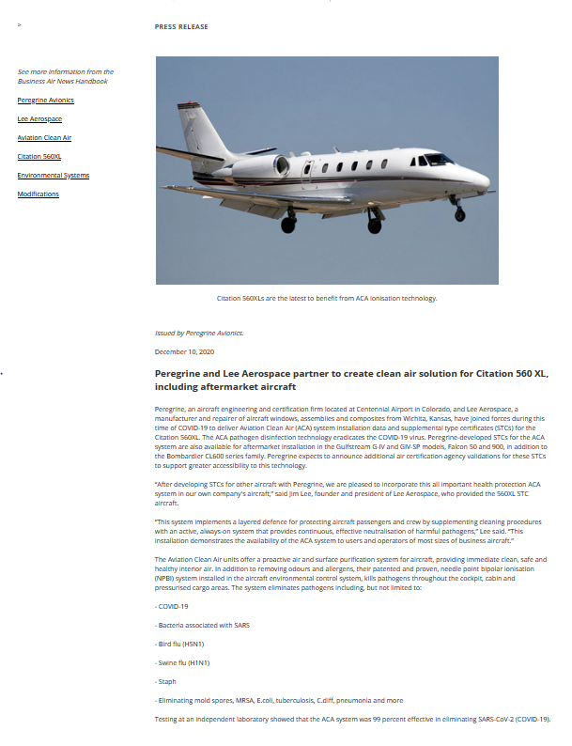

## [AWIN - Dec 16, 2020](https://aviationweek.com/mro/peregrine)

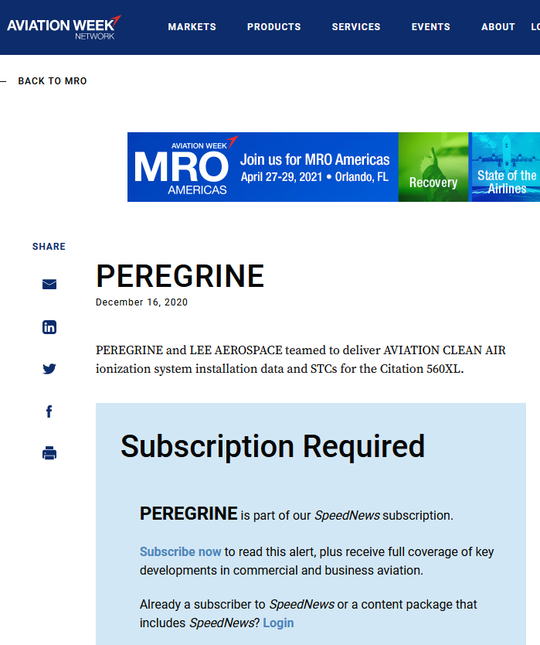

## [Business Air News - Dec 21, 2020](https://www.businessairnews.com/mag_story.html?ident=19968)

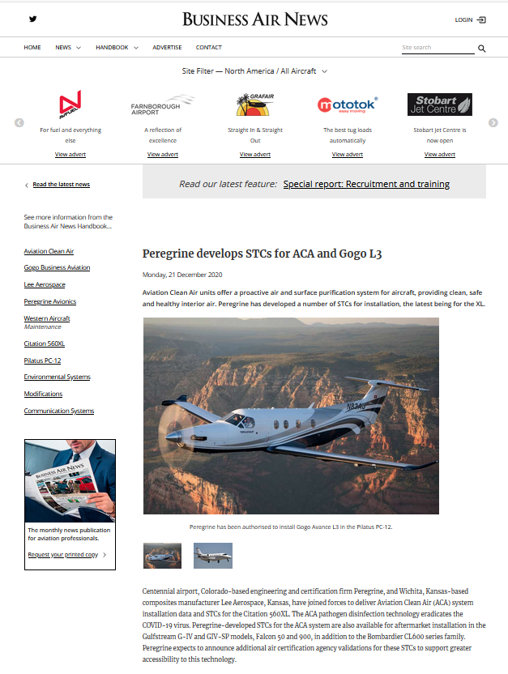

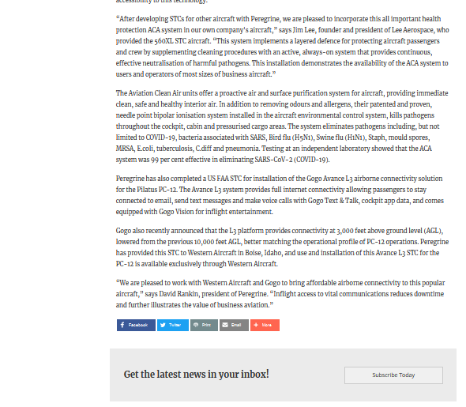

## [Lee Aerospace Press Release - Dec 10, 2020](https://leeaerospace.com/clean-air-solutions-citation-560-xl/)

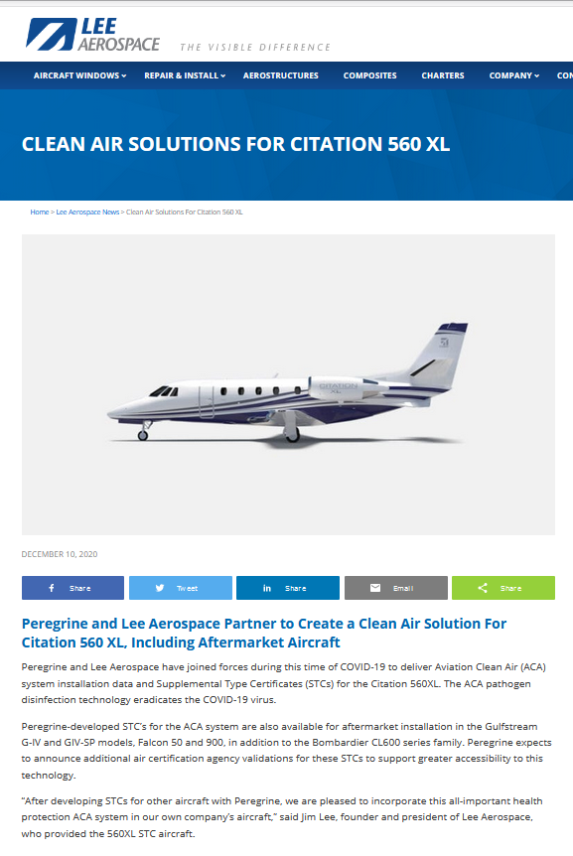

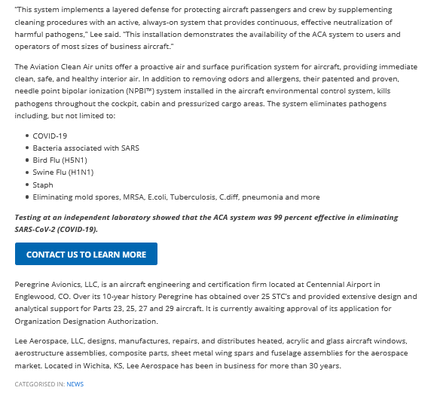

## [AINonline - Dec 28, 2020](https://www.ainonline.com/aviation-news/business-aviation/2020-12-28/lee-aero-peregrine-partner-stc-combat-covid-19)

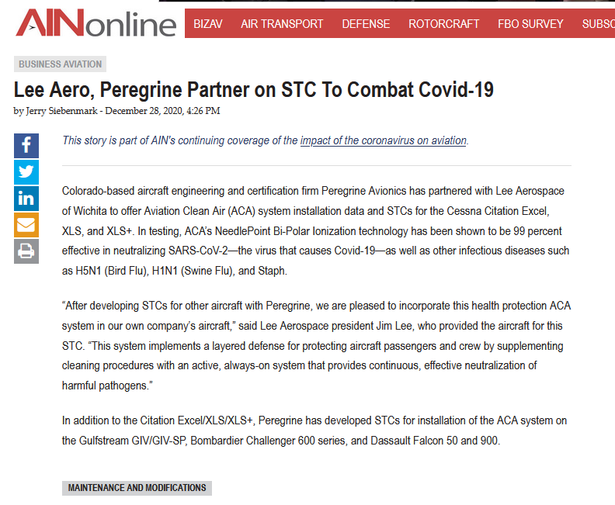

# PC-12 Gogo AVANCE L3

## [Aero News Network - Dec 16, 2020](http://www.aero-news.net/index.cfm?do=main.textpost&id=c993e494-5f91-4497-a6c4-dc56e2a5ccf1)

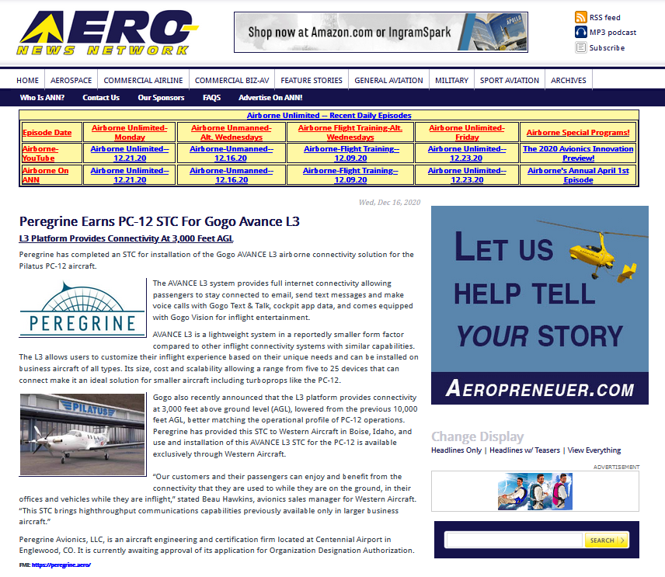

## [Love Air (UK) - Dec 16, 2020](https://www.loveair.co.uk/2020/12/15/peregrine-earns-pc-12-stc-for-gogo-avance-l3/)

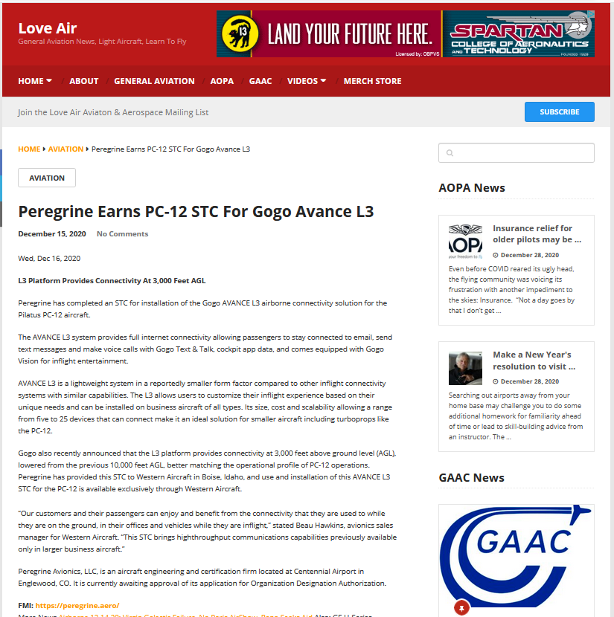

## [Business Air News - Dec 21, 2020](https://www.businessairnews.com/mag_story.html?ident=19968)





## [EASA News Feed link to Aero News Network](https://www.easa.europa.eu/eccsa/feed-items/peregrine-earns-pc-12-stc-gogo-avance-l3)

Link points to Aero News Network

# G700 TXi STC EMB-120 Press

## [News Break (Aerospace) - Aug 11, 2020](https://www.newsbreak.com/news/1615702641048/peregrine-and-worldwide-aircraft-services-stc-for-first-comprehensive-embraer-emb-120-glass-cockpit-update)

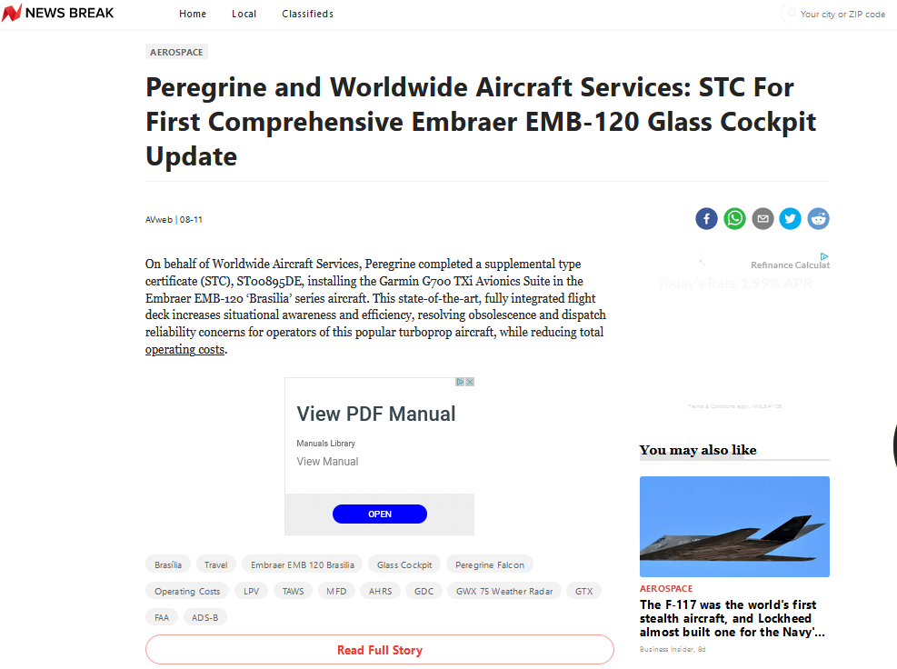

## [AVweb - Aug 11, 2020](https://www.avweb.com/press-releases/peregrine-and-worldwide-aircraft-services-stc-for-first-comprehensive-embraer-emb-120-glass-cockpit-update/)

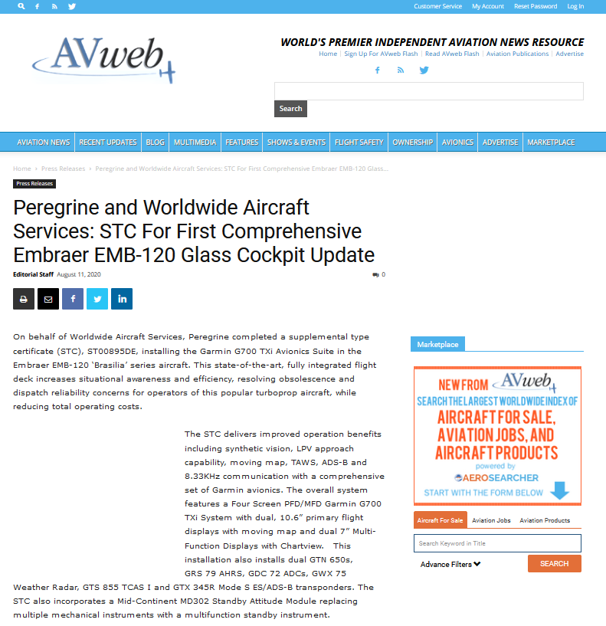

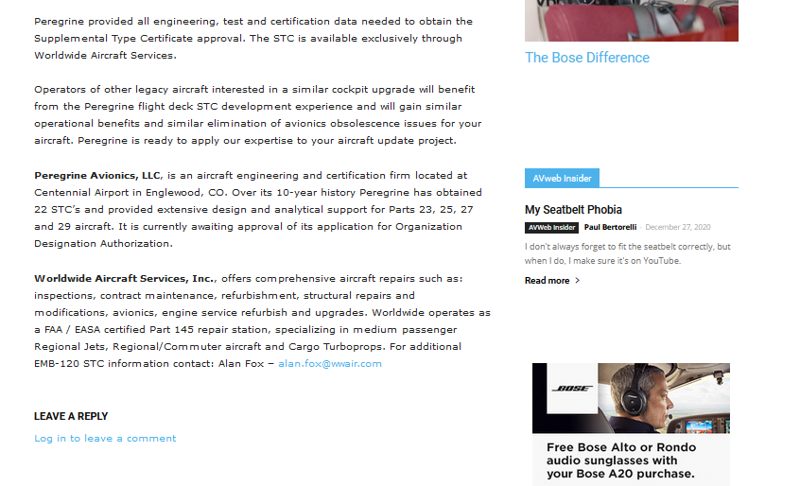

## [Business Air News - Aug 11, 2020](https://www.businessairnews.com/mag_story.html?ident=18892)

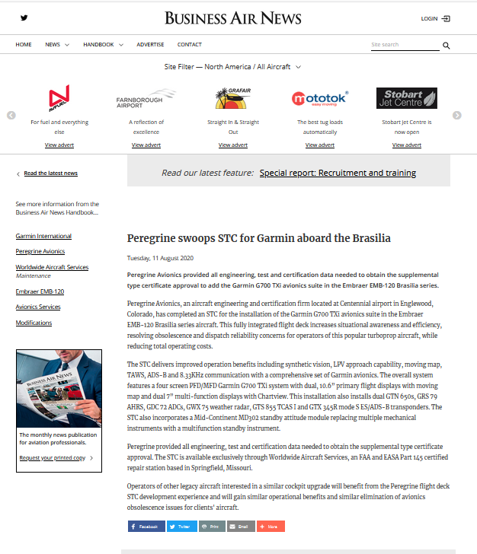

## [AEA Wired - Aug 12, 2020](https://myemail.constantcontact.com/AEA-Wired----Aug--12--2020.html?soid=1102873717486&aid=jwbA8Yy9vHE)



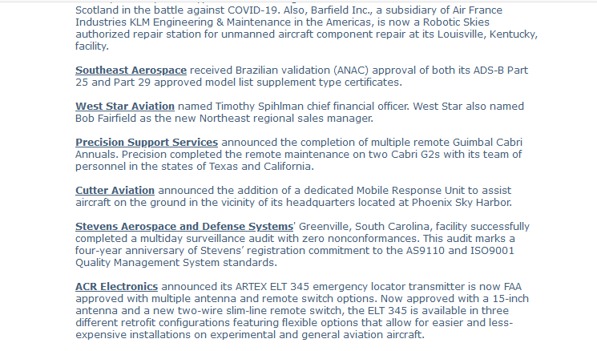

## [Big Jet TV - Aug 11, 2020](https://bigjet.tv/peregrine-and-worldwide-aircraft-services-stc-for-first-comprehensive-embraer-emb-120-glass-cockpit-update/)

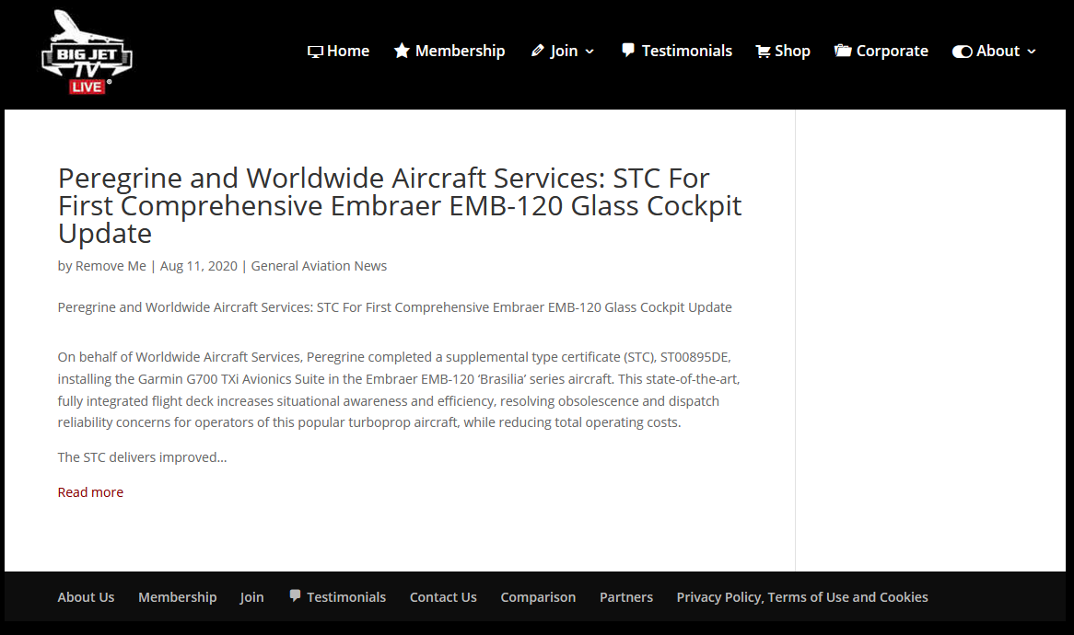

## [MRO Business Today - Aug 2020](https://www.mrobusinesstoday.com/peregrine-successfully-completed-stc-in-embraer-brasilia-series-on-behalf-of-worldwide-aircraft-services/)

[](https://www.mrobusinesstoday.com/peregrine-successfully-completed-stc-in-embraer-brasilia-series-on-behalf-of-worldwide-aircraft-services/#)

## [Avionics News - Sep 2020, Pg 66](http://www.brightcopy.net/allen/avne/57-9/index.php?startid=66#/p/66)



# ACA G-IV

## [AviationPros - May 26, 2020](https://www.aviationpros.com/engines-components/press-release/21139747/lee-aerospace-inc-peregrine-and-lee-aerospace-have-partnered-to-offer-stcs-for-installation-of-aviation-clean-airs-cabin-air-decontamination-system-in-gulfstream-givsgivsps)

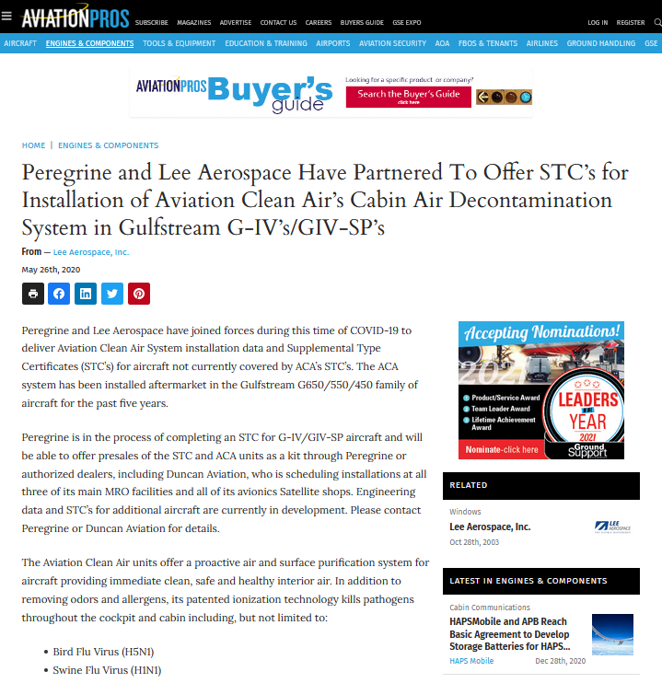 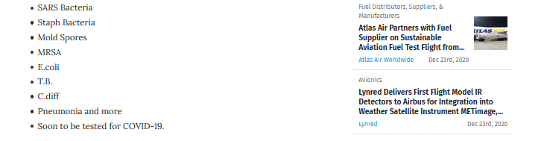

## [Aviation Maintenance Magazine - May 26, 2020](https://www.avm-mag.com/peregrine-and-lee-aerospace-partner-to-offer-stcs-for-installation-of-aviation-clean-airs-cabin-air-decontamination-system-in-g-iv-giv-sp/)

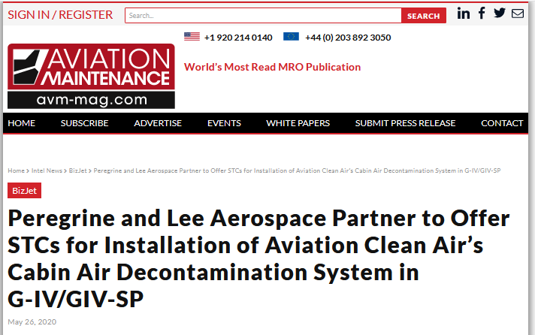

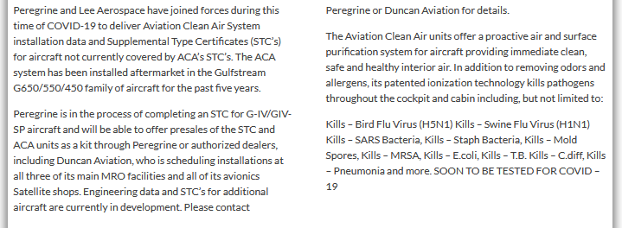

## [AEA Wired - Jun 10, 2020](https://myemail.constantcontact.com/AEA-Wired----June-10--2020.html?soid=1102873717486&aid=Tsnbzk7Btms)



