**Peregrine**

7385 S. Peoria Street Unit C4

Englewood, CO 80112

303 325-3873

www.peregrine.aero

November 19, 2020

FOR IMMEDIATE RELEASE:

PEREGRINE STC INTRODUCES AVIATION CLEAN AIR’S CABIN AIR DECONTAMINATION SYSTEM IN CITATION 560 XL

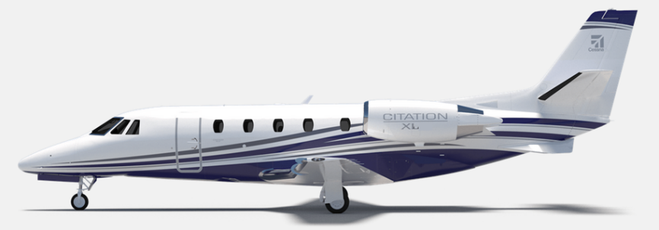Peregrine announces the availability of an active SARS-CoV-2 (COVID-19) virus sanitization technology for the Citation 560XL. Using the Aviation Clean Air System’s (ACA) unique needle point bipolar ionization (NPBI™) system installed in the aircraft environmental control system, cabin and cockpit air is continually infused with positive and negative ions that effectively neutralize viruses and other pathogens. The system installation data and Supplemental Type Certificates (STCs) for 560XL aircraft is now available from Peregrine. Peregrine-developed STCs for the ACA system are also available for aftermarket installation in the Gulfstream G-IV and GIV-SP models, Falcon 50 and900, in addition to the Bombardier CL604 family.

Figure : Cessna Citation 560XL

“We are pleased to incorporate the ACA system in our own company’s aircraft after developing STCs for other aircraft with Peregrine.” commented Jim Lee, founder and president of Lee Aerospace, who provided the 560XL STC aircraft.

“This system implements a layered defense for protecting aircraft passengers and crew by supplementing cleaning procedures with an active, always-on system that provides continuous, effective neutralization of harmful pathogens.” Lee stated. “This installation and the other collaboratively developed STCs demonstrate the availability of the ACA system to users and operators of all sizes of business aircraft.”

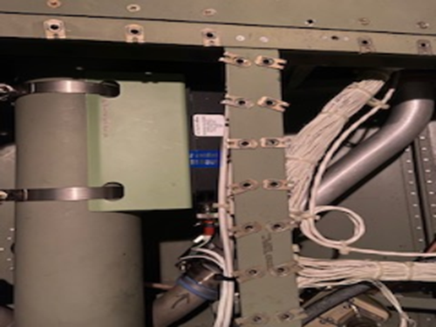The ACA units are a proactive air and surface purification technology installed in the aircraft environmental control system ductwork giving crew and passengers immediate clean, safe and healthy interior air. In addition to removing odors and allergens, its patented ionization technology kills pathogens throughout the cockpit and cabin including, but not limited to COVID‑19, Bird Flu Virus (H5N1), Swine Flu Virus (H1N1), SARS Bacteria, Staph Bacteria, Mold Spores, MRSA, [E.coli](http://E.coli/), T.B., [C.diff](http://C.diff/), Pneumonia and more. ***Testing for SARS-CoV-2 (COVID-19) effectiveness validation performed by an independent laboratory demonstrates over 99% effectivity.***

Figure : ACA NPBI Active Ionization System

The ACA NPBI™ unit weighs less that one pound and installs on the existing ECS output ductwork to provide continuous protection from harmful pathogens.

**Peregrine Avionics, LLC**, is an aircraft engineering and certification firm located at Centennial Airport in Englewood, CO. Over its 10-year history Peregrine has obtained over 25 STCs and provided extensive design and analytical support for Parts 23, 25, 27 and 29 aircraft. It is currently awaiting approval of its application for Organization Designation Authorization.

**Lee Aerospace, LLC**, designs, manufactures, repairs and distributes acrylic aircraft windows, aerostructure assemblies, composite parts, sheet metal wing spars and fuselage assemblies for the aerospace market. Located in Wichita, KS, Lee Aerospace has been in business for over 30 years.

###