**Peregrine**

7385 S. Peoria Street Unit C4

Englewood, CO 80112

303 325-3873

www.peregrine.aero

November 24, 2020

FOR IMMEDIATE RELEASE:

PEREGRINE AND GULFSTREAM: IMPROVED G150 FLAP/SLAT OPERATION

On behalf of Gulfstream Aerospace, Peregrine has obtained an FAA Supplemental Type Certificate (STC), ST01075DE, installing flap and slat actuator heaters on the G150.  Gulfstream expects to offer this modification through a Service Bulletin in the near future. The heaters further enhance reliability and deployment of the leading-edge slats and flaps in all operational environments.

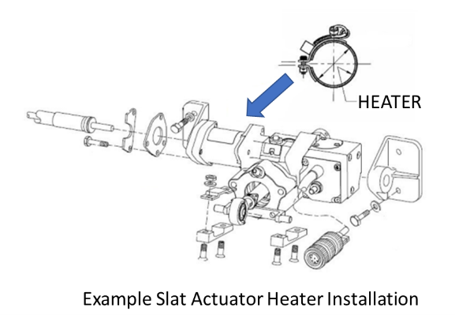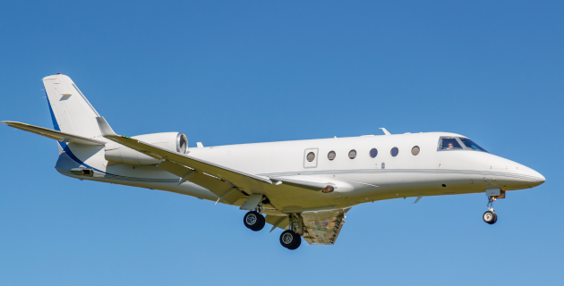

Peregrine provided all engineering, test and certification data needed to obtain the Supplemental Type Certificate approval. Operators of the G150 can contact their Gulfstream Authorized Service Center for installation of this STC.

**Peregrine Avionics, LLC**, is an aircraft engineering and certification firm located at Centennial Airport in Englewood, CO. Over its 10-year history Peregrine has obtained over 25 STCs and provided extensive design and analytical support for Parts 23, 25, 27 and 29 aircraft. It is currently awaiting approval of its application for Organization Designation Authorization.

###