**Peregrine**  **Western Aircraft**

7385 S. Peoria Street Unit C4 4300 S Kennedy St.

Englewood, CO 80112 Boise, ID 83705

303 325-3873 (208) 338-1800

www.peregrine.aero info@westair.com

November 24, 2020

FOR IMMEDIATE RELEASE:

PEREGRINE AND WESTERN AIRCRAFT: STC FOR GOGO AVANCE L3 AIRBORNE CONNECTIVITY FOR PILATUS PC-12

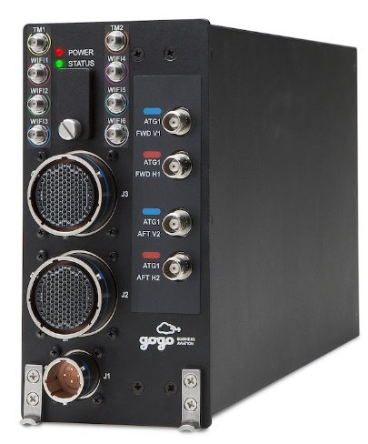On behalf of Western Aircraft, Peregrine completed a US FAA supplemental type certificate (STC) installing the Gogo AVANCE L3 airborne connectivity solution for the popular Pilatus PC-12 aircraft. The AVANCE L3 system provides unmatched email/VPN/Web, Voice/Text, Inflight entertainment, cockpit app data and simple operation is available with continuous inflight connectivity for up to 25 devices. Gogo also recently announced that the L3 platform provides connectivity at 3,000 feet AGL, lowered from the previous 10,000 feet above the ground, better matching the operational profile of PC-12 operations.

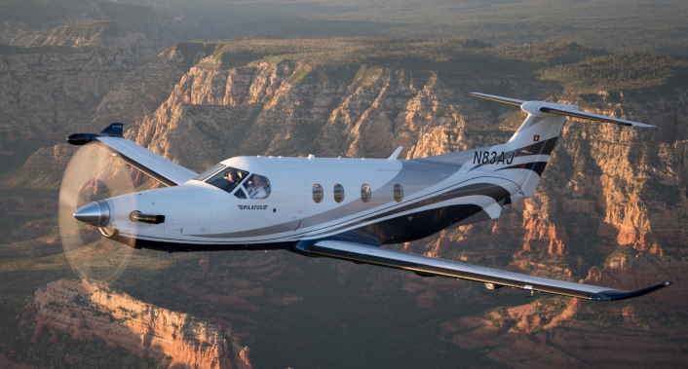

“We are pleased to work with Western Aircraft and Gogo to bring affordable airborne connectivity to this popular aircraft.” said David Rankin, president of Peregrine. “Inflight access to vital communications reduces downtime and further illustrates the value of business aviation.”

“Our customers and their passengers can enjoy and benefit from the connectivity that they are used to while they are on the ground, in their offices and vehicles while they are inflight.” stated avionics sales manager Beau Hawkins, of Western Aircraft. “This STC brings high-throughput communications capabilities previously available only in larger business aircraft.”

**Peregrine Avionics, LLC**, is an aircraft engineering and certification firm located at Centennial Airport in Englewood, CO. Over its 10-year history Peregrine has obtained over 25 STCs and provided extensive design and analytical support for Parts 23, 25, 27 and 29 aircraft. It is currently awaiting approval of its application for Organization Designation Authorization.

**Western Aircraft,** one of ten aerospace components of Greenwich AeroGroup, is an authorized service center, certified aircraft repair station (FE6R532N) and worldwide distributor of parts and avionics for many of the world’s top aircraft manufacturers and OEMs such as Dassault Falcon, Pilatus, Embraer, Beechcraft, King Air, Cessna, Piper, Quest, Honeywell and Collins. As an Authorized Pilatus Service Center, Western Aircraft technicians have logged hundreds of thousands of maintenance hours on Pilatus PC-12 aircraft in recent years. In addition, Western Aircraft has sold more than 300 new and used PC-12s and PC-24s since 1996.

**Gogo** is the Inflight Internet Company. We are the leading global provider of broadband connectivity products and services for aviation. We design and source innovative network solutions that connect aircraft to the Internet and develop software and platforms that enable customizable solutions for and by our aviation partners. Once connected, we provide industry leading reliability around the world. Our mission is to help aviation go farther by making planes fly smarter, so our aviation partners perform better and their passengers travel happier.

You can find Gogo's products and services on thousands of aircraft operated by the leading global commercial airlines and thousands of private aircraft, including those of the largest fractional ownership operators. Gogo is headquartered in Chicago with additional facilities in Broomfield, Colo., and locations across the globe. Connect with us at gogoair.com.

###