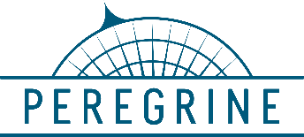

**Peregrine Lee Aerospace**

7385 S. Peoria Street Unit C4 9323 E34 St N

Englewood, CO 80112 Wichita KS 67226

303 325‐3873 316 636‐9200

[www.peregrine.aero](http://www.peregrine.aero) [www.leeaerospace.com](http://www.leeaerospace.com)

December 9, 2020

**Peregrine and Lee Aerospace Partner**

**to Create a Clean Air Solution for Citation 560 XL, including Aftermarket Aircraft**

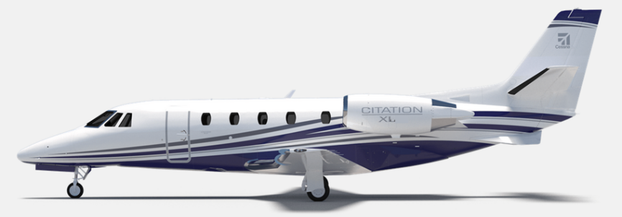Peregrine and Lee Aerospace have joined forces during this time of COVID-19 to deliver Aviation Clean Air (ACA) system installation data and Supplemental Type Certificates (STCs) for the Citation 560XL. The ACA pathogen disinfection technology eradicates the COVID-19 virus.

Figure 1: Cessna Citation 560XL

Peregrine-developed STC’s for the ACA system are also available for aftermarket installation in the Gulfstream G-IV and GIV-SP models, Falcon 50 and 900, in addition to the Bombardier CL600 series family. Peregrine expects to announce additional air certification agency validations for these STCs to support greater accessibility to this technology.

“After developing STCs for other aircraft with Peregrine, we are pleased to incorporate this all-important health protection ACA system in our own company’s aircraft,” said Jim Lee, founder and president of Lee Aerospace, who provided the 560XL STC aircraft.

“This system implements a layered defense for protecting aircraft passengers and crew by supplementing cleaning procedures with an active, always-on system that provides continuous, effective neutralization of harmful pathogens,” Lee said. “This installation demonstrates the availability of the ACA system to users and operators of most sizes of business aircraft.”

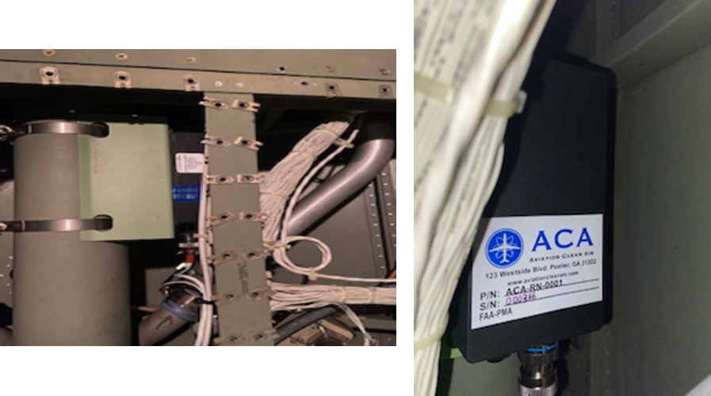

Figure 2: The ACA NPBI™ unit weighs less that one pound (right) and installs on the existing ECS output ductwork (left) to provide continuous protection from harmful pathogens.

The Aviation Clean Air units offer a proactive air and surface purification system for aircraft, providing immediate clean, safe, and healthy interior air. In addition to removing odors and allergens, their patented and proven, needle point bipolar ionization (NPBI™) system installed in the aircraft environmental control system, kills pathogens throughout the cockpit, cabin and pressurized cargo areas. The system eliminates pathogens including, but not limited to:

* COVID-19
* Bacteria associated with SARS
* Bird Flu (H5N1)
* Swine Flu (H1N1)
* Staph
* Eliminating mold spores, MRSA, [E.coli](http://E.coli/), Tuberculosis, [C.diff](http://C.diff/), pneumonia and more

***Testing at an independent laboratory showed that the ACA system was 99 percent effective in eliminating SARS-CoV-2 (COVID-19).***

**Peregrine Avionics, LLC**, is an aircraft engineering and certification firm located at Centennial Airport in Englewood, CO. Over its 10-year history Peregrine has obtained over 25 STC’s and provided extensive design and analytical support for Parts 23, 25, 27 and 29 aircraft. It is currently awaiting approval of its application for Organization Designation Authorization.

**Lee Aerospace, LLC**, designs, manufactures, repairs, and distributes heated, acrylic and glass aircraft windows, aerostructure assemblies, composite parts, sheet metal wing spars and fuselage assemblies for the aerospace market. Located in Wichita, KS, Lee Aerospace has been in business for more than 30 years.

###