**Peregrine**

7385 S. Peoria Street Unit C4

Englewood, CO 80112

303 325-3873

www.peregrine.aero

December 10, 2020

FOR IMMEDIATE RELEASE:

PEREGRINE: STC FOR GOGO AVANCE L3 AIRBORNE CONNECTIVITY FOR PILATUS PC-12

Peregrine has completed a US Federal Aviation Administration (FAA) supplemental type certificate (STC) for installation of the Gogo AVANCE L3 airborne connectivity solution for the popular Pilatus PC-12 aircraft. The AVANCE L3 system provides full internet connectivity allowing passengers to stay connected to email, send text messages and make voice calls with Gogo Text & Talk, cockpit app data, and comes equipped with Gogo Vision for inflight entertainment.

AVANCE L3 is a lightweight system in a much smaller form factor compared to other inflight connectivity systems with similar capabilities. The L3 allows users to customize their inflight experience based on their unique needs and can be installed on business aircraft of all types. It’s size, cost and scalability allowing a range from five to 25 devices that can connect make it an ideal solution for smaller aircraft including turboprops like the PC-12.

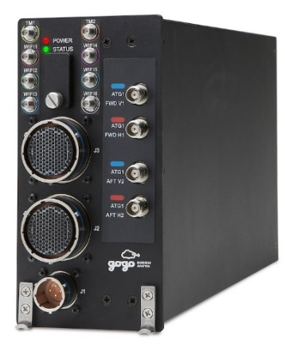Gogo also recently announced that the L3 platform provides connectivity at 3,000 feet above ground level (AGL), lowered from the previous 10,000 feet AGL, better matching the operational profile of PC-12 operations. Peregrine has provided this STC to Western Aircraft and use and installation of this AVANCE L3 STC for the PC-12 is available exclusively through Western Aircraft.

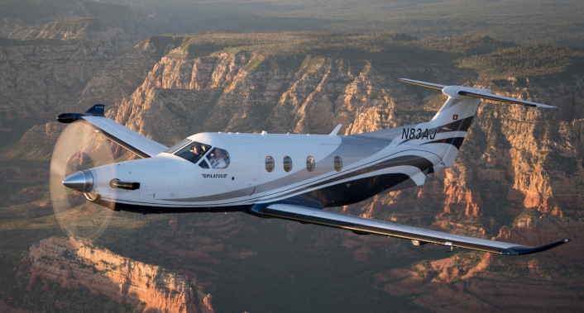

“We are pleased to work with Western Aircraft and Gogo to bring affordable airborne connectivity to this popular aircraft.” said David Rankin, president of Peregrine. “Inflight access to vital communications reduces downtime and further illustrates the value of business aviation.”

“Our customers and their passengers can enjoy and benefit from the connectivity that they are used to while they are on the ground, in their offices and vehicles while they are inflight.” stated avionics sales manager Beau Hawkins, of Western Aircraft. “This STC brings high-throughput communications capabilities previously available only in larger business aircraft.”

**Peregrine Avionics, LLC**, is an aircraft engineering and certification firm located at Centennial Airport in Englewood, CO. Over its 10-year history Peregrine has obtained over 25 STCs and provided extensive design and analytical support for Parts 23, 25, 27 and 29 aircraft. It is currently awaiting approval of its application for Organization Designation Authorization.

###