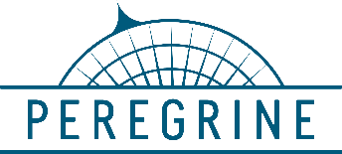

**Peregrine**

7385 S. Peoria Street Unit C4

Englewood, CO 80112

303 325‐3873

[www.peregrine.aero](http://www.peregrine.aero/)

ddaymmonth2021

FOR IMMEDIATE RELEASE

RTCA / EUROCAE AIRCRAFT DISINFECTION GUIDANCE DOCUMENT RELEASED -

COVERS IONIZATION METHOD IN USE BY PEREGRINE / ACA IONIZATION SYSTEM

RTCA, Inc. and EUROCAE, on 24 December 2020, jointly announced the publication of their first guidance[1] material containing the best practices and technologies for aircraft disinfection that will be used by all aircraft operators. This guidance is a result of shared expertise and international coordination and cooperation. It covers both chemical and non-chemical types of virus disinfection and neutralization measures.

The non-chemical methods covered in the guidance document includes the use of ionization such as the Aviation Clean Air (ACA) system and available through Peregrine. The ACA pathogen disinfection technology eradicates the COVID-19 virus, as well as neutralizing a host of other pathogens and it is the first and only ionization system approved for aircraft installation by aviation authorities, including the US FAA and EASA.

Peregrine and ACA have joined forces during this time of COVID-19 to deliver ACA system installation data and Supplemental Type Certificates (STCs) for a variety of business aircraft.

Peregrine-developed STCs for the ACA system are also available for aftermarket installation in the Gulfstream G-IV and GIV-SP models, Falcon 50 and 900, Citation XL(S) and the Bombardier CL600 series family. Peregrine expects to announce additional air certification agency validations for these STCs to support greater accessibility to this technology.

“This FAA/ EASA approved system implements continuous, layered defense, protecting aircraft passengers and crew by supplementing single-event cleaning procedures with an active, always-on system, effectively neutralizing harmful pathogens,” per David Rankin, Peregrine President. “The ACA ionization makes a real, proven and positive difference.”

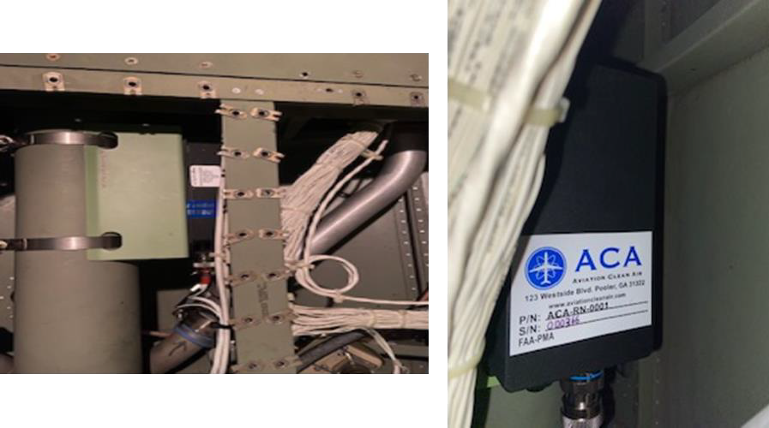

*Figure 2: The ACA NPBI™ unit weighs less that one pound (right) and typically installs on the existing ECS output ductwork (left) to provide continuous protection from harmful pathogens.*

The Aviation Clean Air units offer a proactive air and surface purification system for aircraft, providing immediate clean, safe, and healthy interior air. In addition to removing odors and allergens, their patented and proven, needle point bipolar ionization (NPBI™) system installed in the aircraft environmental control system, kills pathogens throughout the cockpit, cabin and pressurized cargo areas. The system eliminates pathogens including, but not limited to:

* COVID-19
* Bacteria associated with SARS
* Bird Flu (H5N1)
* Swine Flu (H1N1)
* Staph
* Eliminating mold spores, MRSA, E. coli, Tuberculosis, C. diff, pneumonia and more

***Testing at an independent laboratory showed that the ACA system was 99 percent effective in eliminating SARS-CoV-2 (COVID-19).***

**Peregrine Avionics, LLC**, is an aircraft engineering and certification firm located at Centennial Airport in Englewood, CO. Over its 10-year history Peregrine has obtained over 25 STCs and provided extensive design and analytical support for Parts 23, 25, 27 and 29 aircraft. It is currently awaiting approval of its application for Organization Designation Authorization.

###

1. RTCA: DO-388 “Guidance Document on Aircraft Cleaning and Disinfection”

   EUROCAE: ED-287 “Guidance Document on Aircraft Cleaning and Disinfection”

   Copies of this document are available for purchase and download at [www.rtca.org](http://www.rtca.org) or [www.eurocae.net](http://www.eurocae.net) .