Peregrine
7385 S. Peoria Street Unit C4
Englewood, CO 80112
303 325-3873
www.peregrine.aero

April 13, 2021
FOR IMMEDIATE RELEASE:

PEREGRINE’S HAWKER 4000 STC IMPROVES AFT BAY COOLING RELIABILITY
 | 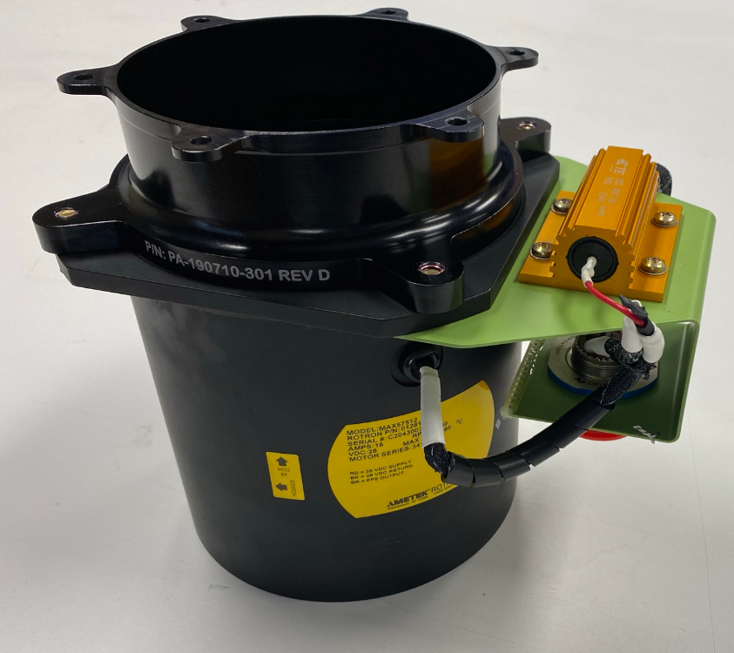
Figure 1: Hawker "Horizon" 4000 | Figure 2: Improved Reliability Blower
Peregrine received FAA approval for improved reliability of the Hawker 4000 cooling blowers. Applicable to the entire fleet of the Hawker 4000, formerly known as the Hawker Horizon, the installation data and Supplemental Type Certificates (STCs) #ST01035DE are now available from Peregrine.
“This STC, while addressing a single aircraft model, demonstrates the versatility of the Peregrine team to develop a targeted solution to meet a customer’s unique needs.” David Rankin, president of Peregrine stated. “Solutions such as this STC complement our team’s other Approved Model List (AML) STCs that address installation of systems multiple aircraft models and types.”
The STC and Parts Manufacturing Approval (PMA)-qualified installation hardware improves dispatch reliability and reduces maintenance actions caused by annunciated failures of the aft compartment heat exchange blower. Used during ground operations in higher ambient temperatures, the Peregrine STC incorporates an AMETEK brushless blower exhibiting significantly higher reliability and greater assurance of eliminating hot spots in this compartment.
“We described our needs to the Peregrine team and their team delivered the solution that met our requirements; on time and on budget. We look forward to the benefits that this STC will provide to our fleet maintenance and, most importantly, higher dispatch reliability for customers that depend on our aircraft.” Andrew Hall, director of maintenance for Talon Air stated.
Peregrine Avionics, LLC, is an aircraft engineering and certification firm located at Centennial Airport in Englewood, CO. Over its 10-year history Peregrine has obtained more than 25 STCs and provided extensive design and analytical support for Part 23, 25, 27 and 29 aircraft. Included in these STCs are COVID-19 STC solutions for popular business jets, cockpit upgrades STCs and AML STCs for avionics upgrades. Peregrine is currently awaiting approval of its application for Organization Designation Authorization.

###

