Peregrine
7385 S. Peoria Street Unit C4
Englewood, CO 80112
303 325-3873
www.peregrine.aero

May 27, 2021
FOR IMMEDIATE RELEASE:

PEREGRINE’S CRASH-SURVIVABLE RECORDER SYSTEM STC AFFORDABLY MEETS ICAO AND AFAC REQUIREMENTS
  Still looking for the  Right picture | 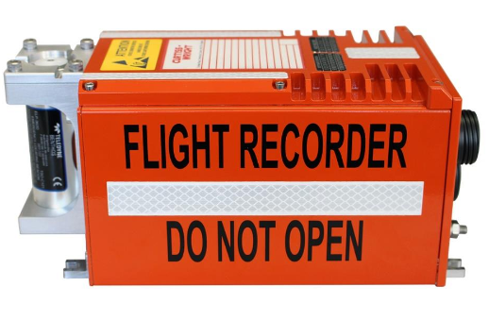
Figure 1: Hawker "Horizon" 4000 | Figure 2: Fortress™ CVR/CAIR/FDR
Peregrine received an FAA Supplemental Type Certificate (STC) for the installation of the Curtiss Wright Fortress series recording system and supporting equipment as a replacement of existing Cockpit Voice Recording (CVR) systems. This configuration allows owner and operators of aircraft to simultaneously meet the ICAO flight data recording system requirement using airborne image recording and 25-hour CVR requirements instead of costly retrofit of CVRs, flight data recorders, flight data acquisition systems and additional sensors.
Extending beyond the ICAO requirements, the Mexico Federal Civil Aviation Agency (Agencia Federal de Aviación Civil, AFAC) issued NOM-022-SCT3-2011 mandating that all aircraft that have a configuration of 10 or more seats or maximum certified weight of 5700kg (12,500lbs) must be equipped with a recording equipment. One option listed in this section is a Class C AIR recorder. This option reduces the cost of meeting this requirement and ICAO Annex 6 requirements when compared to FDR and CVR modifications.
“We estimate that there are over 500 jets in Mexico that will require this upgrade due to weight requirements,” stated Mark Francetic, SoCal Jets, “we also estimate that over 2000 aircraft of the U.S. fleet of Part 25 jets will require this upgrade due to Mexican airspace operation requirements.”
“Working with our partners, SoCal Jets and Curtiss-Wright, we collaborated to engineering and certify a cost-effective solution to newly-mandated airspace operation requirements.”, said David Rankin, president, Peregrine, “we look forward to helping Part 25 aircraft operators as they equip the aircraft with this system.”
The Approved Model List (AML) for the Crash Survivable Recorder System includes: BAe.125/Hawker 800 and 1000 models; Learjet 31, 35, 36 and 45; and Textron (Cessna Citation) 750. The STC covers the installation of the Curtiss-Wright Fortress Recorder, Cockpit Control Unit, Cockpit Aera Camera and a three-axis AMETEK accelerometer.
Peregrine Avionics, LLC, is an aircraft engineering and certification firm located at Centennial Airport in Englewood, CO. Over its 10-year history Peregrine has obtained more than 25 STCs and provided extensive design and analytical support for Part 23, 25, 27 and 29 aircraft. Included in these STCs are COVID-19 STC solutions for popular business jets, cockpit upgrades STCs and AML STCs for avionics upgrades. Peregrine is currently awaiting approval of its application for Organization Designation Authorization.

Lee,
Good start. The ICAO requirement/recommendation is a bit hard to follow. The following is correct:
The Mexico Federal Civil Aviation Agency (Agencia Federal de Aviación Civil, AFAC) issued NOM‑022‑SCT3‑2011 mandating that all aircraft that have a configuration of 10 or more seats or maximum certified weight of 5700kg (12,500lbs) must be equipped with a recording equipment.
But, the models covered by our AML also fall into the “should be equipped” category.
6.7.8.1 Fix Wing Turbine 10+ Pax 5,700 to 27,000 kg MFG < Jan '87 SHOULD have FDR (10+ Pax or >5,700 kg) Time, Alt, AS, Norm Acc, Hdg
On our AML, only the Cessna 750 can be configured for 10+ pax. Thanks.
Dave

###

