**Peregrine**

7385 S. Peoria Street Unit C4

Englewood, CO 80112

303 325-3873

www.peregrine.aero

June 21, 2021

FOR IMMEDIATE RELEASE:

PEREGRINE AML STC ISSUED FOR ACA VIRUS DISINFECTION SYSTEM FOR KEY BUSINESS AIRCRAFT

The Peregrine developed Supplemental Type Certificate (STC) and Approved Model List (AML) for the installation of Aviation Clean Air (ACA) Airborne Air and Surface Purification System. This active pathogen disinfection technology, including the neutralization of the COVID-19 virus, is now available for the Bombardier Challenger Series 600 models CL-600-1A11 (600), CL-600-2A12 (601), CL-600-2B16, Dassault models Mystere-Falcon 50, Mystere-Falcon 900, Falcon 900EX, Gulfstream models G-IV and G‑IVSP aircraft. The system installation data, STC ST01066DE and AML for these popular business aircraft is now available from Peregrine.

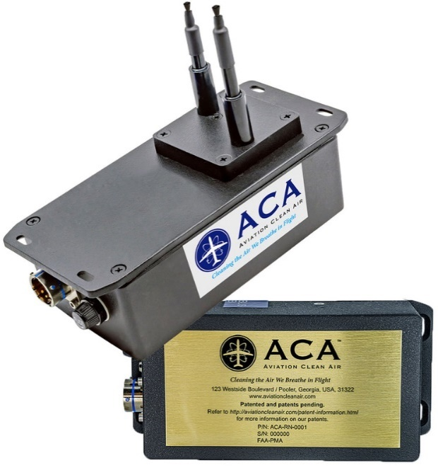

Figure 1: ACA NPBI™ Unit Weighs Only 1.34 lbs, Unit Dimensions are 7.02” x 3.27” x 5.36” (w/Probes Extended)

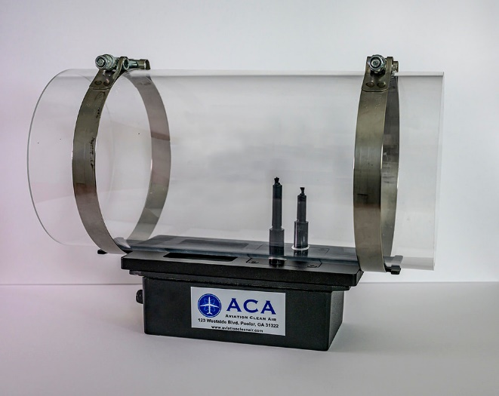

Figure 2: Internal View of Component Installed into an Example of Aircraft ECS Duct

Installation of the compact ACA system into the environmental control system (ECS) ducting provides continuous removal action during the entire aircraft ground and air operation and is the key to complete and continuous defense against pathogens. All pressurized areas of the aircraft are infused with positive and negative ions that neutralizes viruses and other pathogens using the ACA unique needle point bipolar ionization (NPBI™) system fitted to the aircraft ECS airflow.

Through a separate STC, the ACA system is available from Peregrine for the Citation 560XL aircraft.

“This ACA system implements a key part of a layered defense for protecting aircraft passengers and crew by augmenting conventional cleaning procedures. The ACA solution works for both surface and aerosol viruses providing continuous neutralization of harmful pathogens.” David Rankin, president of Peregrine stated.

Peregrine is an exhibitor at the 64th Annual Aircraft Electronics Association (AEA) International Convention & Trade Show, June 22-25, 2021, Dallas Hilton Anatole. See Peregrine at Booth 1206.

**Peregrine Avionics, LLC**, is an aircraft engineering and certification firm located at Centennial Airport in Englewood, CO. Over its 10-year history Peregrine has obtained over 25 STCs and provided extensive design and analytical support for Parts 23, 25, 27 and 29 aircraft. It is currently awaiting approval of its application for Organization Designation Authorization.

Additional details can be found at [peregrine.aero](https://peregrine.aero/) and [www.aviationcleanair.com](http://www.aviationcleanair.com/)

###