August 31, 2021

FOR IMMEDIATE RELEASE:

Mexico ICAO recorder FAA STC

Curtiss-Wright Corporation, in conjunction with SoCal Jets, Inc. and Peregrine Avionics have developed a solution to meet the requirements for recorders as outlined in NOM‑022‑SCT3 2011 in accordance with CP AV-022 dated April 15, 2019. The Approved Model List Supplemental Type Certificate (AML STC) #ST01070DE has been awarded to Peregrine and is now available for installation. The Federal Civil Aviation of Mexico, AFAC, approval of this FAA AML STC is in process.

This AML STC, “Curtiss-Wright Fortress Flight Data Recorder (with Cockpit Voice Recorder), Class C Cockpit Image Recorder, and Dukane Seacom Underwater Locating Device Installation covers the Learjet 30 Series, Learjet 45, Hawker 800 and 1000 Series and Citation 10 (750) aircraft and incorporates the use of a Class C Airborne Image Reorder camera and a new cockpit voice recorder. This camera records images of the cockpit instrument panel and thus installation costs and downtime are significantly reduced.

Any Part 25 charter aircraft (USA) that operates in Mexican airspace or is Mexican registered over 5500kg must have this equipment installed per AFAC requirements.

The Mexico requirement is based on ICAO Annex 6 documentation. All equipment is ED-112A certified and includes an EASA (E) approved 25-hour Cockpit Voice Recorder and (E)TSO-176a two (2) hour Airborne Image Recorder.

“Under certain regulatory bodies, Class C recorders are allowed as a means for recording flight data where it is not practical or prohibitively expensive to record on an FDR, or where an FDR is not required. This AML STC offers an economical means of complying with the new AFAC and ICAO requirements.”, states David Rankin, president, Peregrine.

For more information regarding this STC or to place an order for an installation or equipment, please SoCal Jets, Mark Francetic, [mfrancetic@SoCalJets.aero](mailto:mfrancetic@SoCalJets.aero), +1 (702) 690-8947, Curtiss-Wright, Xxxx Yyyy, or Peregrine, +1 (303) 325-3873, <peregrine.aero>.

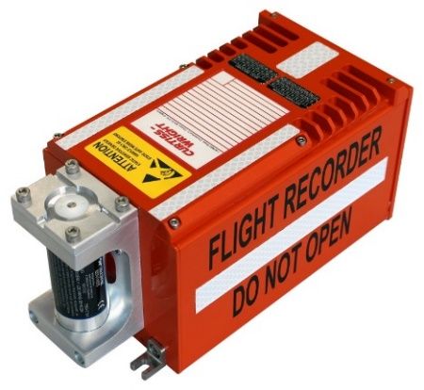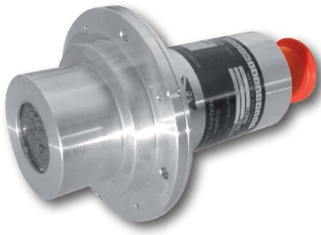

Figure : Airborne Image Recorder Camera

Figure : Curtiss-Wright Fortress Flight Data Recorder (with Cockpit Voice Recorder)

**Peregrine Avionics, LLC**, is an aircraft engineering and certification firm located at Centennial Airport in Englewood, CO. Over its 10-year history Peregrine has obtained over 25 STCs and provided extensive design and analytical support for Parts 23, 25, 27 and 29 aircraft. It is currently awaiting approval of its application for Organization Designation Authorization. Additional details can be found at [peregrine.aero](https://peregrine.aero/)

**SoCal Jets, Inc.** is a full-service, FAA Part 145 Repair Station, providing aircraft maintenance, avionics and repair at the Van Nuys airport. SoCal Jets is authorized dealer for major avionics suppliers in corporate aviation, SoCal Jets can install ADS-B Out Solutions, FANS installations, Broadband Internet/Wifi Installations, Cockpit System upgrade, Cabin & Entertainment upgrades, Phone Systems, Safety and Weather systems and other custom solutions to match your requirements. See us at <www.socaljets.aero>

**Curtiss-Wright Corporation** (NYSE:CW) is a global innovative company that delivers highly engineered, critical function products and services to the Aerospace and Defense markets, and to the Commercial markets including Power, Process and General Industrial. Building on the heritage of Glenn Curtiss and the Wright brothers, Curtiss-Wright has a long tradition of providing reliable solutions through trusted customer relationships. The company employs approximately 8,200 people worldwide. For more information, visit <www.curtisswright.com>.

###