August 31, 2021

FOR IMMEDIATE RELEASE:

PEREGRINE ANNOUNCES TODD BAILEY, VP Operations

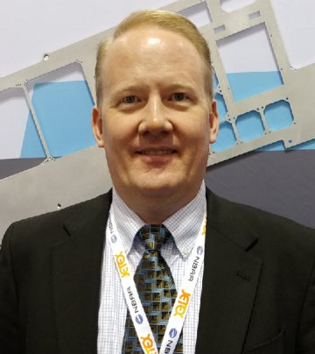

Figure : Todd Bailey, Vice President, Operations, Peregrine

Peregrine announces the addition of Todd Bailey to the executive team as Vice President, Operations. Mr. Bailey brings over 30 years of aerospace engineering and management experience to Peregrine.

Peregrine is excited to expand its current avionics and certification capabilities with the addition of structural design and fabrication experience that Mr. Bailey brings to the organization, including over 15 years in engineering and program management in roles as manager, director and president.

Through Mr. Bailey’s experience in utilizing additive manufacturing for the development of rapid prototypes, short-run tooling and complex production parts, Peregrine customers can expect significant cost and schedule savings over traditional tooling and fabrication methods commonly used during the development of supplemental type certificates and installation kits.

Mr. Bailey will provide additional focus to the company goals of achieving FAA-ODA delegation and expansion and diversification of the company customer base through his experience in special mission aircraft modifications and accessories.

In addition to holding a Bachelor of Science degree in Aeronautical Engineering from the University of Washington, Mr. Bailey’s engineering, leadership and management expertise ranges from aircraft OEMs and modification facilities to founder and President of AirMods LLC, an AS9100-certfied structural design and fabrication company, where he led a team of eight engineers and technicians through a wide variety of aircraft modification programs, and 3D-printed over 500 items of free PPE for NYC nurses during the early days of the COVID-19 pandemic.

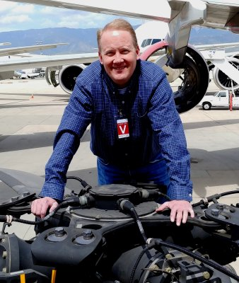

Figure : Todd Bailey, Vice President, Operations, Peregrine

**Peregrine Avionics, LLC,** is an aircraft engineering and certification firm located at Centennial Airport in Englewood, CO. Over its 10-year history Peregrine has obtained over 25 STCs and provided extensive design and analytical support for Parts 23, 25, 27 and 29 aircraft. It is currently awaiting approval of its application for Organization Designation Authorization. Additional details can be found at peregrine.aero

###