October 10, 2021

FOR IMMEDIATE RELEASE:

TALON AIR SELECTS PEREGRINE CABIN DISINFECTION SYSTEM stc

Peregrine’s Aviation Clean Air Supplemental Type Certificate has been selected by Talon Air, Inc. for installation of the Aviation Clean Air (ACA) ionic air cleaning system in the Talon Air Challenger aircraft. This system, part of a multi-layered disinfection program, utilizes ionic air cleansing to protect the Talon Air flight crew and clients from airborne and surface pathogens. The system installation data and Supplemental Type Certificate (STC) ST01066DE is available from Peregrine and Bombardier Service Centers.

“With the continuing concern with the COVID-19 pandemic and our commitment to transporting our private business jet customers with the greatest degree of care, we are confident that the Peregrine-developed installation of the ACA ionization system add another client benefit to our charter and business jet services,” stated James Chitty, CEO of Talon AIr.

Installation of the compact ACA system into the environmental control system (ECS) ducting provides continuous removal action during the entire aircraft ground and air operation and is the key to complete and continuous defense against pathogens. All pressurized areas of the aircraft are infused with positive and negative ions that neutralizes viruses and other pathogens using the ACA unique needle point bipolar ionization (NPBI™) system fitted to the aircraft ECS airflow.

“Working closely with Bombardier, Bombardier Service Centers and Talon Air, our STC installation for large cabin business aircraft can help to reduce cabin air quality concerns by crews and customers alike. The system operates continuously without flight crew interaction, providing a turn-key solution for Part 135 charter and business jet operations,” said David Rankin, president of Peregrine.

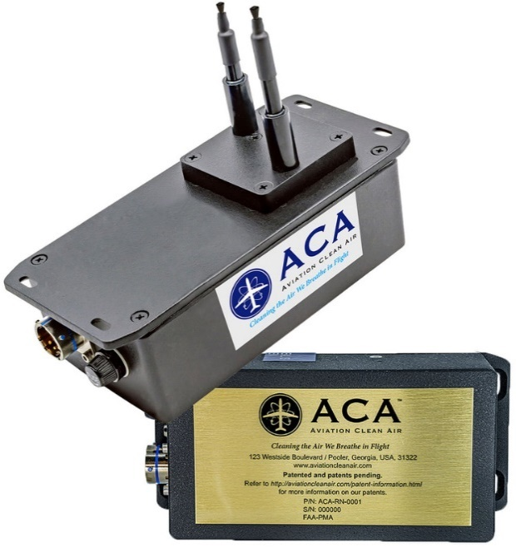

Figure 1: ACA NPBI™ Unit Weighs Only 1.34 lbs, Unit Dimensions are 7.02” x 3.27” x 5.36” (w/Probes Extended)

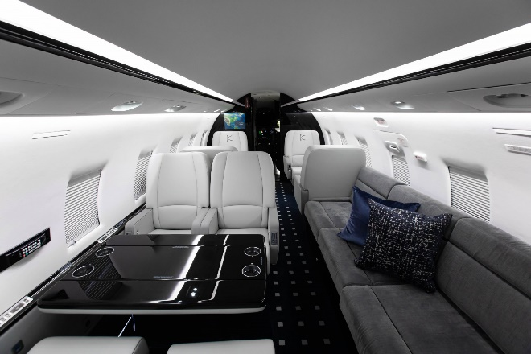

Figure 2: Interior view of a Talon Air Challenger 604 cabin environment treated by the ionic disinfection system

Peregrine’s Approved Model List (AML) STC ST01066DE multi-duct system includes Bombardier Challenger Series 600 models CL-600-1A11 (600), CL-600-2A12 (601), CL-600-2B16, Dassault models Mystere-Falcon 50, Mystere-Falcon 900, Falcon 900EX, and Gulfstream models G-IV and G‑IVSP aircraft.

Single duct ECS equipped aircraft covered by Peregrine’s AML STC ST01083DE include Learjet Models 35, 35A, 36, 36a, Textron/Cessna Citation 560XL and the Gulfstream G150.

The Aviation Clean Air units offer a proactive air and surface purification system for aircraft, providing clean, safe and healthy interior air. In addition to removing odors and allergens, their patented and proven, needle point bipolar ionization (NPBI™) system installed in the aircraft environmental control system, kills pathogens throughout the cockpit, cabin and pressurized cargo areas. The system eliminates pathogens including, but not limited to:

* COVID-19
* Bacteria associated with SARS
* Bird Flu (H5N1)
* Swine Flu (H1N1)
* Staph
* Eliminating mold spores, MRSA, [E.coli](http://E.coli/), Tuberculosis, [C.diff](http://C.diff/), pneumonia and more

***Testing at an independent laboratory showed that the ACA system was 99 percent effective in eliminating SARS-CoV-2 (COVID-19).***

**Peregrine Avionics, LLC**, is an aircraft engineering and certification firm located at Centennial Airport in Englewood, CO. Over its 10-year history Peregrine has obtained over 25 STCs and provided extensive design and analytical support for Parts 23, 25, 27 and 29 aircraft. It is currently awaiting approval of its application for Organization Designation Authorization. ACA cabin disinfection system STCs and STC installation data are available from Peregrine. Additional details can be found at [peregrine.aero](https://peregrine.aero/)

**Talon Air** is a full-service private jet charter company specializing in private jet services, charters, Part 145 maintenance and aircraft management. As the owner and operator of the most diverse fleet of private aircraft in the world, Talon Air offers clients access to heavy, super-midsize, midsize, light jets, turbo-prop, amphibious aircraft and executive helicopters. Talon Air’s expansive in-house fleet of aircraft enables clients private jet charter flights to any destination world-wide. Our company maintains ARG/US Platinum, Wyvern Wingman and IS-BAO Stage 2 certifications to ensure our clients’ safety during every flight. See: [www.talonairjets.com/](https://www.talonairjets.com/)

###