October 10, 2021

FOR IMMEDIATE RELEASE:

PEREGRINE PARTNERS WITH PEAK MEDEVAC FOR CABIN DISINFECTION SYSTEM

Peregrine, Peak Medevac International and Haggan Aviation partnered for Learjet STC installations of the Aviation Clean Air (ACA) ionic air cleaning system in medevac aircraft. This system, part of a multi-layered disinfection program utilizes ionic air cleansing to protect the medevac flight crew and patients from airborne and surface pathogens. The system installation data and Supplemental Type Certificate (STC) ST01083DE is now available from Peregrine.

“With the continuing concern with the COVID-19 pandemic and our commitment to transporting medical patients with the greatest degree of care, we are confident that the Peregrine-developed installation of the ACA ionization system improves the aircraft environment for our patients and crews,” stated Geno Haggan, CEO of Peak Medevac.

Installation of the compact ACA system into the environmental control system (ECS) ducting provides continuous removal action during the entire aircraft ground and air operation and is the key to complete and continuous defense against pathogens. All pressurized areas of the aircraft are infused with positive and negative ions that neutralizes viruses and other pathogens using the ACA unique needle point bipolar ionization (NPBI™) system fitted to the aircraft ECS airflow.

“Working closely with Peak Medevac and Haggan Aviation, we jointly developed an installation for these aircraft popular in the medevac fleet. The system operates continuously without flight crew interaction, providing a turn-key solution for medevac operations,” said David Rankin, president of Peregrine.

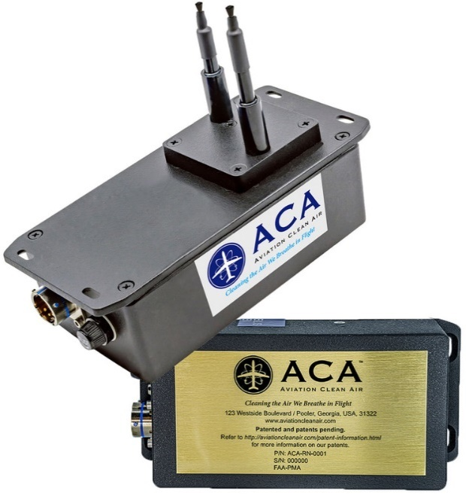

Figure : ACA NPBI™ Unit Weighs Only 1.34 lbs, Unit Dimensions are 7.02” x 3.27” x 5.36” (w/Probes Extended)

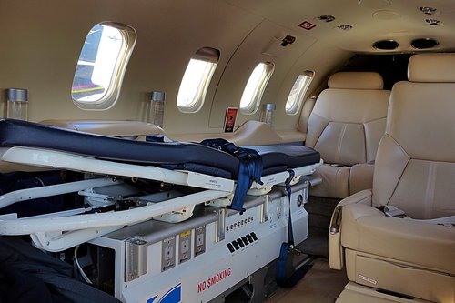

Figure : Interior view of a Peak Medevac International cabin environment treated by the ionic disinfection system

Learjet Models 35, 35A, 36, 36a, Textron/Cessna Citation 560XL and the Gulfstream G150 are covered by Peregrine Approved Model List (AML) STC ST01083DE.

Peregrine has previously received FAA approval of an AML STC ST01066DE for the Bombardier Challenger Series 600 models CL-600-1A11 (600), CL-600-2A12 (601), CL-600-2B16, Dassault models Mystere-Falcon 50, Mystere-Falcon 900, Falcon 900EX, and Gulfstream models G-IV and G‑IVSP aircraft.

The Aviation Clean Air units offer a proactive air and surface purification system for aircraft, providing clean, safe and healthy interior air. In addition to removing odors and allergens, their patented and proven, needle point bipolar ionization (NPBI™) system installed in the aircraft environmental control system, kills pathogens throughout the cockpit, cabin and pressurized cargo areas. The system eliminates pathogens including, but not limited to:

* COVID-19
* Bacteria associated with SARS
* Bird Flu (H5N1)
* Swine Flu (H1N1)
* Staph
* Eliminating mold spores, MRSA, [E.coli](http://E.coli/), Tuberculosis, [C.diff](http://C.diff/), pneumonia and more

***Testing at an independent laboratory showed that the ACA system was 99 percent effective in eliminating SARS-CoV-2 (COVID-19).***

**Peregrine Avionics, LLC**, is an aircraft engineering and certification firm located at Centennial Airport in Englewood, CO. Over its 10-year history Peregrine has obtained over 25 STCs and provided extensive design and analytical support for Parts 23, 25, 27 and 29 aircraft. It is currently awaiting approval of its application for Organization Designation Authorization. ACA cabin disinfection system STCs and STC installation data are available from Peregrine. Additional details can be found at [peregrine.aero](https://peregrine.aero/)

**Haggan Aviation**, located at Centennial Airport (KAPA) just south of Denver, Colorado, is a full-service FAA-approved Part 145 repair station specializing in small to mid-size jet maintenance. Our team of factory-trained experts are up-to-date with the latest avionics systems and mandates and will provide installations and upgrades to meet your needs.

Established in 1996, Haggan Aviation offers full airframe inspections, engine maintenance, avionics, major retrofits for cabin and cockpit systems, as well as paint and interior capabilities.  In addition, Haggan provides complete Wi-fi and in-flight entertainment installations to create the ultimate onboard experience. For more information, visit [www.hagganaviation.com/](https://www.hagganaviation.com/)

**Peak Medevac International**, is the premier long distance medical transport company operating in the western hemisphere. With our dedicated fleet of air ambulance jets that are owned, operated, and maintained- highly trained critical care teams, and multilingual case management and medical coordination teams, we are unmatched in our ability to serve our clients. See: [peakmedevac.com/](https://peakmedevac.com/)

###