**Peregrine**

7385 S. Peoria Street Unit C4

Englewood, CO 80112

303 325-3873

www.peregrine.aero

March XX, 2022

FOR IMMEDIATE RELEASE:

PEREGRINE AND GULFSTREAM: IMPROVED G150 FLAP/SLAT OPERATION

On behalf of Gulfstream Aerospace, Peregrine completed a supplemental type certificate (STC), ST0107DE, installing flap and slat actuator heaters to improve high-lift system performance in cold weather landing situations.

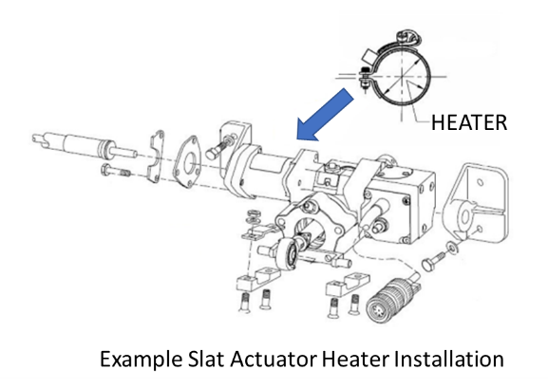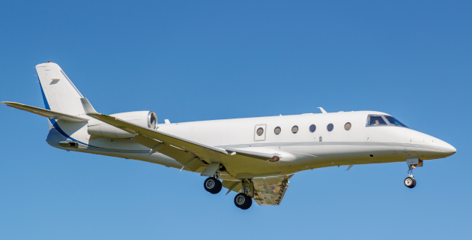

The STC covers the installation of heaters to prevent inadvertent freezing of the aircraft’s linear actuator components that control wing flaps and slats positions. The heaters ensure the reliable operation and deployment of the leading-edge slats and flaps in all operational environments. STC does not modify the G150 Flap/Slat drive system including controls, indications, safety mechanisms or recommended lubrication maintenance procedures

Peregrine provided all engineering, test and certification data needed to obtain the Supplemental Type Certificate approval. The components, heaters control systems and installation documentation package are available as a package directly from Peregrine.

Peregrine is ready to provide a turn-key installation of the system at our Centennial Airport (KAPA) Part 145 repair station partner, or can supply the STC and installation components for installation by your preferred authorized repair station. Contact XXXXX for further details and scheduling information.

**Peregrine Avionics, LLC**, is an aircraft engineering and certification firm located at Centennial Airport in Englewood, CO. Over its more than 10-year history, Peregrine has obtained over 25 STCs and provided extensive design and analytical support for Parts 23, 25, 27 and 29 aircraft. It is currently awaiting approval of its application for Organization Designation Authorization.

###