**Peregrine**

7385 S. Peoria Street Unit C4

Englewood, CO 80112

303 325-3873

www.peregrine.aero

October 28, 2022

FOR IMMEDIATE RELEASE:

PEREGRINE STC IMPROVES PREMIER I AND IA LIGHTING

Peregrine developed a supplemental type certificate (STC) to improve exterior lighting performance and reliability for the Beechcraft 390 Premier I/IA. Working on behalf of Wichita Aerospace, Peregrine created this STC (SA1988WI) that replaces the entire pair of wingtip light clusters including Navigation, Recognition and Strobes with modern LED technology. Additionally, the STC covers the replacement of the original lens and housing in the tail cone with a single, dual function LED.

Reusing the existing clear lenses, the STC replaces the entire wingtip light assembly. The existing power supplies, strobes and incandescent bulbs are removed, yielding a load reduction of over 28 amps and weight reduction of over eight pounds.

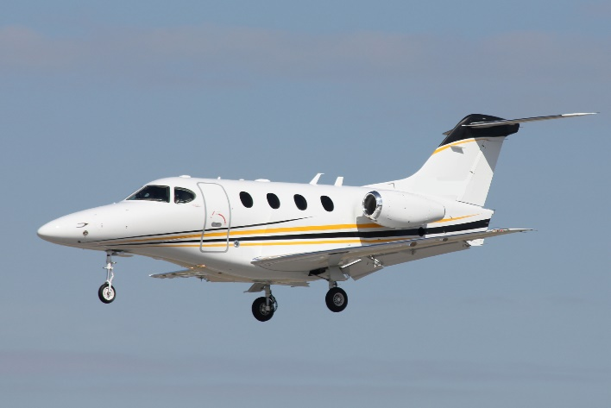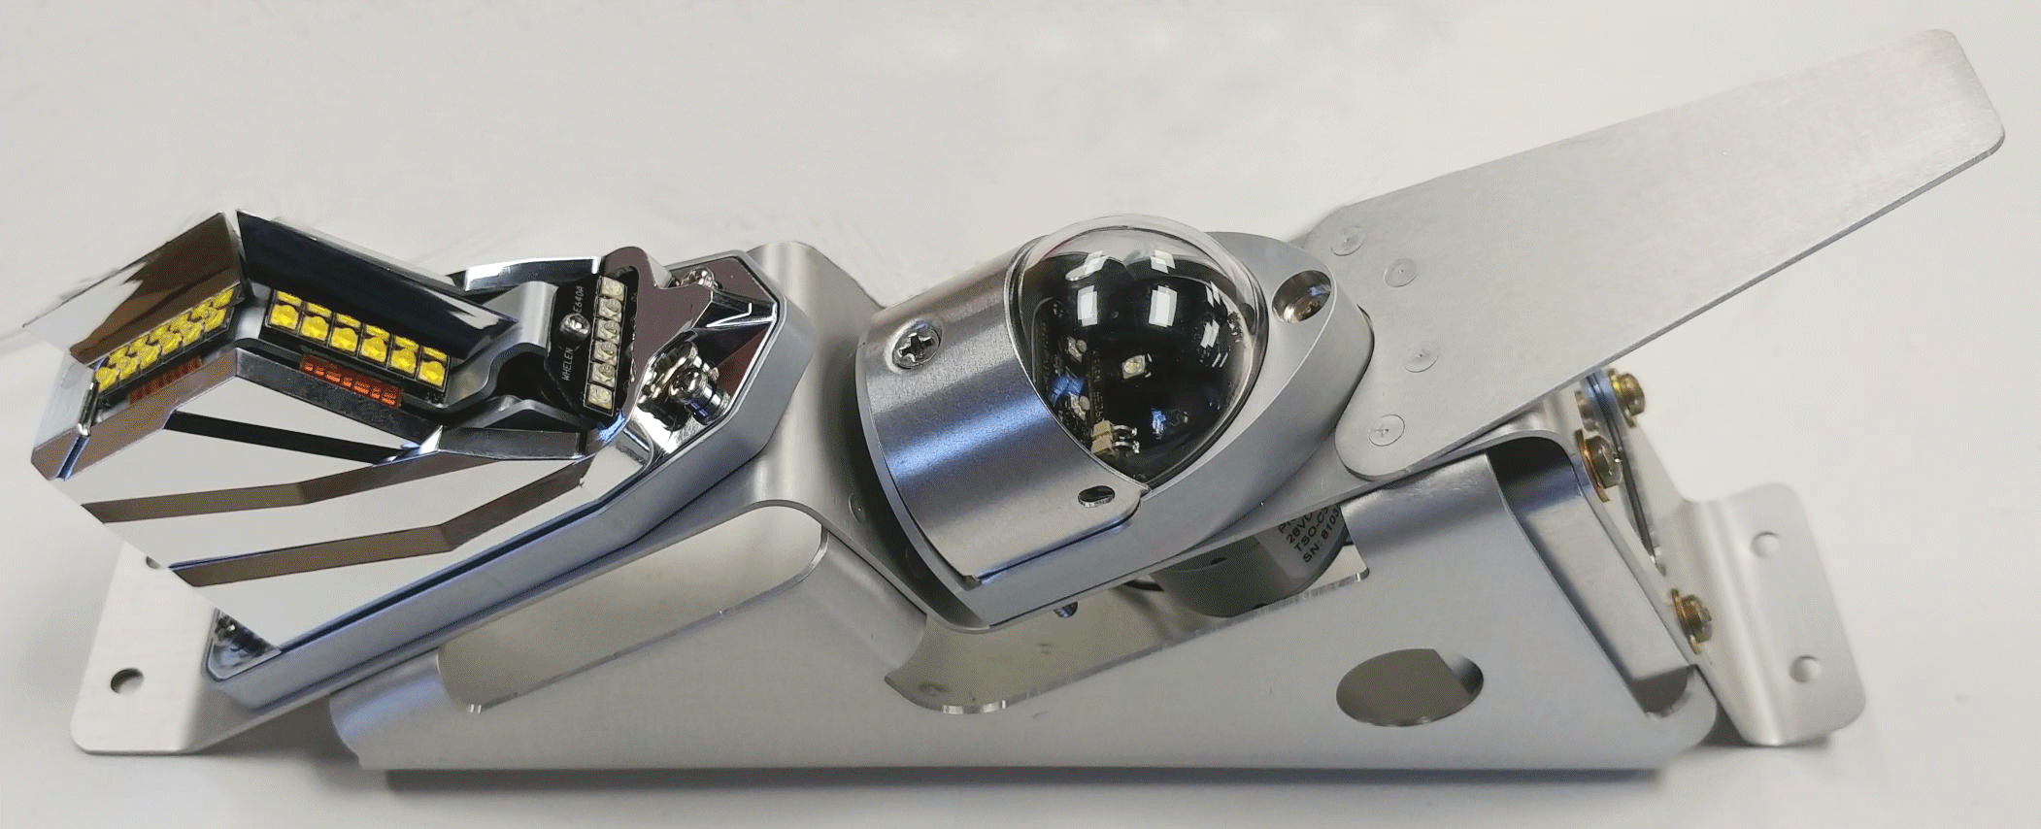

*Replacement wingtip lamp assembly Beechcraft Premier*

“Working with Wichita Aerospace to complete the certification and STC process further demonstrates our focus on streamlining engineering and certification for the benefit of our customers, allowing their resources to focus on their customer and business needs,” remarked David Rankin, President and Founder of Peregrine.

“The Whelen Aerospace Technologies (WAT) designed replacement lights that require no external components and use newer technology LEDs,” states Christophe Maskell, Managing Director, Wichita Aerospace. “Installation of the WAT replacement lights will result in a significant reduction in equipment weight, electrical bus loading and maintenance costs for the airplane owner/operator.”

This simple, robust installation can be accomplished in under a day by an A&P. The “WA 390 LED STC Premier Wingtip and Tail Cone LED Upgrade” is available for $21,000 USD. The installation package is available directly from Wichita Aerospace. Peregrine provided all engineering, test and certification data needed to obtain the Supplemental Type Certificate approval.

The STC installation kit includes the new Whelen lighting assemblies mounted to new sheet metal brackets and a pre-wired harness. The Devore lights, replaced by this STC, were designed in the 1990’s, used older flash tube or incandescent bulbs, were inefficient, and required external components to function. Of additional concern to owners and operators is that the original lights are no longer available from the manufacturer.

**Peregrine Avionics, LLC**, is an aircraft engineering and certification firm located at Centennial Airport in Englewood, CO. Over its more than 10-year history, Peregrine has obtained over 27 STCs and provided extensive design and certification support for Parts 23, 25, 27 and 29 aircraft. It is currently awaiting approval of its application for Organization Designation Authorization.

**Wichita Aerospace, LLC**, is a detail-oriented, customer-focused, solutions provider for the Beechcraft Premier and other legacy aircraft. Contact us at (316)-844-3400 or email [cmaskell@wichitaaero.com](mailto:cmaskell@wichitaaero.com). Visit us at wichitaaerospace.com

Premier aircraft photo: 30646839 / Beechcraft Jet © Shutterbas | Dreamstime.com

###