**Peregrine**

7385 S. Peoria Street Unit C4

Englewood, CO 80112

303 325-3873

www.peregrine.aero

December 1, 2022

FOR IMMEDIATE RELEASE:

TJ SPITZMILLER JOINS PEREGRINE AS BUSINESS DEVELOPMENT VP

TJ Spitzmiller returns to Peregrine as VP, Business Development and Administration and provides over twenty years of experience in the aerospace industry. Beginning with five years of Supply Chain Management with Eclipse Aviation, where his efforts were instrumental to the first flight of the Eclipse 500 Very Light Jet. He expanded these skills with Honeywell, where he achieved the Six Sigma Green Belt Certification. Most recently as General Manager of Sarasota Avionics, Sarasota, FL location (KSRQ), Spitzmiller continued to build an impressive in-depth knowledge of advanced navigation and communication electronics.

In addition to his corporate background, Spitzmiller holds an FAA Commercial Pilot and Flight Instructor certificate with Instrument and Advanced Ground Instructor ratings; logging over 2000 hours in 55 different types of aircraft. As a subject matter expert, TJ is a contributor to aerospace publications such as *IFR Magazine, AVweb*, and *Aviation Consumer Magazine*.

“The Peregrine team is excited to have TJ back as an integral part of the executive team,” stated David Rankin, President of Peregrine, adding “TJ’s product knowledge, experience in market development and his focus on customer satisfaction will benefit both our company and our clients.”

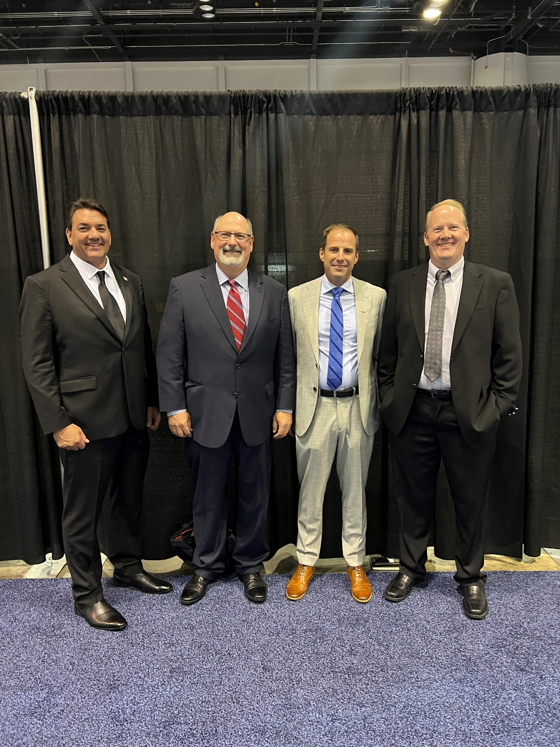

*Peregrine Executive Team: TJ Spitzmiller, Wesley Lumry, David Rankin and Todd Bailey*

**Peregrine Avionics, LLC**, is an aircraft engineering and certification firm located at Centennial Airport in Englewood, CO. Over its more than 13-year history, Peregrine has obtained over 30 STCs and provided extensive design and certification support for Parts 23, 25, 27 and 29 aircraft. It is currently awaiting approval of its application for Organization Designation Authorization.

###