April, 2023

FOR IMMEDIATE RELEASE:

Mexico ICAO recorder REQUIREMENT STC Model List Expanded

Peregrine, in collaboration with Curtiss-Wright Defense Solutions and Texas Aerospace Technologies has expanded the Approved Model List (AML) for Supplemental Type Certificate (STC) #ST01070DE. This STC provides operators with a compliant, affordable, solution to meet the requirements for recorders as outlined in NOM‑022‑SCT3 2011 in accordance with CP AV-022 dated April 15, 2019. The Approved Model List has been awarded to Peregrine and is now available for installation through Texas Aerospace Technologies. The Federal Civil Aviation of Mexico, AFAC, validation of this FAA AML STC has been completed.

This AML STC, “Curtiss-Wright Fortress Flight Data Recorder (with Cockpit Voice Recorder), Class C Cockpit Image Recorder, and Dukane Seacom Underwater Locating Device Installation” covers the Learjet 30 Series, Learjet 45, 55 Series and Model 60; Hawker 400, 800 and 1000 Series; Hawker Siddeley HS.125 Series 700A/B; Mitsubishi MU300-10 and Citation 10 (750), 550, S550, 560, 650 aircraft. The STC incorporates the use of a Class C Airborne Image Recorder camera and a new cockpit voice recorder. This camera records images of the cockpit instrument panel and thus installation costs and downtime are significantly reduced.

Any Part 25 charter aircraft (USA) that operates in Mexican airspace or is Mexican registered over 5500kg must have this equipment installed per AFAC requirements. The Mexico requirement is based on ICAO Annex 6 documentation. All equipment is ED-112A certified and includes an EASA (E) approved 25-hour Cockpit Voice Recorder and (E)TSO-176a two (2) hour Airborne Image Recorder.

“Under certain regulatory bodies, Class C recorders are allowed as a means for recording flight data where it is not practical or prohibitively expensive to record on an FDR, or where an FDR is not required. This expanded AML STC offers an economical means of complying with the new AFAC and ICAO requirements for additional aircraft,” states David Rankin, president, Peregrine.

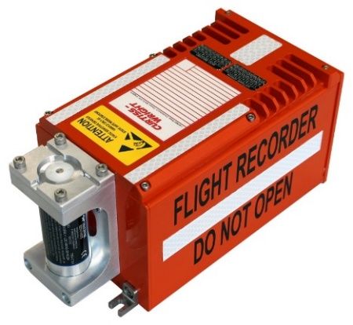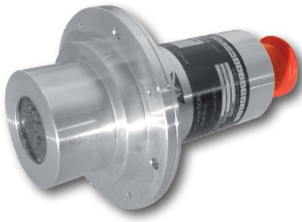

Figure 1: Airborne Image Recorder Camera

Figure 2: Curtiss-Wright Fortress Flight Data Recorder (with Cockpit Voice Recorder)

In addition to the AML expansion, the FAA has clarified allowing the use of the system as an alternate means of compliance to meet the AFAC (Mexico) operational requirements. The system can also be configured to include the Texas Aerospace Technologies' TXA201 Tri-Axial Accelerometer. The TXA201 directly replaces outdated Accelerometers, meeting form, fit, and function. The ARINC 542A mounting form and pin-for-pin connector make the TXA201 a true plug-and-play solution. The TXA201 is designed to be installed in a non-environmentally controlled equipment bay.

For more information regarding this STC or to place an order for an installation or equipment, please contact: Texas Aerospace Technologies, Brad Sutphin, +1 (325) 788-2418, [www.txaero.com](http://www.txaero.com); Curtiss-Wright, Stephen Leaper, +44 (0) 7802 676868, www.curtisswrightds.com; or Peregrine, +1 (303) 325-3873, peregrine.aero. For information about the AFAC mandates, see <https://peregrine.aero/mexico-increases-enforcement-of-key-equipage-mandates/>.

**Peregrine** is an aircraft engineering and certification firm located at Centennial Airport in Englewood, CO. Over its 10-year history Peregrine has obtained over 25 STCs and provided extensive design and analytical support for Parts 23, 25, 27 and 29 aircraft. It is currently awaiting approval of its application for Organization Designation Authorization. Additional details can be found at [peregrine.aero](https://peregrine.aero/)

**Curtiss-Wright Corporation** (NYSE:CW) is a global innovative company that delivers highly engineered, critical function products and services to the Aerospace and Defense markets, and to the Commercial markets including Power, Process and General Industrial. Building on the heritage of Glenn Curtiss and the Wright brothers, Curtiss-Wright has a long tradition of providing reliable solutions through trusted customer relationships. The company employs approximately 8,200 people worldwide. For more information, visit www.curtisswright.com.

**SoCal Jets, Inc.** is a full-service, FAA Part 145 Repair Station, providing aircraft maintenance, avionics and repair at the Van Nuys airport. SoCal Jets is authorized dealer for major avionics suppliers in corporate aviation, SoCal Jets can install ADS-B Out Solutions, FANS installations, Broadband Internet/Wifi Installations, Cockpit System upgrade, Cabin & Entertainment upgrades, Phone Systems, Safety and Weather systems and other custom solutions to match your requirements. See us at www.socaljets.aero

**Texas Aerospace Technologies,** a subsidiary of Texas Aerospace Services, is a solution-based company with a primary focus on value-added distribution, STC development, new product development, and introductions to the avionics and aviation marketplace. Texas Aerospace Technologies’ core focus is high technology products that help push aviation boundaries and promote safety. Our goal is to provide the best products and services in the industry while maintaining the highest level of integrity for all our partners**.** See us at [www.txaero.com](http://www.txaero.com)

###