April 24, 2023

FOR IMMEDIATE RELEASE:

Mexico ICAO recorder REQUIREMENT STC Model List Expanded

Peregrine, in collaboration with Curtiss-Wright Defense Solutions and SoCal Jets has expanded the Approved Model List (AML) for Supplemental Type Certificate (STC) #ST01070DE. This STC provides operators with a compliant, affordable, solution to meet the requirements for recorders as outlined in NOM‑022‑SCT3 2011 in accordance with CP AV-022 dated April 15, 2019. The Approved Model List has been awarded to Peregrine and is now available for installation. The Federal Civil Aviation of Mexico, AFAC, has validated this FAA AML STC.

This AML STC, installs the Curtiss-Wright Fortress Flight Data Recorder with Cockpit Voice Recorder), Class C Cockpit Image Recorder, and Dukane Seacom Underwater Locating Device. The expanded AML now covers additional legacy Learjet, Citation, and Hawker models including the Lear 60, the Hawker 400, and the Cessna 560. The STC utilizes the Class C AIR camera to record images of the cockpit instrument panel to record key flight parameters. This simplified installation significantly reduces costs and downtime when compared to a traditional FDR installation.

Any Part 25 charter aircraft (USA) that operates in Mexican airspace or is Mexican registered over 5500kg must have this equipment installed per AFAC requirements. The Mexico requirement is based on ICAO Annex 6 documentation. All equipment is ED-112A certified and includes an EASA (E) approved 25-hour Cockpit Voice Recorder and (E)TSO-176a two (2) hour Airborne Image Recorder.

“Under certain regulatory bodies, Class C recorders are allowed as a means for recording flight data where it is not practical or prohibitively expensive to record on an FDR, or where an FDR is not required. This expanded AML STC offers an economical means of complying with the new AFAC and ICAO requirements for additional aircraft,” states David Rankin, president, Peregrine.

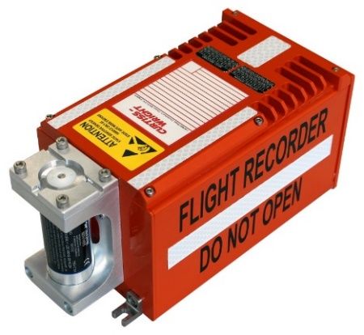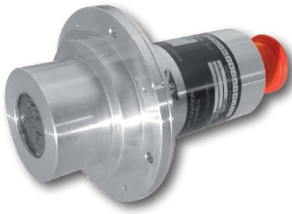

Figure 1: Airborne Image Recorder Camera

Figure 2: Curtiss-Wright Fortress Flight Data Recorder (with Cockpit Voice Recorder)

In addition to the AML expansion, the STC now more clearly allows the use of the system as an acceptable Class C Cockpit Image Recorder compliant with EUROCAE ED-112A, Chapter III, that may be installed to meet the AFAC (Mexico) operational requirements. Further, the updated STC now allows integration with the Texas Aerospace Technologies' TXA201 Tri-Axial Accelerometer.

For more information regarding this STC or to place an order for an installation or equipment, please contact: SoCal Jets, +1 (818) 782-6658, www.socaljets.aero; Curtiss-Wright, Stephen Leaper, +44 (0) 7802 676868, www.curtisswrightds.com; or Peregrine, +1 (303) 325-3873, peregrine.aero. For information about the AFAC mandates, see <https://peregrine.aero/mexico-increases-enforcement-of-key-equipage-mandates/>.

**Peregrine** is an aircraft engineering and certification firm located at Centennial Airport in Englewood, CO. Over its 10-year history Peregrine has obtained over 25 STCs and provided extensive design and analytical support for Parts 23, 25, 27 and 29 aircraft. It is currently anticipating approval of its application for Organization Designation Authorization. Additional details can be found at [peregrine.aero](https://peregrine.aero/)

**Curtiss-Wright Corporation** (NYSE:CW) is a global innovative company that delivers highly engineered, critical function products and services to the Aerospace and Defense markets, and to the Commercial markets including Power, Process and General Industrial. Building on the heritage of Glenn Curtiss and the Wright brothers, Curtiss-Wright has a long tradition of providing reliable solutions through trusted customer relationships. The company employs approximately 8,200 people worldwide. For more information, visit www.curtisswright.com.

**SoCal Jets, Inc.** is a full-service, FAA Part 145 Repair Station, providing aircraft maintenance, avionics and repair at the Van Nuys airport. SoCal Jets is authorized dealer for major avionics suppliers in corporate aviation, SoCal Jets can install ADS-B Out Solutions, FANS installations, Broadband Internet/Wifi Installations, Cockpit System upgrade, Cabin & Entertainment upgrades, Phone Systems, Safety and Weather systems and other custom solutions to match your requirements. See us at www.socaljets.aero

###