December 20, 2023

FOR IMMEDIATE RELEASE:

Mexico AFAC VALIDATES recorder STC EXPANDED Model List

The Mexico Agencia Federal de Aviación Civil (AFAC) has validated the Peregrine Supplemental Type Certificate (STC) #ST01070DE that includes additional aircraft models.

Peregrine, in collaboration with Curtiss-Wright and SoCal Jets, Inc. expanded the Approved Model List (AML) for STC #ST01070DE. This STC already provides operators with a compliant, affordable, solution to meet the requirements for recorders as outlined in NOM‑022‑SCT3 2011 in accordance with CP AV-022 dated April 15, 2019. This validation shows that AFAC recognizes this recording system to meet ICAO Annex 6 requirements. Now operators and owners of the more comprehensive Approved Model List (AML) aircraft can utilize this STC and operate aircraft in Mexico airspace as an FAA and AFAC approved installation.

This AML STC installs the Curtiss-Wright Fortress Flight Data Recorder with Cockpit Voice Recorder, Class C Cockpit Image Recorder including a Dukane Seacom Underwater Locating Device. The expanded AML now includes Learjet 30 Series, Learjet 45, 55 Series and Model 60; Hawker 400, 800 and 1000 Series; Hawker Siddeley HS.125 Series 700A/B; Mitsubishi MU300-10 (Beechjet) and Citation 10 (750), 550, S550, 560, 650 aircraft. The STC utilizes the Class C AIR camera to record images of the cockpit instrument panel to record key flight parameters. This simplified installation significantly reduces costs and downtime when compared to a traditional FDR installation.

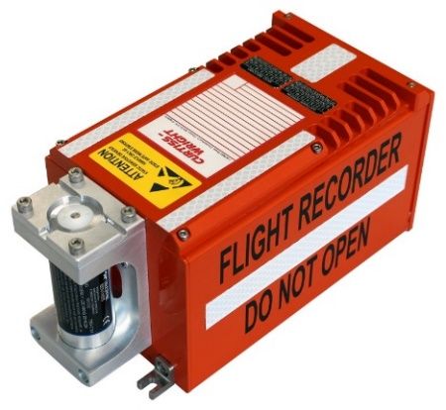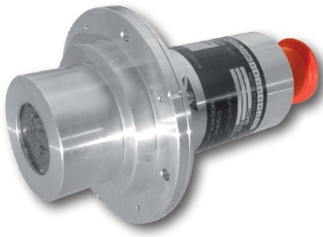

Figure 1: Airborne Image Recorder Camera

Figure 2: Curtiss-Wright Fortress Flight Data Recorder (with Cockpit Voice Recorder)

For more information regarding this STC, please contact: SoCal Jets, or Peregrine, +1 (303) 325-3873, peregrine.aero. For information about the AFAC mandates, see <https://peregrine.aero/mexico-increases-enforcement-of-key-equipage-mandates/>.

**Peregrine** is an FAA ODA, providing aircraft engineering and certification expertise located at Centennial Airport in Englewood, CO. Over its 14-year history Peregrine has obtained over 35 STCs and provided extensive design and analytical support for Parts 23, 25, 27 and 29 aircraft. Additional details can be found at [peregrine.aero](https://peregrine.aero/)

**SoCal Jets, Inc.** is headquartered in Van Nuys, CA, SoCal Jets employs some of the best aircraft technicians and promotes a positive attitude that ensures company-wide success as it proudly celebrates over 37 years in business. Each SoCal Jets employee is dedicated to maintaining aircraft to the highest standard, with the utmost commitment to the safety of our customers. SoCal Jets services primarily Gulfstream, Challenger, Falcon, Hawker, Learjet, and Citation aircraft. SoCal Jets also supports many aircraft in Mexico, and is proud to be one of just a handful of U.S. companies to have received certification from AFAC. You can learn more about SoCal Jets online at [www.socaljets.aero](http://www.socaljets.aero)

**Curtiss-Wright Corporation** (NYSE:CW) is a global innovative company that delivers highly engineered, critical function products and services to the Aerospace and Defense markets, and to the Commercial markets including Power, Process and General Industrial. Building on the heritage of Glenn Curtiss and the Wright brothers, Curtiss-Wright has a long tradition of providing reliable solutions through trusted customer relationships. The company employs approximately 8,200 people worldwide. For more information, visit www.curtisswright.com.

###