03 January 2022

David Rankin, President  
Peregrine Avionics LLC  
7385 South Peoria Street, Unit C4  
Englewood, CO 80112 USA

RE: Business Growth Enhancement Proposal

David,

AviaGlobal Group, LLC (AGG) is pleased to provide this proposal to Peregrine for leveraging the Peregrine online presence, enhancing revenue generation beyond current projections. There are a number of solid activities that can promoted beyond a presence on the current Peregrine web site.

A prime example is the G150 flap and slat actuator heater where our efforts are aimed at securing specific opportunities through targeted direct marketing, leveraging tailored web presence.

We are confident the increased business will more than offset the modest expense associated with the proposed AGG tasking.

AGG PARTNER

*Co-Founder & Managing Partner*

*AviaGlobal Group, LLC*

*Attachments: Proposals*

*cc: K. Gould, T. Bailey*

# Summary:

AviaGlobal Group, LLC, (AGG) offers Peregrine a path for additive revenue generation by enhancing web-based and email marketing presence of Peregrine general capabilities and specific revenue generating Peregrine STCs. More importantly, these proposed efforts are action oriented and specifically targeted to generate more revenue through generating direct opportunities, prospective clients.

AGG proposes to expand the current Peregrine web site maintenance tasking with specific, *initial* targeted activities:

1. Extended website enhancement by incorporating additions and extensions to the peregrine.aero website, providing engagement improvement for website visitors. This is detailed below in “Website Marketing Proposal”
2. Develop a specific web and email campaign to target sales the Gulfstream G150 flap and slat actuator heater STC. This is detailed below in “G150 Flap and Slat Heater Email and Web Campaign Proposal”, or other STC opportunities as identified and agreed by Peregrine and AGG.

AGG has prepared this proposal in response to preliminary telecon discussions with Peregrine. The final tasking is based on collaboration and will incorporate Peregrine input to ensure that we have aligned your goals and objectives with our proposal.

As an example of targeted website enhancement, AGG recognizes that the G150 flap and slat actuator heater STC offers a prime opportunity. AGG proposes specific actions aimed at related operators, brokers and service centers, alerting and educating potential customers regarding the STC. AGG proposes that this specific opportunity, an example of targeted promotion, is folded into our proposed 2022 website and marketing activity.

This proposed targeted opportunity tasking illustrates AGG ability to generate specific, measurable revenue opportunities. AGG, as a part of the ongoing engagement with Peregrine, will continuously identify and act on other specific, direct revenue generating promotional campaigns.

The AGG work and pricing schedule proposal for these tasks below in “Proposal Pricing and Schedule”

2022 Website and Marketing Proposal

# Website work product

The current website allows for visitors to gain insight into Peregrine-developed STCs, download STC certificate and approved model list (AML) PDF images, communicate messages to Peregrine and to gain an understanding of the broad capabilities of Peregrine.

The language in this proposal uses the concept of Peregrine work product as “Projects” aligns with the current website vernacular. Aligning the concept to “Projects” as Peregrine “Products” can be achieved with minor modification to the website.

We are confident that expansion of the “Projects” aspect of historical work of Peregrine can further enhance the scope of work performed by Peregrine that will lead website visitors to engage Peregrine to perform engineering and certification work on behalf or specifically for new or existing clients.

## Projects

Currently, four projects are highlighted as static images (jpg) on the “Our Projects” page of the website, as shown in Figure 1:

* Curtiss-Wright Fortress FDR
* ACA and Lee Aerospace C560
* Worldwide Aircraft Services EMB-120 glass cockpit retrofit
* DAC International CRT display replacement

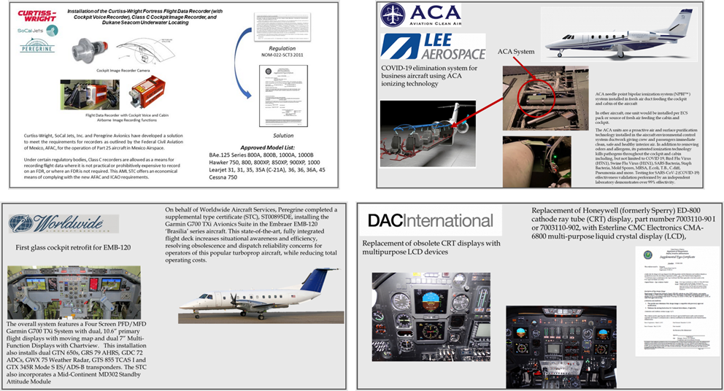

Figure 1: A gallery of our other recent projects follows...

These images contain textual information that is not “crawlable” by search engines and do not trigger keyword recognition for search engine optimization (SEO) algorithms.

### AGG proposes to:

1. Expand the “Project Gallery” to include information for the STC projects that Peregrine has undertaken to date.
2. Develop each element of the project gallery as “web content” that will be available to search engines and SEO algorithms.
   1. AGG will develop a template for the gallery elements.
   2. Peregrine will provide, upon AGG inquiry, with details necessary to complete each project gallery element.
   3. AGG will create the content for each project gallery element.
   4. Peregrine will provide a timely review to ensure accuracy of the developed information.
3. Assign keywords to further enhance web recognition of Peregrine project information.
4. Make each project addressable so that links elsewhere in the website can directly take the visitor to the specific project description. For example, when the website visitor clicks on a featured project on the home page, they will be taken to the specific project in the gallery of projects.
5. Each project in the project gallery will have cross references to:
   1. Press releases (if applicable).
   2. STC and AML information.
   3. Availability and “contact us” for more information or quotation.
6. In addition to the project gallery elements being addressable for direct access, the gallery will be scrollable so that the visitor can gain an appreciation of the total scope of the work performed by Peregrine.
7. A search feature on the gallery page will allow for selection of information from the project gallery presentation.

## STC Page

The STC page allows visitors to sort, search and download STC and AML documents as available from the FAA. Also, a link is provided to the company providing the STC.

### AGG proposes to:

1. Restructure the STC table to allow for better interpretation by search engines and SEO algorithms.
2. Add links to the project gallery for further information about the project related to the STC.

## Client Page

### AGG proposes to:

1. Add links and other cross references between clients, customers and project sponsors to visually connect logos to projects, STCs and press information.
2. Include, expand client testimonials.

G150 Flap and Slat Heater Email and Web Campaign

# Summary

AGG recognizes that the G150 flap and slat actuator heater STC offers a prime revenue opportunity by targeting operators, brokers and service centers regarding the details of this STC.

# Campaign Work Product

Develop, maintain and adjust, as needed, promotional activities such as the website, email, physical collateral and campaign plan, thus stimulating sales of the G150 slap slat actuator heater STC and kitting.

### AGG proposes to:

1. Develop specific website pages that feature this project and lead potential customers to learn more about this STC.
2. Develop marketing material, press releases, white papers and collateral as appropriate to distribute over the course of the campaign.
3. Develop a target list of potential customers, including operators, service centers and brokers, including:
   1. Email, where available.
   2. Physical address where available.
   3. Curate a list of press contacts to enhance coverage of this STC that includes subcontracting with press release vendors, if desired by Peregrine.
4. Through a combination of Mailchimp and physical mail piece distribution, each target will be touched through one or both means.
5. Specific response mechanisms will be created to track responses and gauge effectiveness of the campaign as measurable by the campaign targets’ responses.
6. AGG will provide regular reports, as needed, to Peregrine detailing:
   1. Mailchimp response information.
   2. Website engagement information.
   3. Email response information.

Proposal Pricing and Schedule

# Summary

AviaGlobal Group, LLC (AGG) views these projects as distinct additions to the current website maintenance and this proposal replaces the current structure currently provided to Peregrine.

# 2022 Website and Marketing Proposal

1. Price: $6k retainer for 12 months (includes current maintenance activity)
2. Milestones:
   1. Storyboard for website updates 30 days ARO
   2. Draft project gallery elements 60 days ARO
   3. Launch of initial website content update 90 days ARO
   4. Completion of updated website content & SEO 120 days ARO
   5. Website maintenance Ongoing
   6. Identify, develop, execute concurrent specific marketing promotions
      1. As identified and agreed Ongoing

Initial Concurrent Specific Marketing Promotion

G150 Flap and Slat Heater Email and Web Campaign Detail

1. Milestones:
   1. Storyboard for campaign 30 days ARO
   2. Launch of Mailchimp and/or mail piece 60 days ARO
   3. Campaign endpoint 90 days ARO
2. Embedded services:
   1. Additional website plug-ins and template enhancements will be billed to Peregrine
   2. Third-party press or mailer agency services will be priced to Peregrine for approval

Potential Follow-on Concurrent Specific Marketing Promotion Campaigns

* Curtiss-Wright Fortress FDR
* ACA and Lee Aerospace C560
* Worldwide Aircraft Services EMB-120 glass cockpit retrofit
* DAC International CRT display replacement