ddmmonth 2022

David Rankin, President  
Peregrine Avionics LLC  
7385 South Peoria Street, Unit C4  
Englewood, CO 80112 USA

RE: REVISION - Business Growth Enhancement Proposal

In consideration of discussions and feedback, AviaGlobal Group, LLC (AGG) is pleased to provide this proposal revision. The focus is the providing for a way of actively increasing Peregrine revenue beyond current operating plan expectations. The AGG primary objective centers around converting project STC recurring revenue opportunities, utilizing direct end-user, or enabler, chase & capture. That is; AGG will identify, contact and close new business, supported by Peregrine.

This direct approach is necessarily supported by significantly enhancing and leveraging the Peregrine online presence and marketing research, thus expanding both passive on line presence as well as supporting active chase & capture. The objective is to secure added income from additive direct sales *and* sales conversions of Peregrine website visitors.

The first active effort proposed is the G150 flap and slat actuator heater where our efforts will result in identified opportunity conversions to actual sales, additive revenue. Also, the G150 Peregrine/ AGG effort will be key in shaping the business model for follow-on direct sales efforts.

We understand the challenges associated with this effort and as such we are proposing that in consideration of this significant increase in AGG effort, the monthly website retainer be increased to $3,000 per month, plus a commission of $1000 per successful G150 STC sale. We envision the commission amount to be variable, depending on the expected revenue.

We can bring value-added to your business, David. Thank you for your consideration.

Very best regards,

xxxxxxxxxxxx

*Co-Founder & Managing Partner*

*AviaGlobal Group, LLC*

*Attachments: Proposal*

*cc: K. Gould, T. Bailey*

# Summary:

AviaGlobal Group, LLC, (AGG) offers Peregrine the potential for additive revenue generation primarily through direct sales of revenue producing STCs as well as enhancing on-line sales by significantly enhancing Peregrine’s web-based and email marketing. Most importantly, these proposed efforts are action oriented and specifically targeted to generate more revenue, both direct to market and through on-line visit sales conversions.

AGG proposes to generate additive revenue through direct solicitation and by expanding the current Peregrine web site maintenance tasking.

1. The initial, primary, direct sales targets are those Peregrine “Products”, STC projects completed and for which those sales have potential to generate Peregrine revenue.
2. Primary and secondary market research, identifying actionable direct sales targets as well as continuous website refinement, enhancement.
3. Extended website enhancement by incorporating additions and extensions to the peregrine.aero website, providing engagement improvement for website visitors. This is detailed below in “Website Marketing Proposal”.

Implementing a successful direct STC sales effort requires developing specific, supporting web and email campaigns to identify and target opportunities. We propose for the first additive revenue opportunity, the Gulfstream G150 flap and slat actuator heater STC. While marketing research will position the direct sales effort, on-line effort parallels and support the direct sale process. The on-line effort is detailed below in “G150 Flap and Slat Heater Email and Web Campaign Proposal” other STC opportunities as identified and agreed by Peregrine and AGG.

As an example of targeted direct sales and website enhancement, AGG recognizes that the G150 flap and slat actuator heater STC offers a prime opportunity. AGG proposes specific actions aimed at related operators, brokers and service centers. Supplementing and guiding identification of the direct sale contact efforts, the web site enhancement is important in alerting and educating potential customers regarding the STC. Another key web site enhancement benefit, is the continued credibility building of Peregrine as a leading force in aviation engineering services.

Importantly, while initial efforts involve G150 revenue generation, is proposing, that we , jointly with Peregrine,

Note: AGG proposes that this specific opportunity, an example of targeted promotion, is folded into our proposed 2022 website and marketing activity. The AGG work and pricing schedule proposal for these tasks below in “Proposal Pricing and Schedule”

2022 Marketing Proposal

# Direct Sales

AGG proposes to develop and implement direct action “chase & capture” (C&C) efforts, aimed at securing additive revenue for Peregrine, initially based on sale of those STC products that have potential for recurring revenue. AGG will undertake, with Peregrine support market research to identify C&C targets.

The direct sale of Peregrine products are technical sales. AGG principals are, collectively, intimately familiar with the target markets. AGG solid technical understanding of Peregrine solutions is critical and will be a joint effort with Peregrine technical staff and AGG principals. The manner of sharing technical information to be determined and mutually agreed.

Identification of other C&C Peregrine product opportunities, beyond the initial G150 opportunity, is considered part of the joint Peregrine, AGG continuous revenue C&C process. Peregrine and AGG will make best efforts to identify and develop this C&C process.

AGG will provide regular feedback regarding direct sales efforts, the frequency and details of the feedback is to be mutually determined.

# Continuing Website Enhancement

The current website allows for visitors to gain insight into Peregrine-developed STCs, download STC certificate and approved model list (AML) PDF images, communicate messages to Peregrine and to gain an understanding of the broad capabilities of Peregrine.

The language in this proposal uses the concept of Peregrine work product as “Projects” aligns with the current website vernacular. Aligning the concept to “Projects” as Peregrine “Products” can be achieved with minor modification to the website.

We are confident that expansion of the “Projects” aspect of historical work of Peregrine can further enhance the scope of work performed by Peregrine that will lead website visitors to engage Peregrine to perform engineering and certification work on behalf or specifically for new or existing clients.

## Projects

Currently, four projects are highlighted as static images (jpg) on the “Our Projects” page of the website, as shown in Figure 1:

* G150 Flap and Slats Heater
* Curtiss-Wright Fortress FDR
* ACA and Lee Aerospace C560
* DAC International CRT display replacement

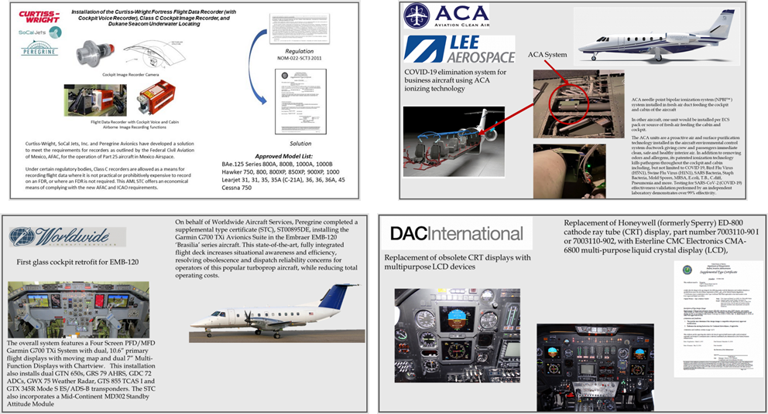

Figure 1: A gallery of our other recent projects follows...

These images contain textual information that is not “crawlable” by search engines and do not trigger keyword recognition for search engine optimization (SEO) algorithms.

### AGG proposes to:

1. Expand the “Project Gallery” to include information for the STC projects that Peregrine has undertaken to date.
2. Develop each element of the project gallery as “web content” that will be available to search engines and SEO algorithms.
   1. AGG will develop a template for the gallery elements.
   2. Peregrine will provide, upon AGG inquiry, with details necessary to complete each project gallery element.
   3. AGG will create the content for each project gallery element.
   4. Peregrine will provide a timely review to ensure accuracy of the developed information.
3. Assign keywords to further enhance web recognition of Peregrine project information.
4. Make each project addressable so that links elsewhere in the website can directly take the visitor to the specific project description. For example, when the website visitor clicks on a featured project on the home page, they will be taken to the specific project in the gallery of projects.
5. Each project in the project gallery will have cross references to:
   1. Press releases (if applicable).
   2. STC and AML information.
   3. Availability and “contact us” for more information or quotation.
6. In addition to the project gallery elements being addressable for direct access, the gallery will be scrollable so that the visitor can gain an appreciation of the total scope of the work performed by Peregrine.
7. A search feature on the gallery page will allow for selection of information from the project gallery presentation.

# STC Page

The primary goal of revenue generation includes, in addition to direct sales, conversion of Peregrine web site from visitors to “buyers”. As such, AGG activities are aimed more and repeatable visitor/ buyer revenue generation.

The STC page allows visitors to sort, search and download STC and AML documents as available from the FAA. Also, a link is provided to the company providing the STC.

### AGG proposes to:

1. Restructure the STC table to allow for better interpretation by search engines and SEO algorithms.
2. Add links to the project gallery for further information about the project related to the STC.

# Client Page

### AGG proposes to:

1. Add links and other cross references between clients, customers and project sponsors to visually connect logos to projects, STCs and press information.
2. Include, expand client testimonials.

G150 Flap and Slat Heater Email and Web Campaign

# Summary

AGG recognizes that the G150 flap and slat actuator heater STC offers a prime revenue opportunity by targeting operators, brokers and service centers regarding the details of this STC.

# Campaign Work Product

Develop, maintain and adjust, as needed, promotional activities such as the website, email, physical collateral and campaign plan, thus stimulating sales of the G150 slap slat actuator heater STC and kitting.

### AGG proposes to:

1. Develop specific website pages that feature this project and lead potential customers to learn more about this STC.
2. Develop marketing material, press releases, white papers and collateral as appropriate to distribute over the course of the campaign.
3. Develop a target list of potential customers, including operators, service centers and brokers, including:
   1. Email, where available.
   2. Physical address where available.
   3. Curate a list of press contacts to enhance coverage of this STC that includes subcontracting with press release vendors, if desired by Peregrine.
4. Through a combination of Mailchimp and physical mail piece distribution, each target will be touched through one or both means.
5. Specific response mechanisms will be created to track responses and gauge effectiveness of the campaign as measurable by the campaign targets’ responses.
6. AGG will provide regular reports, as needed, to Peregrine detailing:
   1. Mailchimp response information.
   2. Website engagement information.
   3. Email response information.

Proposal Pricing and Schedule

# Summary

AviaGlobal Group, LLC (AGG) views these projects as distinct additions to the current website maintenance and this proposal replaces the current structure currently provided to Peregrine.

# 2022 Website and Marketing Proposal

1. Price: $6k per month retainer for 12 months (includes current maintenance activity)
2. Milestones:
   1. Storyboard for website updates 30 days ARO
   2. Draft project gallery elements 60 days ARO
   3. Launch of initial website content update 90 days ARO
   4. Completion of updated website content & SEO 120 days ARO
   5. Website maintenance Ongoing
   6. Identify, develop, execute concurrent specific  
      marketing promotions As identified and agreed

## Initial Concurrent Specific Marketing Promotion

G150 Flap and Slat Heater Email and Web Campaign Detail

1. Milestones:
   1. Storyboard for campaign 30 days ARO
   2. Launch of Mailchimp and/or mail piece 60 days ARO
   3. Campaign endpoint 90 days ARO
2. Embedded services:
   1. Additional website plug-ins and template enhancements will be billed to Peregrine
   2. Third-party press or mailer agency services will be priced to Peregrine for approval

Potential Follow-on Concurrent Specific Marketing Promotion Campaigns

* Curtiss-Wright Fortress FDR
* ACA and Lee Aerospace C560
* Worldwide Aircraft Services EMB-120 glass cockpit retrofit
* Other Peregrine revenue-generating STCs