February 17, 2022

David Rankin, President  
Peregrine Avionics LLC  
7385 South Peoria Street, Unit C4  
Englewood, CO 80112 USA

RE: Amendment 1 - Business Growth Enhancement Proposal

Referencing our telecon of February 9, 2022, and your email of 01 Feb 2022, we propose the following amendment to the Business Growth Enhancement Proposal as agreed with effective date of 01 February 2022.

1. The term of the Website Enhancement activity is six (6) months as previously agreed, and the term may be extended by mutual agreement.
2. The term of the G150 Flap Slat STC campaign is twelve (12) months, and the term may be extended by mutual agreement.

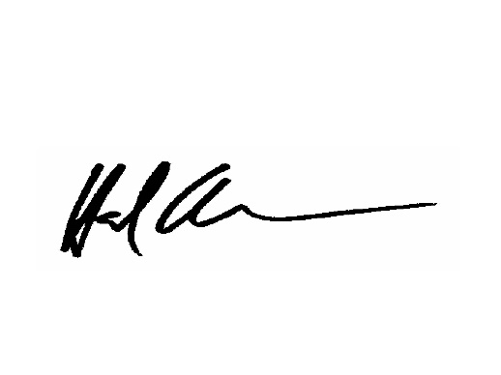Trust this meets with your approval. Please advise of your acceptance.

Very best regards,

Hal Adams

*Co-Founder & Managing Partner*

*AviaGlobal Group, LLC*

*cc: K. Gould, T. Bailey*