Next Generation Air Transportation System (NextGen)

The Next Generation Air Transportation System (NextGen) is a large-scale FAA initiative to modernize the U.S. National Airspace System (NAS).

Through NextGen, the FAA has revamped air traffic control infrastructure for communications, navigation, surveillance, automation, and information management to increase the safety, efficiency, capacity, predictability, flexibility, and resiliency of U.S. aviation. NextGen’s scope includes airport infrastructure improvements, new air traffic technologies and procedures, and safety and security enhancements.

NextGen also helps to reduce aviation’s effects on the environment. The FAA supports programs to facilitate sustainable aviation fuel uptake as well as aircraft and engines that lower fuel consumption and emissions.

We engage with the public and share practices with the aviation community to accelerate the adoption of innovative technologies. The FAA and its partners have implemented new technologies and capabilities, which are leading to a new way of managing air traffic known as Trajectory Based Operations (TBO).

Our modernization initiative enables a more flexible — yet robust and resilient — aerospace infrastructure that ensures the safe introduction of non-traditional aviation, such as commercial space transportation and advanced air mobility.

Through research and collaboration, NextGen is defining new standards and further advancing our global leadership in aviation. The FAA fosters international cooperation in evolving enhanced aviation technologies to improve airspace system safety and mobility around the world.

Explore the past, present, and future of NextGen.

[**Background**](https://www.faa.gov/nextgen/background)

The United States has the world’s busiest and most complex airspace system. Spurred by forecasts of increased air traffic, the FAA started NextGen to make flying safer, more efficient, and more predictable.

[**NextGen Today**](https://www.faa.gov/nextgen/today)

NextGen capabilities are active and expanding at locations across the nation.

[**Future NAS**](https://www.faa.gov/nextgen/future)

The FAA is looking to further improve NAS operations through TBO and introducing a vision for an information-centered system built for diverse operations.

[**Performance Reporting and Benefits**](https://www.faa.gov/nextgen/reporting-benefits)

NextGen improvements have realized benefits that we have measured by year and type. Benefits will accumulate over time as NextGen pursues its integral contribution to the U.S. airspace, economy, and flying public.

**Documents**

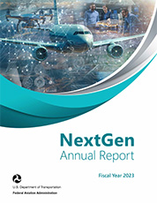  
[NextGen Annual Report, Fiscal Year 2023](https://www.faa.gov/nextgen/NextGen-Annual-Report-2023.pdf)

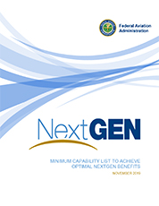  
[Minimum Capability List to Achieve Optimal NextGen Benefits, November 2019](https://www.faa.gov/sites/faa.gov/files/about/office_org/headquarters_offices/ang/Minimum_Capability_List_to_Achieve_Optimal_NextGen_Benefits.pdf)

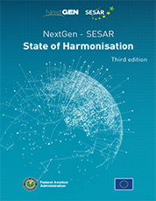  
[NextGen – SESAR State of Harmonisation Third Edition, September 2018](https://www.faa.gov/nextgen/nextgen-sesar-state-harmonisation)

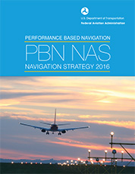  
[PBN NAS Navigation Strategy, September 2016](https://www.faa.gov/nextgen/pbn-nas-navigation-strategy)

**Additional Documents**

* [NextGen Advisory Committee (NAC) Documents](https://www.faa.gov/about/office_org/headquarters_offices/ang/nac/)
* [NextGen Implementation Plans](https://www.faa.gov/nextgen/background/accomplishments)