Trajectory Based Operations (TBO) is an air traffic management (ATM) concept that enhances strategic planning of aircraft flows to reduce capacity-to-demand imbalances in the National Airspace System (NAS), and provides tools to air traffic management personnel and controllers to help expedite aircraft movement between origin and destination airports. Through improved strategic planning and management of traffic flows, TBO helps reduce reactive decision-making and use of static miles-in-trail restrictions.

Aircraft trajectory is the core tenant of TBO. Defined in four dimensions - latitude, longitude, altitude and time - the trajectory represents a common reference for where an aircraft is expected to be - and when - at key points along its route. The trajectory is defined prior to departure, updated in response to emerging conditions and operator inputs, and shared between stakeholders and systems. The aggregate set of aircraft trajectories on the day-of-operation defines demand, and informs traffic management actions. A "day-of operation" refers to operating conditions during the day an operation takes place, including equipment outages, weather, airport conditions, airline delays and cancelations, and other temporary conditions in the NAS.

The key elements of TBO include:

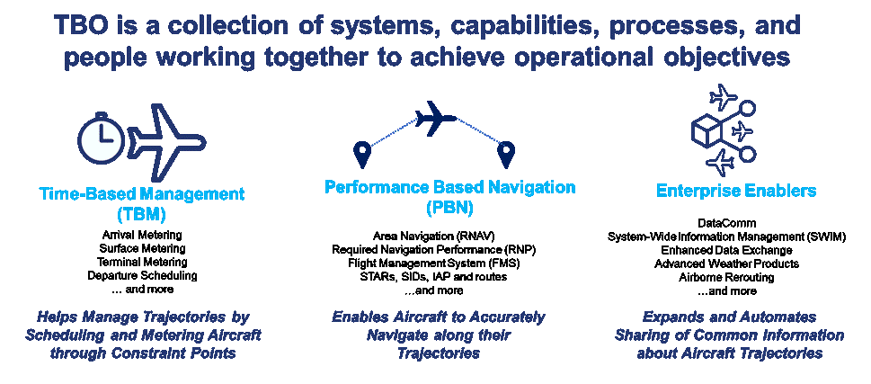

* Time Based Management (TBM), which helps manage traffic flows and trajectories by *scheduling* and *metering* aircraft through congested NAS resources or constraint points.
* Performance Based Navigation (PBN), which enables aircraft to more accurately navigate along their trajectories, and enables decision support tools to improve *feasibility of schedules* for constraint points as well as achieve greater *compliance to schedules*.
* Enabling Technologies, which expand and automate sharing of common information about aircraft trajectories, and include System-wide Information Management (SWIM), Data Communications, enhanced data exchange and many others.