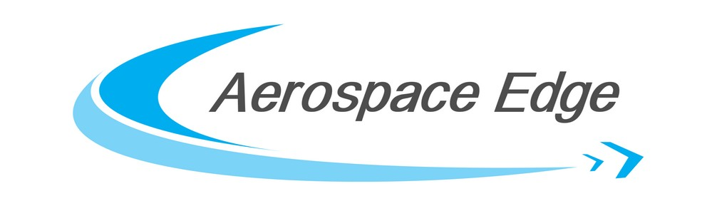

December 31, 2023

**Invoice: 013-23-B**

|  |  |  |
| --- | --- | --- |
| Qty 1 | DMARC Services 2023 | $78.75 |

Aerospace Edge subscribes to DMARC[1] services for several websites and has apportioned the 2023 costs across each website.

In June 2022 we added DMARC protection for the Peregrine.aero domain using DMARCIAN. In June 2023, we changed providers to a more economical provider, PowerDMARC to secure and protect our domains and Peregrine.aero. By apportioning the total cost across several domains, the cost to Peregrine has been reduced.

1. **Domain-based Message Authentication, Reporting and Conformance** (**DMARC**) is an email authentication protocol. It is designed to give email domain owners the ability to protect their domain from unauthorized use, commonly known as email spoofing. The purpose and primary outcome of implementing DMARC is to protect a domain from being used in business email compromise attacks, phishing email, email scams and other cyber threat activities. (https://en.wikipedia.org/wiki/DMARC)