



*Final Report*

Phase 1 Consulting Agreement

RAMI European Antenna Business Development Opportunity

*xx June 2020 (DRAFT)*

*AviaGlobal Group LLC*

*Prepared by Forrest Colliver*

*AGG-RAM-202005-001*

Table of Contents

Introduction 4

An Industry in Transition 5

The Macroeconomic View 5

Direct Effects of the Pandemic on the Aerospace Community 5

An Economic Shift in Progress 6

Progress toward Recovery 6

Evolution of Key Market Sectors Post-COVID 7

Tracking the Evolution of COVID-19 Impact on Aviation 8

Effect on Commercial Air Transport 9

A Slow Return for Commercial Airlines 9

Evolution in Airline Fleets resulting from the Pandemic 11

Retirements of Older Aircraft Already in Progress 11

Near-Term Recovery Favors the Airframe OEM Supply Chain 13

Effect on Business/Private Aviation 14

Demand for New Business Aircraft Has Declined Less Than Expected 14

Shift in Preferred Aircraft Types 14

Growth in First-Time Customers 15

The Current Situation 16

Effect on the Rotorcraft Aviation Sector 18

Dual Impact of Oil Price Wars and the COVID-19 Demand Drop 18

The Effect on Commercial Helicopter Utilization 18

Restructured Aerospace Supply Chain 20

Industry Consolidation 20

Which enterprises have the best chance of survival? 21

Effect on the MRO Sector 23

Key Takeaways for the MRO Sector 24

What does this mean for RAMI? 26

RAMI Business Opportunities in Europe 26

Proposed European Business Capture Strategy 27

Table of Figures

Figure 1: Potential Fleet Recovery Scenario (Fixed Wing - Air Transport) 10

Figure 2: Aircraft Type Winners & Losers 11

Figure 3: Parked Aircraft by Age 12

Figure 4: Parked Aircraft by Type 12

Figure 5: Relative Flight Activity among Private Aviation Aircraft Types 15

Figure 6: Potential Restructuring of Supply Chain 20

Figure 7: Distribution of Liquidity Risk 21

Figure 8: Companies Exposed to the Commercial Aftermarket 22

Figure 9: MRO Spend Forecast by Category 23

# Introduction

This report details the analysis performed by AviaGlobal Group LLC under Phase 1 of the Consulting Agreement dated 20 April 2019, and Amendment 1 dated 11 September 2019, and contains the deliverables for Step 2 and Step 3 of that agreement.

In spite of pessimistic media messages concerning the economic health of the aerospace community, the key recommendations of the Step 1 report remain sound. Our assessment is that RAMI has good reason to launch its European business development activities as soon as possible, including pursuit of a European business *and* production presence.

The key recommendations in Step 1 of this analysis, presented to RAMI in November 2019, are as follows:

1. RAMI’s business model is well-oriented toward a B2B structure, which leads to opportunities with airborne and ground-based systems manufacturers, airframe manufacturers, and systems integrators, both civilian and military. General Aviation (GA) customers may also be reached in a B2B fashion, through dealers and distributors.
2. RAMI’s strong vertical integration culture is a natural fit for the B2B markets, building Original Equipment Manufacturer (OEM) confidence in RAMI’s ability to deliver on time and with quality, and allowing RAMI to control both supply chain and quality performance to meet customer expectations.
3. Key markets identified in the Step 1 deliverable include European fixed wing, rotary wing and military trainer airframe manufacturers serving commercial, military, governmental and business aviation, as well as their tiered supply chain. Maintenance and Repair Organizations (MROs) were identified as a key channel to aftermarket opportunities in these sectors, along with OEMs at various tiered levels.
4. The state of the commercial aviation industry was identified in the Step 1 deliverable as healthy, presenting opportunities for growth forecast in fleets across the world from 2019 to 2024 on average around 3.9%, and with a growth forecast for MRO business on average around 3.4%.

While the growth previously anticipated has certainly been impacted by the pandemic, key players in the European aerospace industry have already launched their COVID-19 recovery efforts, targeting the expected uptick in demand for new airframes over the next several years. In particular, our conclusion is that timing is opportune for RAMI to engage with European OEMs, Tier 1 suppliers and MROs for the long run, with a special focus on antenna supply to private/business aviation, trainer, and rotorcraft markets.

# An Industry in Transition

## The Macroeconomic View

The aerospace industry and the global economy have been impacted significantly by the pandemic, particularly in the following aspects:

* As the reality of the contagion of COVID-19 became apparent, there has been panic over human contact, leading to the near-total shutdown of commercial passenger traffic worldwide for several months and to the parking of aircraft on a grand scale.
* This has led to a massive loss of global and domestic “lift”, affecting both passengers and freight, and including fixed-wing and rotor craft operated in both commercial and public service.
* Unemployment levels and liquidity issues not seen since the Great Depression are widespread.
* Closure of international borders and regional supply shortages are leading to reinforcement of protectionism, contention among markets, and to inefficient supply chains.
* Demand recovery in the commercial airline sector looks to be three or more years away. The resulting drop in commercial aerospace market demand is impacting all sectors of aerospace, even defense.
* This appears to be setting the stage for a restructuring of the aerospace supply chain, with a focus on consolidation and regionalization. Larger companies will tend to absorb the smaller ones, with a trend toward greater vertical integration. Merger & acquisition (M&A) activity is likely to accelerate.

## Direct Effects of the Pandemic on the Aerospace Community

* Return to airline passenger levels of Dec 2019 will likely require 3 years or more, while business and private aircraft will return to service more quickly. This is the result of health safety measures already being deployed, and as a result of commercial passengers becoming “first-time” business/private aviation clients, perhaps permanently.
* Many passenger aircraft are being converted to freighters or are being placed in freight service.
* Non-combat & non-essential military missions will be reduced, to reduce cost & protect personnel.
* Operators of public safety & medical support rotorcraft and fixed wing aircraft will continue to see demand, as needed health safety measures are already being deployed to protect flight crews.
* Parked aircraft will disrupt the business of aircraft OEMs, equipment suppliers, component suppliers and MROs for several years, through return-to-service and part-out opportunities from the boneyards.
* Certain aircraft types may disappear entirely, both in commercial and private aviation, with a clear trend already evolving toward smaller gauge fuselages and more flexible navigation capabilities.
* On a broader economic level, bankruptcies and/or fiscal distress of smaller enterprises is likely, while larger critical enterprises will more likely enjoy bailouts. In any case, healthy employment levels in aerospace will require years to recover.

## An Economic Shift in Progress

In order to assess interest in new business development, such as RAMI envisages in Europe, it is essential to understand the economic challenges faced by the industry overall.

The key issues the industry is facing include the depth and duration of the dip in passenger demand for the case of the airlines worldwide, the corollary effects of this demand shift on the rest of the business, freight and general aviation operations, and the effect of the pandemic on the aerospace supply chain across the board. In addition, it is essential to understand the impact on MRO operations as commercial aircraft maintenance requirements decline due to the high number of parked or mothballed aircraft.

While the RAMI business interest may not primarily be in the commercial aircraft market sector (i.e. the sector served largely by Airbus and Boeing), this sector’s sudden and dramatic demand drop is producing snowball effects throughout the aerospace industry supply chain that will impact private, governmental and military aviation as well as offering potential opportunities in the changing landscape. For example, according to Aviation Week, even the Lockheed Martin F-35 production line is being slowed due to supply chain inefficiencies, with LM declaring a likely 15% reduction in production during 2020 over that realized in 2019. In addition, continued demand for commercial freight lift will manifest itself in structural changes in how that freight is carried, and the change in fleet mix will affect the types of commercial and private aviation airframes that survive this restructuring.

This report addresses the likely shifts in the air transport, business & private aviation and rotorcraft market sectors, as well as in the aerospace supply chain. Subsequently we will address conclusions and recommendations for the RAMI business interests in Europe, in particular.

## Progress toward Recovery

During the last three months, AviaGlobal Group has been in contact with numerous domain experts and industry sources, in order to seek a solid basis for the content of this report.

The industry has already initiated recovery steps; the most lucrative opportunities usually arise from presence in the recovery phase following a crisis.

It is very clear that the aerospace industry has been engaged in broad recovery planning since early March, assessing economic damage and seeking ways to get aircraft back in the air. To do nothing is simply not tenable. And as observed above, the opportunities will be most lucrative for those companies that take part in the recovery, and for those companies that take advantage of the various types of restructuring that is likely during the recovery. This includes merger & acquisition opportunities, as well as opportunities presented by the expected shift toward smaller gauge aircraft, both commercial and private, and the expected growth in first-time clients for private aviation operators.

Commercial aviation is taking tentative steps toward a return to service. For example, Delta has indicated that occupancies on certain flights are expected to approach 60% by summer.

Most of the industry experts forecast a slow return of airline passenger traffic starting during the summer of 2020, assuming that the spread of the virus is largely controlled by end of the summer and assuming that public confidence in the health practices of airlines is restored. Any second-wave activity of the corona virus will potentially delay this restart, however.

On a more positive note, encouraging signs are emerging in the business and private aviation market, with traffic up in both the US and the European Union during the month of May 2020.

On the other hand, one of the more positive trends we have seen is that business and private aviation are expected to recover more quickly than commercial air transport, with flights already picking up at this writing. This market sector is enjoying a rise in first-time customers for a number of reasons, notably that the logistics of safe health operation are simpler, with fewer passengers per flight to screen and smaller cabins to clean. However, a complete recovery even in this sector will likely require 1 to 2 years.

It has been frequently noted though, that the real return to travel, whether by airline or private/business aircraft, will only fully materialize once a vaccine is in widespread use, once a treatment protocol for COVID-19 has been proven, and once borders are again open.

## Evolution of Key Market Sectors Post-COVID

* Since the freight industry has lost around half of its overall lift with the grounding of most of the passenger fleets worldwide, demand is rising for serviceable aircraft of almost any gauge and size to fill this void. Even commercial airlines are starting to conduct freight-only flights, with re-purposed passenger aircraft. Companies and MROs that support freight operations will find increased demand to support the freighter back-fill operations.
* The airline industry is already adopting social distancing and related health practices to allow passengers are to regain confidence. This will drive demand for aircraft that can efficiently carry passengers seated with distancing norms far in excess of today’s seating approach. What this means is that smaller aircraft will tend to be favored, since the cost impact of a reduced passenger load is less serious than that experienced with a larger or wide-body aircraft. This will clearly favor bringing more regional aircraft (back) into service.
* Demand for public safety lift, particularly rotorcraft, will certainly be maintained, and will likely grow in support of medical and police operations.
* Demand for business aviation is already growing, and that sector is expected to continue to grow, as a replacement for corporate and executive travel on airlines. However, the industry will need to adapt to new “first-time” private aviation clients, providing them with an experience that effectively replicates the positive aspects of their commercial air transport experience, in terms of departure amenities (shopping, dining, etc.) and on-board amenities (dining, entertainment, etc.).
* The larger maintenance shops that will survive post-COVID will see gradual increases in business in support of modifications and return-to-service operations for smaller or retired aircraft.

## Tracking the Evolution of COVID-19 Impact on Aviation

As should be quite evident, the evolution of the pandemic impact in aviation is fluid, and depends on a number of external and in some cases unrelated factors. The following reference in Wikipedia may be useful in tracking this impact as it evolves:

<https://en.wikipedia.org/wiki/Impact_of_the_COVID-19_pandemic_on_aviation>

# Effect on Commercial Air Transport

As noted earlier, the profound effect in this sector has been the sudden loss of nearly all commercial air transport lift capacity on a global basis. At this writing, on average, only around 5% to 10% of commercial flights are operating, although the sign of a recovery is emerging.

## A Slow Return for Commercial Airlines

Figure 1 on Page 10 (from Oliver Wyman[1]) illustrates the depth and duration of the problem facing airline passenger operations, following a perhaps optimistic hypothesis that commercial air traffic will largely recover to 2019 levels within two years. It should be noted that a number of industry analysts consulted in the preparation of this report are somewhat more pessimistic on the timing, seeing potentially a three to five-year period as more likely. And the consensus among analysts is that regardless of the timing for a return in passenger traffic, a number of airline companies worldwide are likely to either be absorbed or go out of business entirely.

It is expected that sale of new commercial aircraft will be significantly reduced during this period, given the thousands of parked aircraft and the huge inventory of certain models, such as the B737 MAX, that will need to be exhausted before newly produced aircraft can be sold.

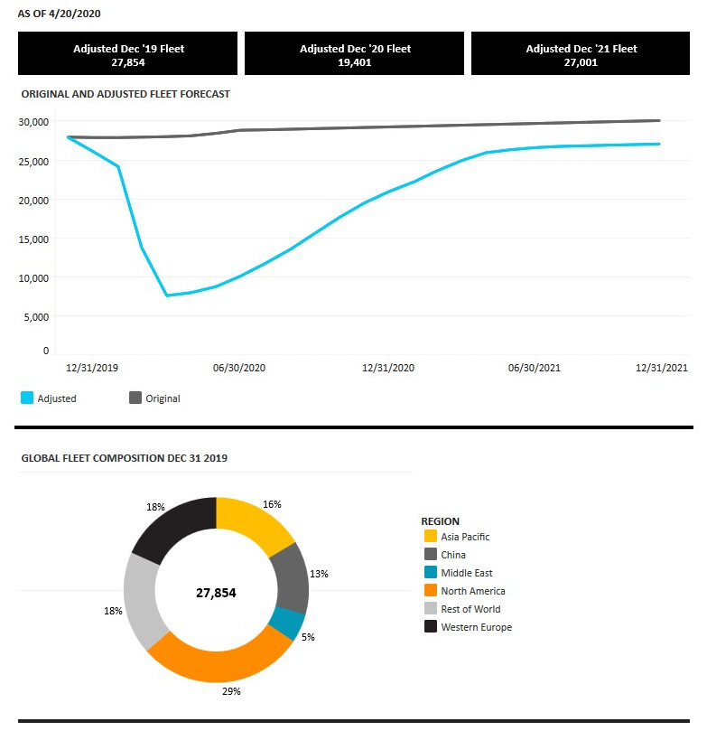

Figure : Potential Fleet Recovery Scenario (Fixed Wing - Air Transport)

## Evolution in Airline Fleets resulting from the Pandemic

The industry consensus is that it is unlikely that demand will recover for current production 4-engine and long-range aircraft, such as the A380, the B777 classic and the A330neo. On the other hand, smaller gauge and more efficient aircraft, such as the A350, the B787 and the A220 will be the likely winners once the recovery is in place. The B737 and the A320neo are also well placed, but the huge inventory of 737 MAX aircraft already on the ground will delay any positive return for Boeing for several years.

See Figure 2 below for a comparison of the likely commercial airframe winners and losers.

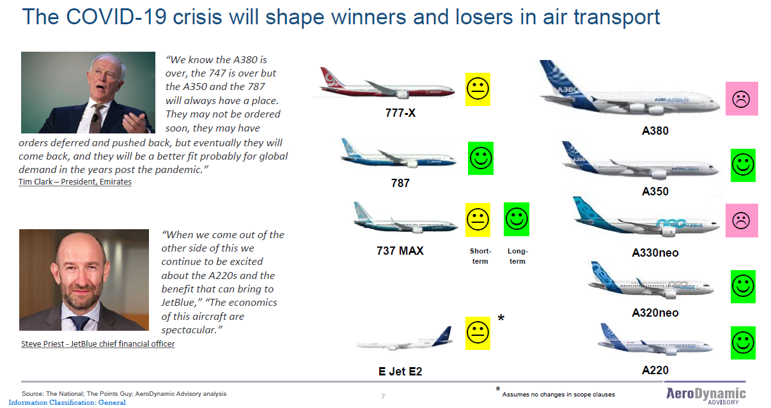

Figure : Aircraft Type Winners & Losers

## Retirements of Older Aircraft Already in Progress

Related to this point, a number of retirements have recently been announced. For example, Delta just announced retirement of its 777-200 classics, although American and United intend at this point to continue 777 classic operations. Delta has also announced the retirement of its MD88/MD90 fleet, with the aircraft to be replaced by Delta's Airbus A320 family aircraft as well as the Airbus A220 series. There have also been a number of retirements announced for the Bombardier CRJ and Embraer ERJ families. Most notably, American has announced the retirement of its E190 fleet, and JetBlue has announced the retirement of their E190s, to be replaced by Airbus A220s. Air Canada is taking the same approach as JetBlue, retiring its E190s in favor of new A220s.

It appears that commercial aerospace is about to enter an era with few MDs, ERJs, CRJs, 757s, 767s, 747s and no A380s and where the 777 and A330neo occupy a middle question mark ground. Remaining solid players are the B787, A350xwb, B737, A320neo and the winning Airbus bet on the A220.

It is also expected that there will be advanced retirements of older aircraft, particularly those aged 15 years or older. Figure 3 and Figure 4 below illustrate the dynamics of this transition.

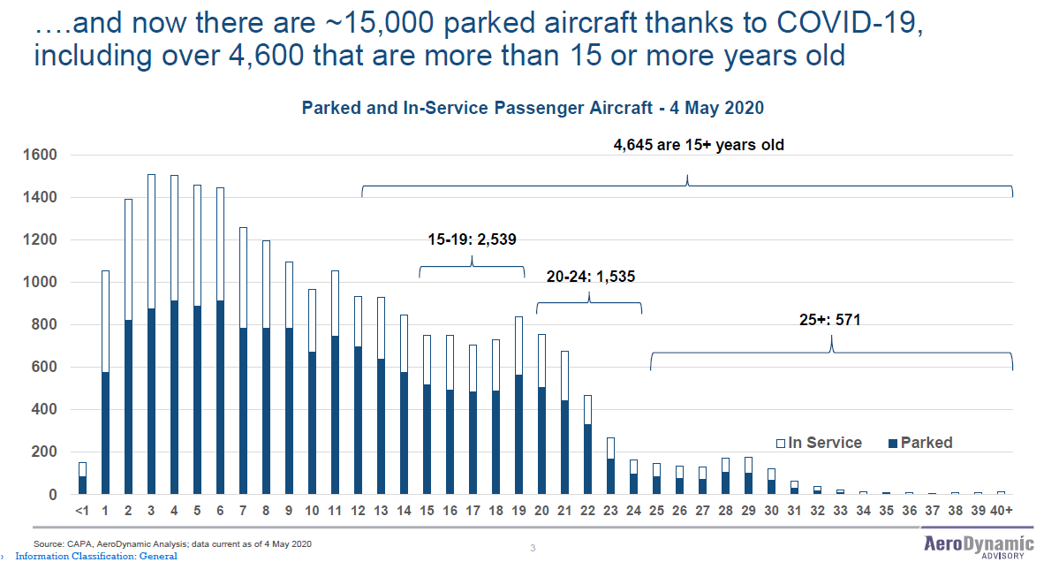

Figure : Parked Aircraft by Age

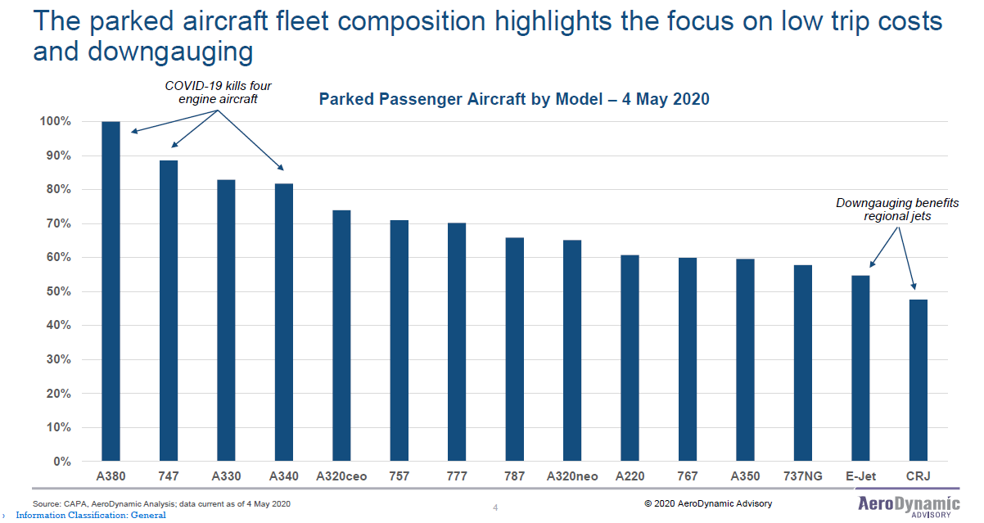

Figure : Parked Aircraft by Type

## Near-Term Recovery Favors the Airframe OEM Supply Chain

In summary, while commercial aviation has been significantly impacted, the industry consensus is that recover to near-2019 levels is possible. This recovery is likely to take several years, and will lead to structural changes in the fleet in any case, along with retirements of older aircraft. Structural changes in the commercial airline sector primarily favor smaller gauge and newer more efficient aircraft, which means that the aftermarket industry targeting the maintenance and sustenance of older aircraft is likely to suffer. Doing business in this sector indicates alignment with the OEM supply chain as a better near-term strategy than pursuing older aircraft and the aftermarket.

# Effect on Business/Private Aviation

Business/private aviation has been in transition since the 2009 financial crisis, from which the sector never fully recovered. On the whole, one could consider the sector roughly flat during the first part of the 21st century. However, a number of key factors are thought to be different as concerns the COVID-19 downturn, being essentially unrelated to the underlying financial and business concerns encountered post-2009. As observed earlier, once means are widely available to counter the pandemic spread, such as vaccines, treatment protocols, physical distancing practices and appropriate sanitary procedures, there is no reason that this sector would not rebound, and in fact prosper. This is primarily due to the comfort passengers will likely feel traveling in less crowded and easier to manage physical conditions.

## Demand for New Business Aircraft Has Declined Less Than Expected

In fact, Aviation Week has recently reported that OEMs in this sector, including Gulfstream, Dassault, Embraer and Bombardier, are not seeing the wave of cancellations that was initially feared. They were impacted by an inability to deliver due to travel restrictions in place since March 2020. However, in general, they expect to resume deliveries once travel is once again possible.

Business aircraft OEMs expect to see demand return within the next two years, essentially at the same pace as that required to mitigate the pandemic, in terms of available COVID-19 vaccines, treatment protocols, and sanitary practices.

This said, some of the big charter and fractional operators are reducing their delivery commitments for 2020, for example with NetJets now planning to take delivery of 25 Bombardier aircraft in lieu of the planned 60 this year. The OEMs have also been affected by the slowdown in the global supply chain affecting all sectors of aviation. But much of this supply chain started to reopen in May, so the industry is guardedly optimistic. The key risk that the industry is facing now is the potential of a recession to follow the pandemic. Assuming that this economic risk is managed on a global scale, the recovery will likely proceed apace, with business jet deliveries reaching 85% of 2019 levels by end-2021, according to analysts at JP Morgan. 2020 will continue to see a delivery downturn of the level of 30% to 40% reduction over plan.

## Shift in Preferred Aircraft Types

One structural change that is expected in the sector however is that the aircraft types that will be preferred post-pandemic are likely to change. As with the commercial sector, long-haul business/private aviation flights are expected to lag continental or domestic flights, due to the extensive border restrictions in place internationally. Although this situation is expected to ease by the fall or 2020, regaining the pre-pandemic rhythm of international flights will take time. For this reason, the boom in large-cabin long-range business jets that has been seen over the past decade is likely to end, while demand for smaller gauge aircraft will increase.

Unlike the recovery from the 2009 financial crisis where large cabin jets were favored and the smaller aircraft market suffered, the industry consensus is that this lucrative market will likely not recover at anywhere near the pace of the smaller aircraft market.

As with commercial airline demand, there is a shift in progress toward smaller cabins in business & private aviation.

According to Aviation Week’s analysis, this is expected for two reasons. Firstly, continued low oil prices which directly impact the energy extraction industry, a key user of long-range private aircraft, and secondly, the dependence of the large cabin market on the mainstay of business aircraft use, the high-value corporate traveler. To the extent that the economy goes into recession, and that corporate profits continue to be impacted, it is expected that these core constituencies for business/private aviation could decline in numbers.

See Figure 5 below (Source: Argus International FlightTrak) for a comparison of the year-on-year flight activity of the various categories of business aircraft.

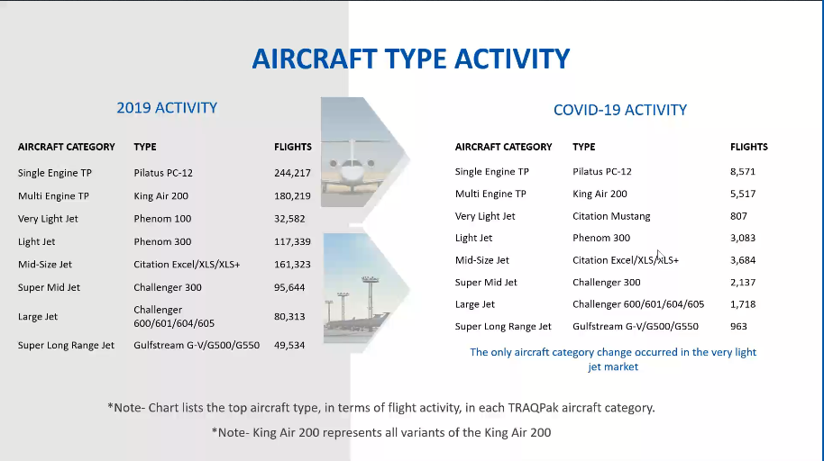

Figure : Relative Flight Activity among Private Aviation Aircraft Types

## Growth in First-Time Customers

On the other hand, one constituency that has propelled around 70% of the recovery to-date in private aviation traffic is the business or leisure traveler who would normally fly commercial. These clients are new to private aviation and are seeking a safe way to fly, avoiding airlines for the time being. This has been quite a near-term boon to the private aviation industry, but what is not known is how durable this boom in first-time private aviation travelers will be. It is clear that private aviation presents advantages for business travel, particularly for corporations seeking safer ways to transport employees and for more efficient point-to-point routing. If commercial airlines are seen as potentially unstable, the case for the shift of routing business travel to private aviation becomes even stronger.

The Business/Private Aviation sector is seeing a trend emerge in terms of the rapid growth in first-time fliers.

It seems reasonable to conclude that whatever happens, the strength of demand for continental/domestic private aviation flights should remain strong, even if there is no dramatic overall growth gained from the current wave of first-time “airline converts”.

One interesting outcome of this shift with respect to RAMI’s core antenna business is that a number of these smaller aircraft are not yet equipped with ADS-B, particularly in Europe. Further, the European mandate date has now been slipped significantly, to June 2023 for aircraft holding a certificate of operation issued between 1995 and 2020, i.e. pretty much the entire fleet. And finally, the global trend toward satellite-based ADS-B means that top-mount antennas will be required, while many aircraft do not have a mounting position available. We envisage a business opportunity in this area, as the dual-band antennas RAMI offers for top-mount application avoid the need for a second mount position.

## The Current Situation

The National Business Aircraft Association (NBAA) has offered this assessment in its 15 June 2020 edition of Insider daily:

*“America is leading the recovery in business aviation activity with flights operated in June down 31 percent, slightly ahead of the 34 percent decline experienced through the first nine days of the month globally, according to the latest data from business aviation analyst WingX. Europe is lagging in the recovery with flights down 50 percent this month, WingX reported, with Asia and Africa 35 percent below June norms. Since the beginning of May, business aviation activity has been down 47 percent globally.*

*From a rolling seven-day daily average standpoint, Europe is seeing improvements. The region has gone from a low point of 375 departures per day in early May to 1,117 by June 9. Germany is the busiest of the European markets, while France, typically the top market, is still down 60 percent. Spain, Italy, and the UK remain among the hardest hit with operations down 70 percent.*

*The UK did see a resurgence leading up to the June 8 enactment of mandatory quarantines for international visitors but then experienced “precipitous declines” after that day. The number of flights fell from 100 on June 7 to a little more than 30 on the 8th and 9th.*

*WingX continues to see the shift toward lighter aircraft, with activity involving super-midsize, midsize, and super light jets down 35 percent this month. This compares with the 50 percent declines involving ultra-long range and heavy jets and 80 percent for bizliner traffic.”*

In summary, while there has been a drop in business/private aviation activity, recovery favors OEMs, MROs and suppliers supporting this sector in the near-term. And as noted above, delays in the European ADS-B mandate effective date and the shift toward maintenance and support of smaller aircraft offers opportunities for suppliers such as RAMI in both the OEM and aftermarket support.

# Effect on the Rotorcraft Aviation Sector

Industry consensus is not yet clear on the net overall effect of the COVID-19 pandemic on the commercial helicopter industry. For the time being, the overall impact has not been dramatic, but a number of rotorcraft have been re-purposed toward medical and public safety missions specific to the COVID-19 environment, as for the case of the surge in first-time users of business/private aviation.

Helicopters tend to be purpose-oriented, mission-specialized and privately operated. Other than commercial operations such as passenger transfer or sightseeing flights, the consensus among analysts is that the helicopter market will not be hit as dramatically as the fixed wing aviation market by current restrictions on tourist travel.

## Dual Impact of Oil Price Wars and the COVID-19 Demand Drop

However, there is a second factor in play for the helicopter sector, as much of the current helicopter market is related to the energy extraction industry, particularly the offshore oil and gas industry.

The helicopter sector is heavily dependent on the fortunes of the energy extraction industries worldwide, which have been seriously impacted by the demand drop during the COVID-19 pandemic. At the same time, Russia and Saudi Arabia have launched an oil price war, dropping prices and destabilizing OPEC.

Since the demand for oil has dropped substantially due to the drop in consumption by the transportation industry overall, so have oil prices. And in addition to this, there have been a renewal of geopolitical price actions in the oil and gas markets, particularly involving Russia, the USA and Saudi Arabia. The ultimate outcome of these price wars is unclear, but analysts expect oil prices to remain lower that usual for at least two years. Worldwide crude oil prices will average $38 per barrel for 2020 and $48 per barrel in 2021, according to the Short-term Energy Outlook published by the U.S. Energy Information Administration (EIA). This in spite of a relatively strong start in January 2020 at $60 per barrel.

## The Effect on Commercial Helicopter Utilization

According to a recent report by the IBA Group Ltd[2]:

*“Commercial helicopter utilization and value is primarily measured against the high end, larger heavy helicopter class that supports the offshore oil and gas industry. Here, interest is gauged by the number of offshore operational platforms in use at the time plus the price per barrel of oil. The original drivers, oil and gas, are today joined by wind turbines, coastguard and search and rescue services: which together drive demand for rotorcraft lift. Although super medium category helicopters, only 3 or 4 years old as a class, are beginning to nibble away at some roles formerly fulfilled by offshore-configured heavy helicopters and reduce operating costs, they have a hefty price tag.*

*The price per barrel of oil heavily dictates demand for commercial helicopters. When oil prices are high, such as the $100 per barrel seen in 2014, approximately 20-25% of all support helicopter utilization is directed towards prospecting for new sources of oil and gas. During oil slumps when prices can sink as low as $25 – $30, exploration for new supplies is deemed unnecessary and helicopter fleets are closely scrutinized for pruning opportunities as demand shrinks. Lower prices for used helicopters results.*

*Currently, the Saudi Arabia vs. Russia oil production price war is affecting OPEC’s stability. With neither nation being prepared to cut production, an oversupply due to falling demand from China has sent prices plummeting. March 15th saw the biggest one-day crash since 1991’s Gulf War and Goldman Sachs predicts oil prices could slump to $20 a barrel.*

*Short term therefore, Covid-19 will adversely affect heli-tourism and private, VIP helicopter use but the pandemic’s impact will be less severe than that felt by short- and long-haul fixed wing carriers. The heavy and super medium helicopter asset classes will however be significantly hit by the recent plunging oil value. Offshore equipped and configured support helicopters will suffer most from GDP contraction; reduced investment in prospecting for new oil and gas resources will cut utilization by 20-25% and stalled growth will result.”*

Bearing some similarity to the opportunities presented in the business/private aviation markets, the increased demand and increased mission requirements placed on smaller helicopter types offers new opportunities to play in both the OEM and aftermarket rotorcraft supply chains.

Thus, to the extent that global oil prices remain lower than around $50 per barrel on average, demand for the super medium and heavy helicopter categories will drop, while the lighter rotorcraft used for public safety applications and for business/private transport missions are expected to be less significantly impacted.

# Restructured Aerospace Supply Chain

Due to the fact that the aerospace supply chain tends to serve all sectors of the aircraft and operations market, including the defense sector, it is likely that there will be consolidation and restructuring across the board. According to Roland Berger, one of two possible post-COVID-crisis industry models could emerge:

1. A more OEM-centric industry model whereby the OEMs consolidate key parts of the supply chain to stabilize and rationalize it.
2. A more balanced industry model between OEMs and key Tier-1 suppliers, where the Tier-1s have consolidated even more, amassed scale and are now on a level playing field with the OEMs.

## Industry Consolidation

In fact, as illustrated in Figure 6 below, the pressure for consolidation at Tiers 2, 3 and 4 will be significant, leading to potential regrouping at these levels under almost any scenario, and there will be motivation at the OEM level to seek closer control and perhaps consolidation with their tier 1 suppliers.

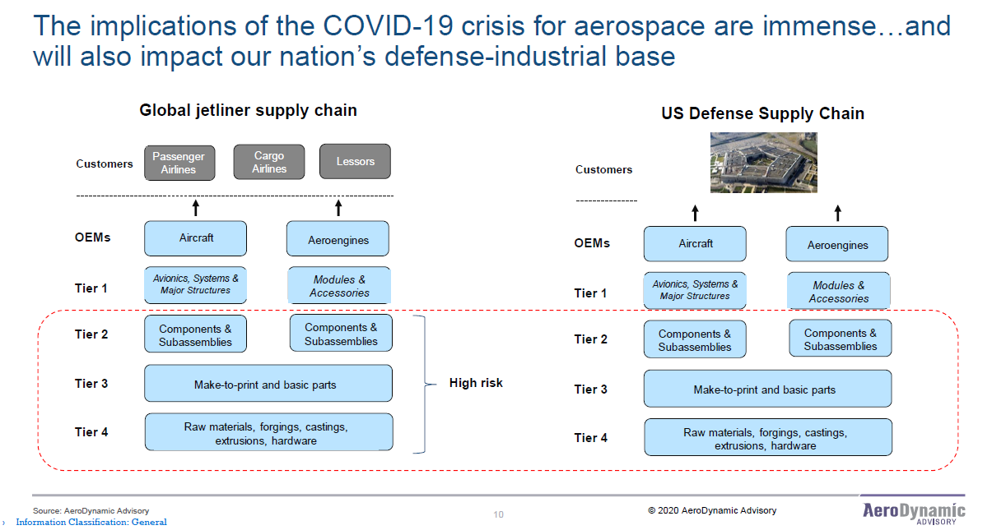

Figure 6: Potential Restructuring of Supply Chain

In addition, since new aircraft sales are unlikely to resume in quantity before 2022, and since MRO activities will be subdued during much of that period, all players in the supply chain will face liquidity challenges, particularly once government support is exhausted later this year. Figure 7 below shows the precarious position of the tier suppliers, since they feed both the new aircraft and the MRO supply chains.

This liquidity risk will be compounded by the huge level of government debt being assumed during 2020 on a global basis, while having a lesser effect on the larger enterprises such as the OEMs and Tier 1 supplier, will continue to disrupt credit accessibility by the Tier 2, 3 & 4suppliers.

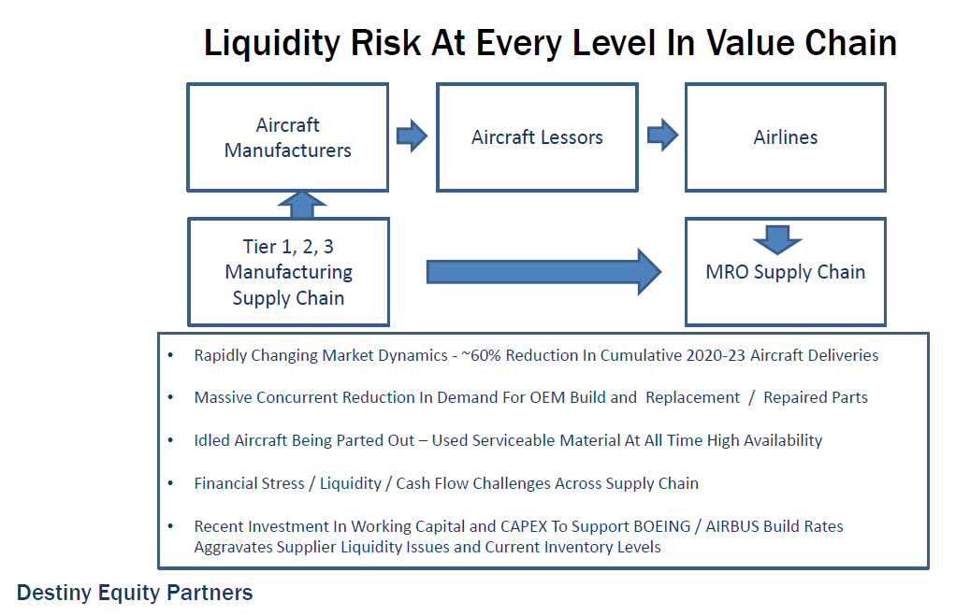

Figure 7: Distribution of Liquidity Risk

## Which enterprises have the best chance of survival?

In the demand environment outlined above, there will be winners and losers in the supply chain and in the industry overall. However, experts agree that there will be across the board support for critical industry, which means that the larger aerospace companies, including many of the major airlines, will be offered financial support. Experts are also predicting that one of the second order effects of the sudden loss of in-service aircraft operations, both civil and military, will be a consolidation in the supply chain, with more of the tier suppliers (Tiers 2, 3 & 4) either going bankrupt or being acquired by the Tier 1 players.

What this means is that the aftermarket will at least be changed, if not weakened, due to the parking and/or retirement of older and larger aircraft in masse. The new aircraft market and its supply chain, while delayed in a recovery that may last 3 or more years, has fewer structural challenges in terms of demand, and will face primarily liquidity challenges in the near term. In addition, companies having a military market backstop will generally be exposed to less risk than those operating purely in the civil sector.

Figure 8 below, from Roland Berger[3], illustrates the relative placement of a representative sample of aerospace companies with respect to commercial aftermarket exposure.

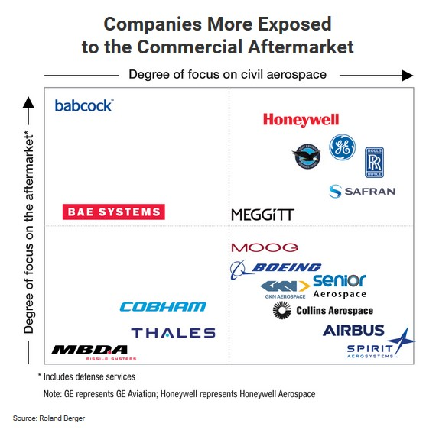

Figure 8: Companies Exposed to the Commercial Aftermarket

# Effect on the MRO Sector

The net result of the large-scale parking of aircraft and early retirement strategy is that the aftermarket industry, comprising component and subsystem manufacturers, MROs, will be impacted, at least for the near and mid-terms. This is due in part to the ready population of aircraft capable of being returned to service when demand returns, and in part to the early retirement of older aircraft to be replaced with newer models when passenger demand returns.

Figure 9 below (from Oliver Wyman) illustrates the expected impact on air transport MRO spending as a result of the widespread grounding of commercial aircraft.

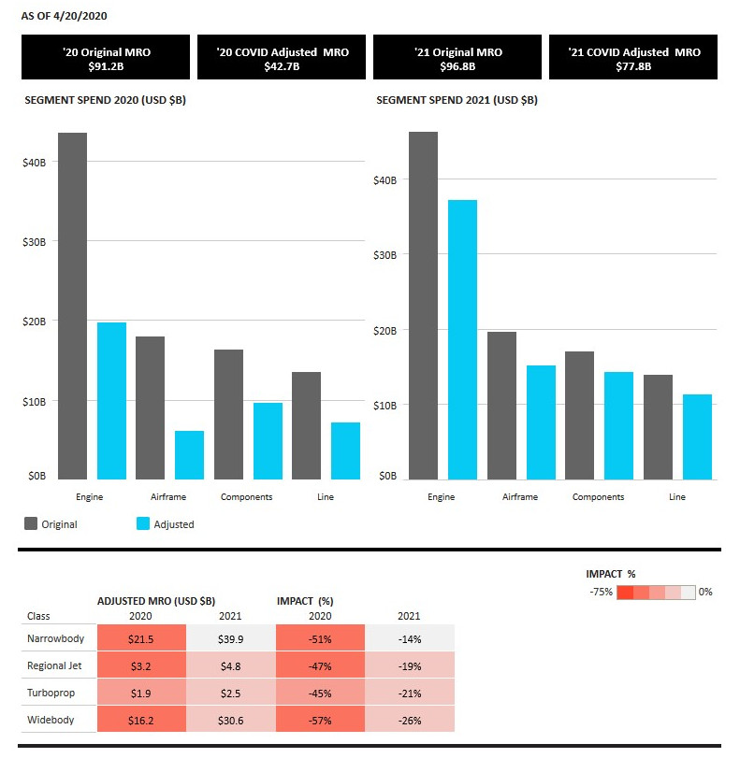

Figure : MRO Spend Forecast by Category

Essentially, maintenance becomes far less critical when aircraft are parked and out of service. And to make matters more difficult, operators are beginning to cannibalize parked aircraft for key components with low service hours, such as engines.

The dynamic in play here is that while essential operational expenditures (OpEx) are easier to manage and justify during hard financial times, the timeline plays in favor of capital investments (CapEx). It appears that demand for commercial passenger lift will grow slowly (again, refer to Figure 1 on page 10) and thus that OpEx would naturally fall during this period.

Commercial airlines are betting that while maintaining older airframes in service would emphasize operating expenses (OpEx) with the hope of an early demand return, capital investment (CapEx) in newer and more efficient aircraft several years hence is better aligned with likely demand timing.

At the end of this period, three or more years in the future, when passenger demand again is expected to approach 2019 levels, the fleet overall will be several years older, and parked aircraft more expensive to return to service. This works in favor of the new aircraft market at that time.

That said, for certain of the parked aircraft marked for return to service, this will work in favor of the MRO industry in two ways:

* During the “parked” period, aircraft worthy of future return to service will require maintenance to airworthiness standards, involving regular interventions by maintenance crews not to mention a storage location fit for potential return-to-service aircraft.
* At the time of return-to-service, some level of maintenance will be required, likely heavy maintenance and D-checks in many cases.

## Key Takeaways for the MRO Sector

While this sector overall will indeed be hard-hit during 2020, it is clear that MROs focusing on areas supporting the early recovery and restructuring of the aerospace market sectors will recover first.

While the MRO industry forecasts a difficult 12 months, it is anticipated that from 2021 forward, demand for MRO services will begin to grow, supported in the mid-term by private/business aviation and rotorcraft customers. For RAMI, specific opportunities with MROs will exist in meeting ADS-B demand within these two sectors, given the extension of the European ADS-B mandate for several years.

These “early recovery” MRO players may be categorized as follows:

* MROs supporting maintenance and repurposing of smaller aircraft, in both the commercial and business/private aviation sectors will find business as these sectors prioritize early return to or entry into service of these smaller aircraft, many of which may have been previously parked.
* MROs supporting light helicopter maintenance and repurposing of smaller rotorcraft will also be candidates for early recovery, starting in late 2020 or early 2021.

For these early recovery candidates, business development opportunities exist as we speak.

# What does this mean for RAMI?

As noted in the introduction to this report, the Step 1 recommendations remain largely valid, however, timing will be impacted for demand-driven tactical reasons.

In the Step 1 report of November 2019, AviaGlobal has recommended a 1st Tier supplier based and MRO based strategy along with a European business presence. While some aspects of timing must change due to the impact of COVID-19 on the aerospace industry, the recommended strategy remains sound.

## RAMI Business Opportunities in Europe

RAMI has opportunities for European business in several areas:

* European nationally-strategic OEMs (Thales, Airbus, Airbus Helicopters, et. al.)
* Business/private aviation operators and OEMs across the board
* MROs & OEMs supporting the recovery of European airlines and business/private aviation operators
* Public Safety and Medical Helicopter maintenance and upgrade

Concerning RAMI interest in M&A (Becker and otherwise)

* The Becker France opportunity is still very much on the table. RAMI has the action to return to Becker on interest in this opportunity.
* Consolidation opportunities may present in 2nd, 3rd and 4th tier aerospace companies on the block elsewhere in Europe.
* And the emphasis on shorter, more regionally secure supply chains makes a RAMI presence in Europe even more interesting than it was one year ago.

AviaGlobal Group recommends that RAMI launch as soon as possible the pursuit of two business development thrusts: (a) the development of the OEM and MRO supply chain markets, and (b) the establishment of a business and manufacturing presence in the European Economic Area (the European Union along with its aligned business partner countries).

## Proposed European Business Capture Strategy

AviaGlobal Group proposes the following capture strategy for business development toward European clients:

1. AviaGlobal Group will organize visits with OEMs and Air Frame Manufacturers to validate initial-fit demand for RAMI’s products and services in the European B2B market. Expected initial targets include Thales Aerospace, Airbus Helicopter, Airbus and ATR.
2. AviaGlobal Group will evaluate the MRO market for retrofit and upgrade potential for RAMI products and services to target MRO facilities performing civil/military upgrades, cargo conversions, and with special focus on those MROs who target the repurposing and return to service of smaller airframes, both fixed wing and rotor craft.
3. AviaGlobal Group will further assess potential in the European market space in the area of trainer aircraft and helicopters, targeting correspondence with and visits to Pilatus, Grob, RUAG, Aero and Leonardo Helicopters, among others.

AviaGlobal Group proposes to support RAMI in its European business development strategy with dedicated support staff engaged on a retainer basis.

1. Oliver Wyman is an American global management consulting firm. Founded in New York City in 1984, the firm currently has more than 60 offices in Europe, North America, the Middle East, and Asia-Pacific, employing over 5,000 professionals. It ranks among the best strategy consulting firms in the world in terms of prestige, growth, and employee satisfaction. The firm is part of the Oliver Wyman Group, a business unit of Marsh & McLennan (Credit: Wikipedia).
2. According to Wikipedia, the IBA Group Limited provides aviation consultancy services. The Company offers asset valuation, corporate aircraft and helicopter advisory and management services, legal services, data services, technical support, asset management, remarketing of aircrafts, lease arrangements, and acquisition and disposal of assets.
3. From Wikipedia, Roland Berger is a global strategy consulting firm headquartered in Munich, with 50 offices in 36 countries. The company was founded under the name Roland Berger Strategy Consultants in 1967 by Roland Berger. In 2011, the company's sales were roughly US$1.2 billion. The company, with around 2,400 employees worldwide, is an independent partnership wholly owned by its approximately 220 partners. Roland Berger is one of the world's seven largest strategy consulting firms. The firm operates as a generalist strategy consultancy and advises clients on management issues ranging from strategy development to performance improvement. Roland Berger also advises in the fields of restructuring and marketing, with a focus on the automobile Industry and the capital goods sector.