Commercial Aviation 2021 Fleet & MRO Forecast Webinar


Brian Coe, Dan Williams, Clay Caffery

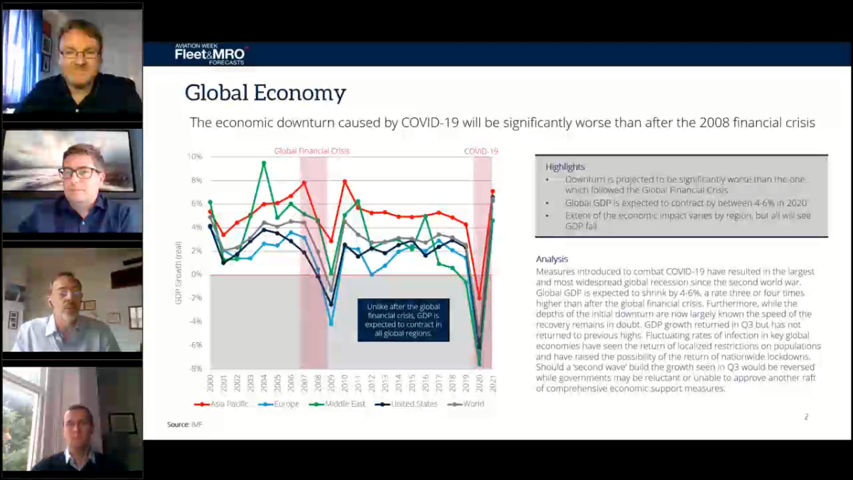
Released a “Service Bulletin” and monthly KPI and early release of forecast.
Estimate by IMF for GDPs across the regions
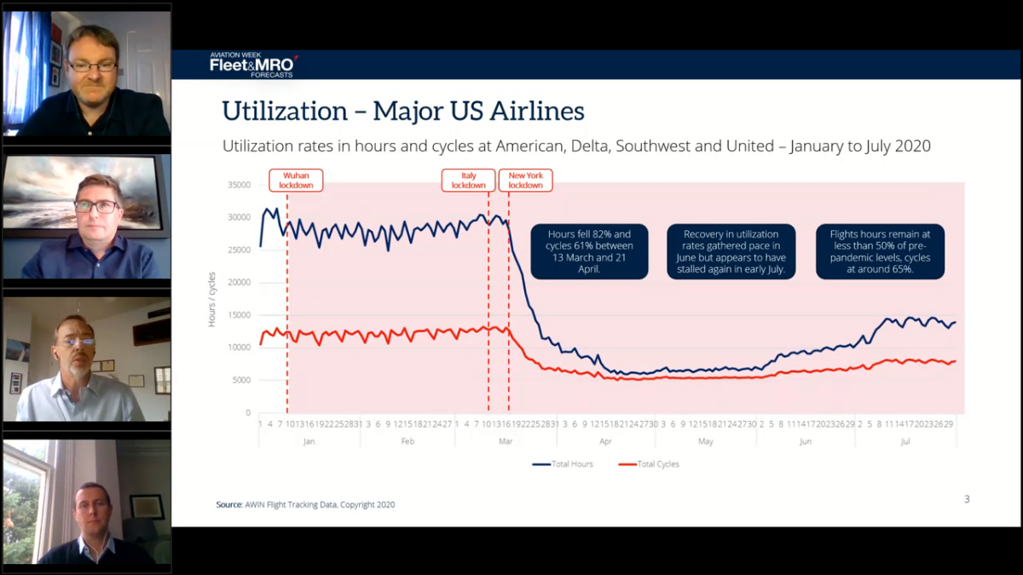
Major US airlines and tracking hours and cycles. Less than 50%
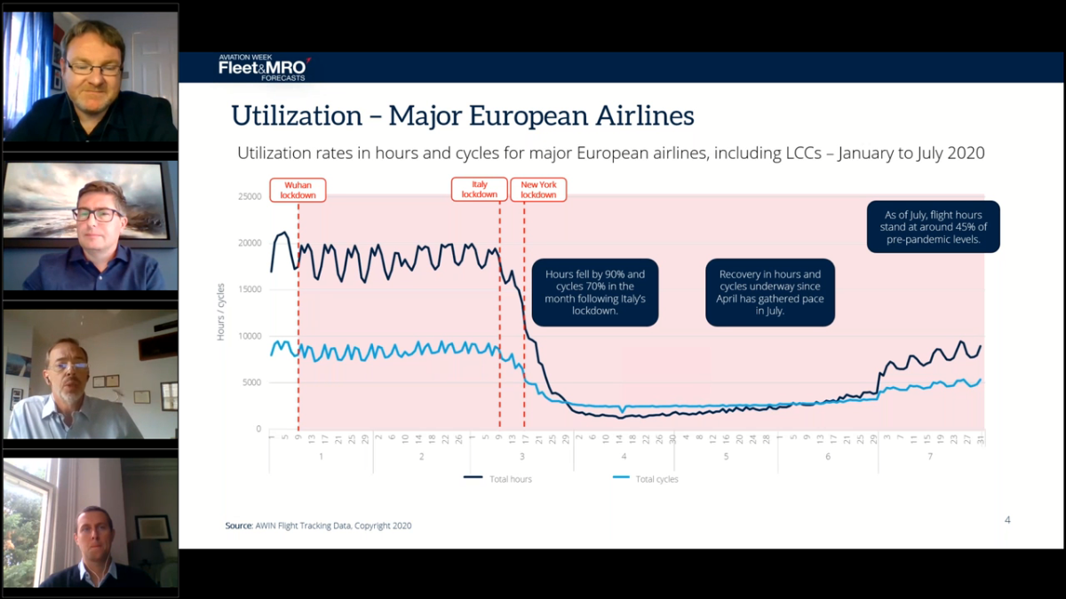
European less than 45% (interesting that longer haul routes seem to be coming on line – Lee’s insight)

Missed slide…
Cargo (non package carriers)
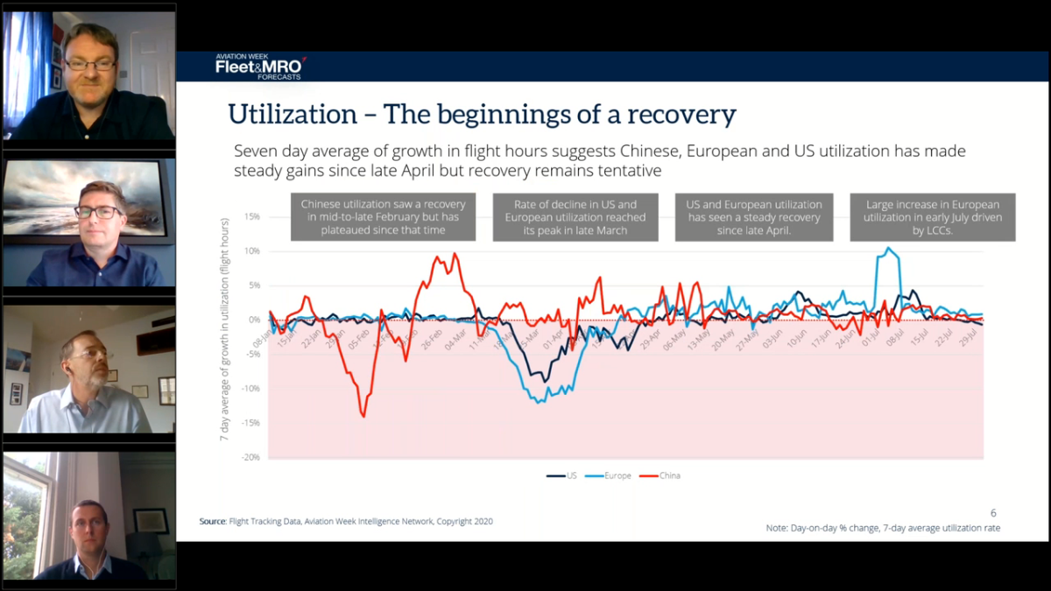
Big Europe spike is Ryanair, Whizz and a couple others came back on line
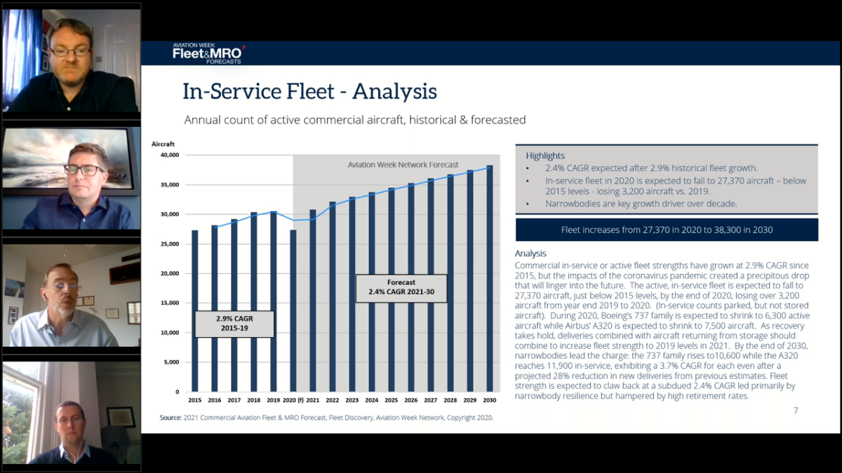
Active: Aircraft – Flying, temp parked, in service (not retired or stored)
Assumes no Max aircraft deliveries 2020 but assumes resumption in
747-400, A340, A330 (costly D-Check), retirements
Some stored aircraft will “come back to life” later and this counters depressed production.
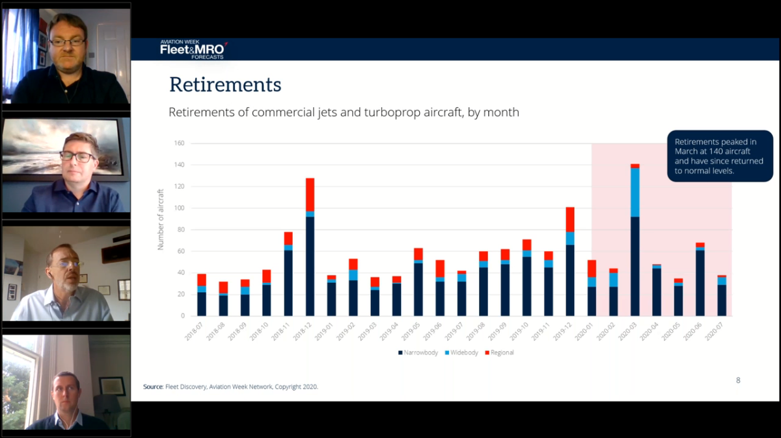
Four engine aircraft “leaving the earth”
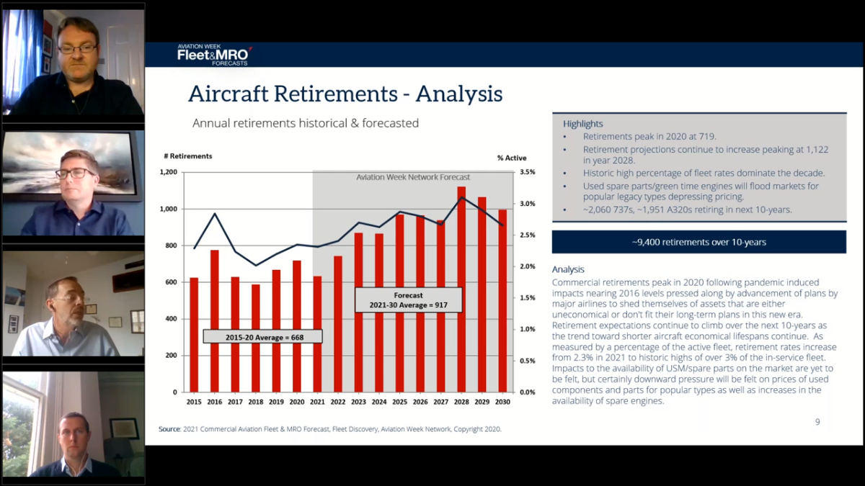
Driven by aircraft age and economic life
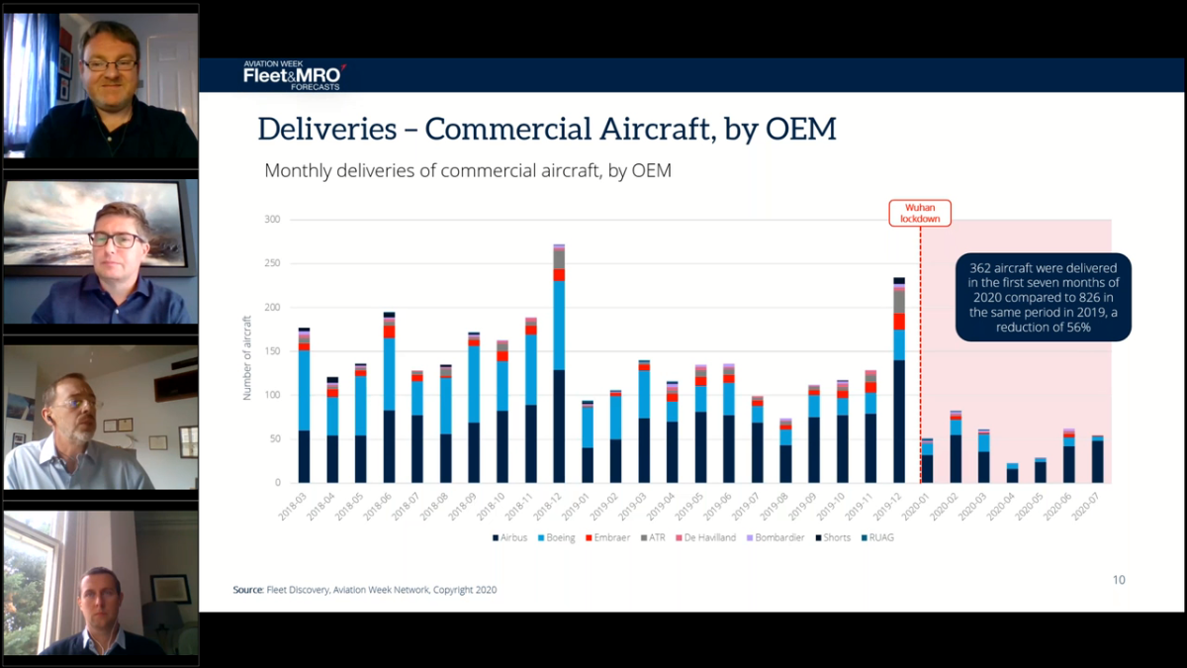
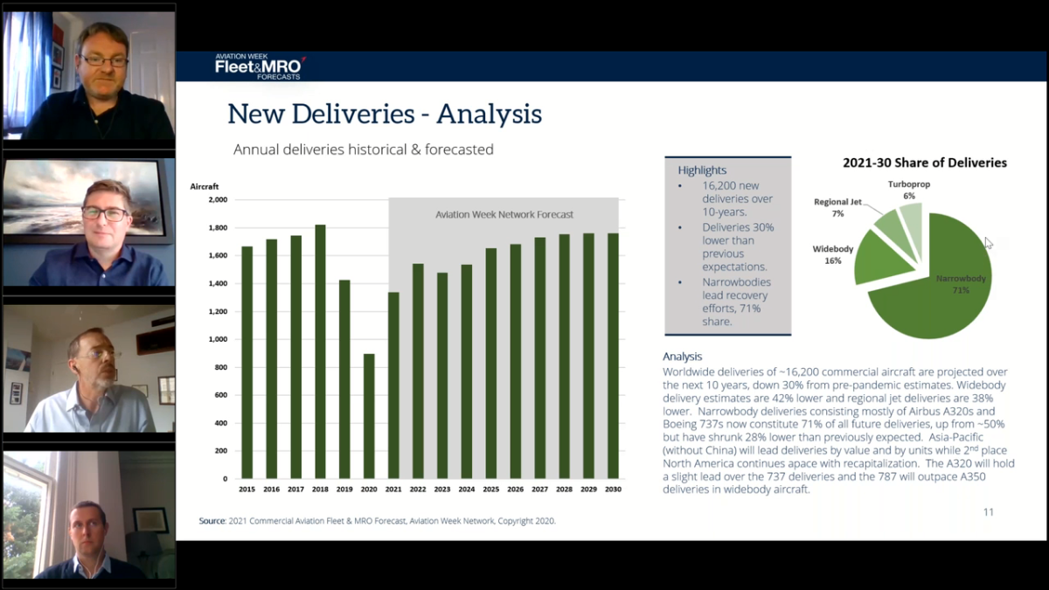
Spikes are 450+ Max aircraft awaiting delivery
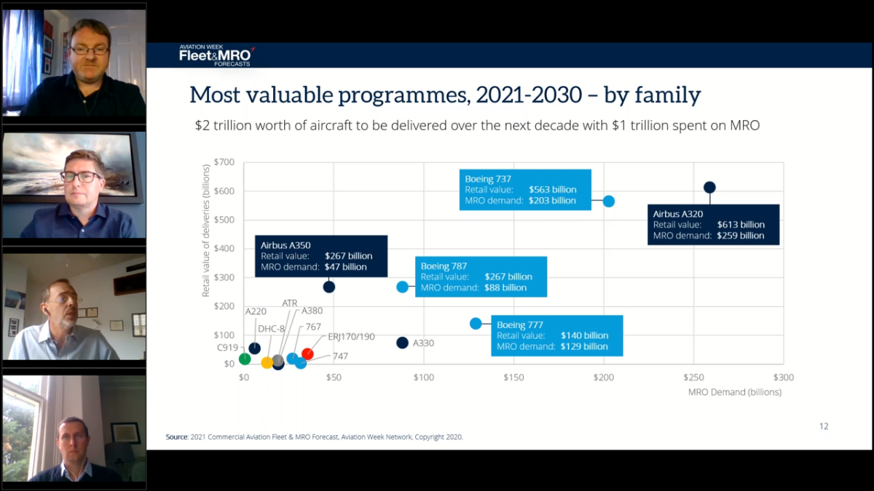
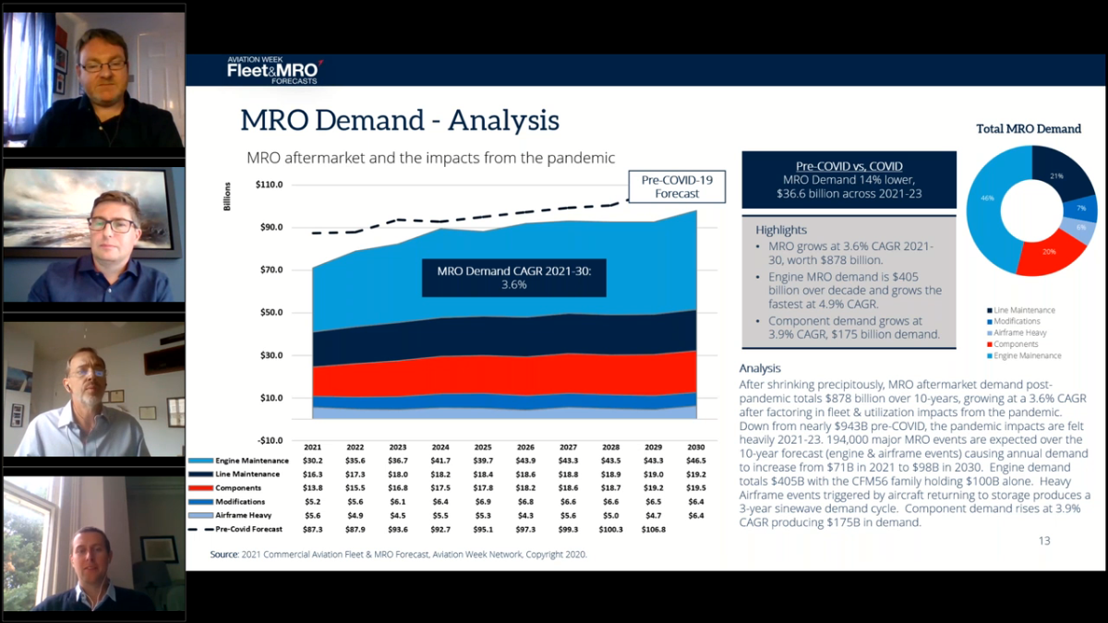
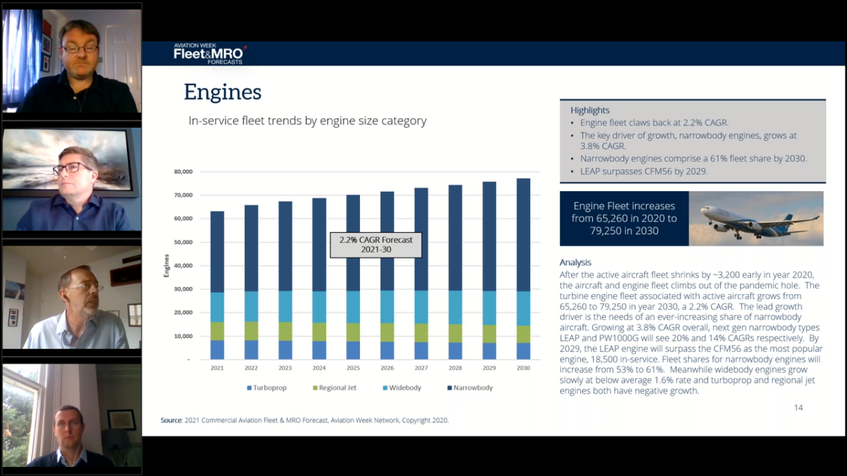
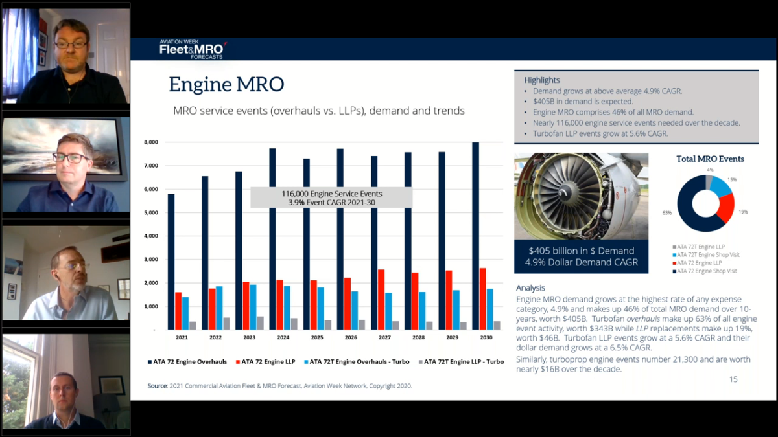
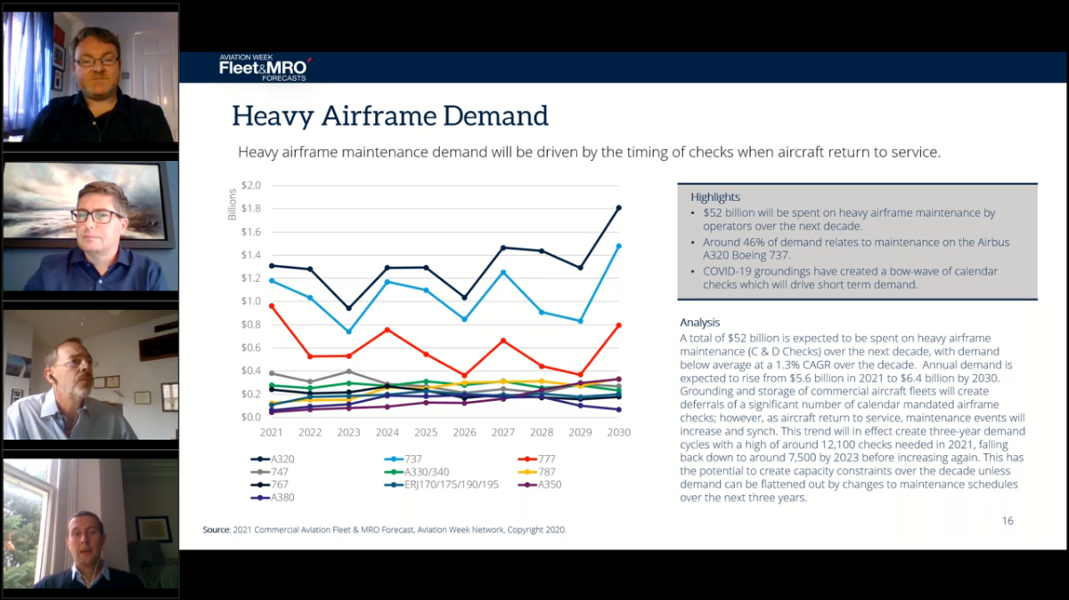
Downstream effects due in part to reintroduction of aircraft from storage
