***Aviation Business Solutions … Insight, Action, Advantage***

Ercoupe to Airbus, Asset to Airspace - Manned & Unmanned, Civil & Military

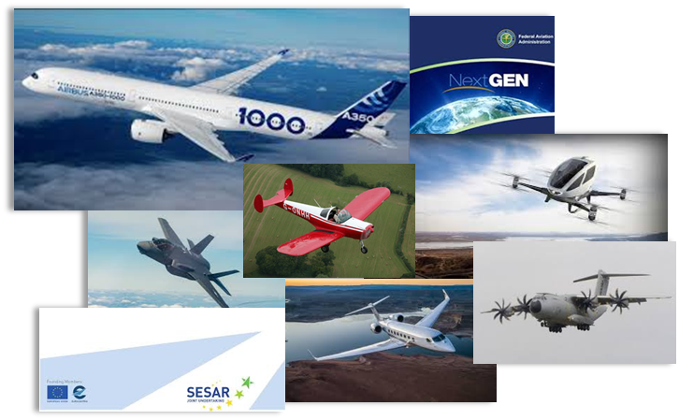

From product and market development to business and operational analysis, The Grey Group provides unique expertise to the aerospace industry. With over 95 years of combined experience including engineering, sales and marketing, M&A, operational development and C-level executive insight, the The Grey Group offers affordable insight and partnership in developing your product and business potential.

For example, using proprietary tools and data, the The Grey Group can help you evaluate fleet and market potential for your product line and business roadmap. Employing The Grey Group’s “Innovation Roundtable” on-site seminars can help your organization discover and develop product ideas from your own hidden talent pool. Or, The Grey Group breadth of experience can help clarify Bid / No Bid decision-making. Whatever the task, The Grey Group can tailor a program to suit your unique requirements

Whether your growth strategies include product development, market expansion, merger and acquisitions, organic growth or outsourced expertise, let the Grey Group advantage help focus your organizations roadmap for success.

**Hal Adams** Co-Founder, Managing Member – Administration Lead

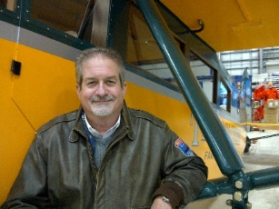Phoenix, Arizona USA

Hal Adams has over 40 years of civil and military aerospace experience.  He is the Managing Director & Co-Founder of Aero Business Development LLC (ABD), specializing in business development and strategies support, with emphasis in avionics.

In 2008, Adams partnered with Accord Software & Systems to found Accord Technology, a leading supplier of Global Navigation Satellite Systems solutions. As COO of Accord Technology, Adams was responsible for the creation, start up and day-to-day operations, during which Accord Technology achieved FAA approval for the industry’s first advanced GPS sensors used in ADS-B and precision approaches.

Aspen Avionics acquired Accord Technology in 2015 and Adams was Executive VP of Aspen until leaving in February 2017 to devote full time to ABD. He is still an investor in Aspen Avionics.

Adams’ broad aerospace and avionics experience includes senior leadership positions in general management, product and business strategies, development activities with Northwest Airlines, Lockheed-Martin, Northrop Grumman, Rockwell Collins, Thales Aerospace and Aviation Communications and Surveillance Systems (ACSS).

Mr. Adams’ global business interface includes over 15 years of in-residence international experience including London, Hong Kong and Paris. Key business activities include new avionic product development, launches such as the Thales new AIRBUS FMS and TAWS, the Litton LTN-92-INS, the Collins series 900 CNI sensors, SATCOM, SATNAV and ACSS T2CAS and Dlink+.

Adams holds a BSBA, major in Aviation Administration, from the University of North Dakota. Life experience includes USAF B-52 combat flight crew member and operations during the Vietnam conflict, awarded the USAF Air Medal with three oak leaf clusters. He is a U.S. FAA commercial pilot with an instrument rating and Certified Flight Instructor. He is a member of the Institute of Navigation, Experimental Aircraft Association, Aircraft Owners and Pilots Association, Alaska Airmen Association, Air Force Association, Guild of Air Pilots, Air Navigators, London and founding member of the Hong Kong Aerospace Forum. He participates in RTCA Special Committees and is an active participant in Equip 2020 industry working group addressing the FAA NextGen (Next Generation Transportation System) modernization program.

**Lee Carlson** Co-Founder & Managing Partner – Marketing & Sales Lead

Grand Rapids, Michigan USA

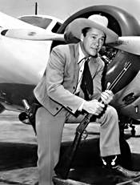Lee Carlson brings product development, sales, marketing and technical expertise to the Grey Group. With a strong, customer-centric focus on market analysis and product conceptualization, Carlson draws on his background with L3 Technologies, Smiths Aerospace (now GE Aviation) and The Boeing Company where his career has included roles in sales, marketing, project management, alliance management and engineering.

Lee’s strong entrepreneurial skills are reflected in guiding the development of new products from initial business case presentation through the successful product launch of several key innovations. In 2017, Carlson established an independent contracting and consulting practice that includes client avionics companies, STC engineering facilities and several other aerospace concerns.

Carlson has been an invited presenter at conferences of Aircraft Electronics Association, AOPA Pilot Forums, World Aviation Training Summits, International Society of Air Safety Investigators and SAE International. Lee has participated in EUROCAE, AEEC, RTCA and FAA NextGen committees and was appointed to the Loss of Control Joint Safety Implementation Team..

Carlson has subject matter expertise with voice and data recorder products, transponder and ADS-B systems, infrared imaging products, flight management systems, cockpit display products and other integrated and federated avionics systems.

Lee holds a Bachelor of Science degree in Computer Science for the Michigan State University College of Engineering. Carlson also has a Private Pilot certificate.

**Forrest Colliver** Co-Founder & Managing Partner, Solutions Lead

Strasbourg, France

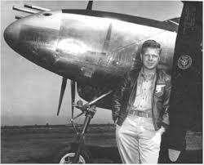Forrest Colliver is Founding Member of The Grey Group and is President & Founder of AeroNextGen SARL, a leading source of solutions and subject matter expertise in airborne communication, navigation and surveillance systems and in operational and technical aspects related to worldwide ATC modernization programs.

Mr. Colliver’s career in aerospace spans 30 years, having lived and worked in both the US and the European Union. He brings to the Grey Group a broad background in aerospace and technology focused on strategic planning and business development for avionics, air traffic management and in-flight entertainment systems. He has also held a number of executive management positions, as well as having global experience in airspace operational and regulatory issues.

For the past three years, Forrest Colliver has served as Managing Director and chief executive officer of the Becker Group, with P&L responsibility for Becker Avionics GmbH (Rheinmünster, Germany), Becker Eléctronique S.A. (Beaucourt, France), Becker Avionics Inc. (Miramar, Florida, USA) and Becker Polska (Wrocław, Poland). Prior to coming to Becker, Mr. Colliver was Vice President, Business Development at Innovative Solutions & Support.

Mr. Colliver previously served as Program Manager for Aviation Research at the MITRE Corporation, a US Federally Funded Research and Development Center (FFRDC) providing systems engineering, research and development support in air traffic management to both U.S. and foreign governments.

Prior to rejoining The MITRE Corporation in 2010, Mr. Colliver was Director of Business Development, Commercial Aircraft Solutions, at Thales S.A. in Toulouse, France. In this role, he led sales & business development teams, drove new product strategy and developed new business and partnership opportunities in the civil aviation domain. Mr. Colliver also served as Vice President of Business Development for EMS Technologies (now part of Honeywell Aerospace) and as Director of Business Development for Sensis Corporation (now part of Saab Aerospace).

Mr. Colliver served as project manager for several European Air Traffic Management research and development projects while with Sofréavia S.A. In this capacity, Mr. Colliver represented the French DGAC’s technology interests in ICAO and other government/industry organizations. During his initial tenure with MITRE, he supported the US Federal Aviation Administration in technology and regulatory matters, and he represented the FAA as a technology and policy advisor at ICAO, RTCA/EUROCAE and AEEC forums.

Mr. Colliver has been engaged as a speaker at numerous aviation-related conferences and symposia throughout his career. He has been honored with the FAA’s Award for Achievement in Technical Excellence, and has received the MITRE Corporation’s Awards for Industry/Government Team Leadership, for Excellence in User Engagement, and for leadership of executive-level industry/government policy advisory teams supporting the FAA’s NextGen program.

Mr. Colliver holds Bachelor’s and Master’s degrees in Electrical Engineering from Virginia Polytechnic Institute and State University and an MBA degree from East Tennessee State University. He is an avid outdoor enthusiast, is passionate about music and world history, and is fluent in both English and French.