***Aerospace Business Driven Solutions … Insight, Action, Advantage***

Ercoupe to Airbus, Asset to Airspace - Manned & Unmanned, Civil & Military

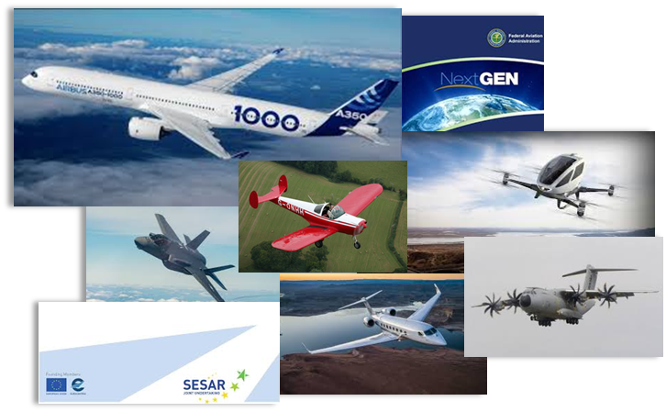

From product and market development to business and operational analysis, The Grey Group provides unique expertise to the aerospace industry. The principal leaders are a team of seasoned professionals with demonstrably successful track records, including engineering, sales and marketing, M&A, business and operational development, and corporate level executive insight. Collectively, the principals leverage their professional networks and knowledge base, providing added value and depth as needed for solutions to client challenges. The Grey Group offers affordable, exceptional insight through partnership in developing, enhancing your products and realizing your business’ potential.

Using proprietary tools and data, the Grey Group can help you evaluate fleet and market potential for your product line and business roadmap. The Grey Group’s “Innovation Roundtable” on-site seminars can help your organization discover and develop product ideas from your own hidden talent pool. We offer decision point structure creation and execution, product business case support, and we offer guidance enabling effective program management structures, all designed to support your business growth objectives. The Grey Group’s breadth of experience can help clarify Bid / No Bid decision-making. Whatever the task, The Grey Group can tailor a program to suit your unique requirements

Whether your growth strategies include product development, market expansion, merger and acquisitions, organic growth or outsourced expertise, let The Grey Group advantage help focus your organizations roadmap for success.

**Hal Adams** Co-Founder & Managing Member – Administration Lead

Phoenix, Arizona USA

Hal Adams has over 40 years of civil and military aerospace experience.  He is the Managing Director & Co-Founder of Aero Business Development LLC (ABD), specializing in business development and strategies support, with emphasis in avionics.

In 2008, Adams partnered with Accord Software & Systems to found Accord Technology, a leading supplier of Global Navigation Satellite Systems solutions. As COO of Accord Technology, Adams was responsible for the creation, start up and day-to-day operations, during which Accord Technology achieved FAA approval for the industry’s first advanced GPS sensors used in ADS-B and precision approaches.

Aspen Avionics acquired Accord Technology in 2015 and Adams was Executive VP of Aspen until leaving in February 2017 to devote full time to ABD. He is still an investor in Aspen Avionics.

Adams’ broad aerospace and avionics experience includes senior leadership positions in general management, product and business strategies, development activities with Northwest Airlines, Lockheed-Martin, Northrop Grumman, Rockwell Collins, Thales Aerospace and Aviation Communications and Surveillance Systems (ACSS).

Mr. Adams’ global business interface includes over 15 years of in-residence international experience including London, Hong Kong and Paris. Key business activities include new avionic product development, launches such as the Thales new AIRBUS FMS and TAWS, the Litton LTN-92-INS, the Collins series 900 CNI sensors, SATCOM, SATNAV and ACSS T2CAS and Dlink+.

Adams holds a BSBA, major in Aviation Administration, from the University of North Dakota. Life experience includes USAF B-52 combat flight crew member and operations during the Vietnam conflict, awarded the USAF Air Medal with three oak leaf clusters. He is a U.S. FAA commercial pilot with an instrument rating and Certified Flight Instructor. He is a member of the Institute of Navigation, Experimental Aircraft Association, Aircraft Owners and Pilots Association, Alaska Airmen Association, Air Force Association, Guild of Air Pilots, Air Navigators, London and founding member of the Hong Kong Aerospace Forum. He participates in RTCA Special Committees and is an active participant in Equip 2020 industry working group addressing the FAA NextGen (Next Generation Transportation System) modernization program.

**Lee Carlson** Co-Founder & Managing Partner – Marketing & Sales Lead

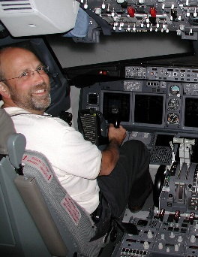Grand Rapids, Michigan USA

Lee Carlson is Founding Member of The Grey Group and President & Founder of ADS-B Global, LLC, a leading source of solutions and knowledge in avionics and the FAA ATC modernization program, NextGen.

Lee Carlson brings product development, sales, marketing and technical expertise to the Grey Group. With a strong, customer-centric focus on market analysis and product conceptualization, Carlson draws on his background with L3 Technologies, Smiths Aerospace (now GE Aviation) and The Boeing Company where his career has included roles in sales, marketing, project management, alliance management and engineering.

Lee’s strong entrepreneurial skills are reflected in guiding the development of new products from initial business case presentation through the successful product launch of several key innovations. In 2017, Carlson established an independent contracting and consulting practice that includes client avionics companies, STC engineering facilities and several other aerospace concerns.

Carlson has been an invited presenter at conferences of Aircraft Electronics Association, AOPA Pilot Forums, World Aviation Training Summits, International Society of Air Safety Investigators and SAE International. Lee has participated in EUROCAE, AEEC, RTCA and FAA NextGen committees and was appointed to the Loss of Control Joint Safety Implementation Team, a national joint government/industry safety advisory board tasked with developing recommendations to improve pilot training and reduce civilian aviation accident rates.

Carlson has subject matter expertise with voice and data recorder products, transponder and ADS-B systems, infrared imaging products, flight management systems, cockpit display products and other integrated and federated avionics systems.

Lee holds a Bachelor of Science degree in Computer Science for the Michigan State University College of Engineering. Carlson also has a Private Pilot certificate.

**Forrest Colliver** Co-Founder & Managing Partner, Solutions Lead

Strasbourg, France

Forrest Colliver is President & Founder of AeroNextGen SARL, a leading source of subject-matter expertise in airborne and ground-based communication, navigation & surveillance systems and operational aspects of global ATC modernization programs. He brings to The Grey Group a broad background in the application of technology, strategic planning, program management and business development disciplines to the deployment of avionics and air traffic management systems.

Mr. Colliver’s career in aerospace spans more than 30 years, having lived and worked in both the US and the European Union. His success in solution-oriented business development derives from application of his strong engineering core capability with his extensive business background to focus on taking ideas from conception to implementation. Mr. Colliver combines personal dedication with team focus to produce the desired operational result.

Mr. Colliver has held a number of executive management positions, serving for the past three years as Managing Director and Chief Executive Officer of the Becker Group, headquartered at Becker Avionics GmbH (Rheinmünster, Germany). Prior to coming to Becker, Mr. Colliver was Vice President, NextGen Systems, at Innovative Solutions & Support. He also served as Program Manager and as Director of Business Development at Thales S.A. in Toulouse, France, as Vice President of Business Development at EMS Technologies, and as Director of Business Development at Sensis Corporation.

Mr. Colliver balances his executive & business skills with expertise in technology leadership based on his long-term support for industry, governmental & non-governmental organizations. He served as Program Manager for Aviation Research at the MITRE Corporation in Washington, D.C., and has supported the US Federal Aviation Administration, serving as a technology & policy advisor at ICAO, RTCA/EUROCAE, IATA & AEEC forums. Mr. Colliver also served as Program Manager for several European Air Traffic Management research consortia, where he represented the French DGAC’s technology & policy interests.

Mr. Colliver has been a speaker at conferences & symposia throughout his career. He has been honored with the FAA’s Award for Achievement in Technical Excellence, has received the MITRE Corporation’s Awards for Team Leadership, and has been recognized by RTCA for his role in leadership of cross-industry technology policy advisory teams.

Mr. Colliver holds Bachelor’s and Master’s degrees in Electrical Engineering from Virginia Polytechnic Institute and State University and an MBA degree from East Tennessee State University. He is an avid outdoor enthusiast and dedicated alpinist, is passionate about music and world history, and is fluent in both English and French.